NATIONAL SERVICE SCHEME
ANNUAL REPORT
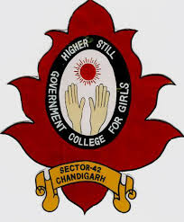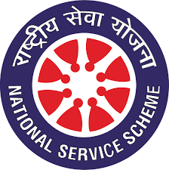

POST GRADUATE GOVERNMENT COLLEGE FOR GIRLS
SECTOR-42, CHANDIGARH
SESSION: 2021-2022

NSS INCHARGE: Mr. Mehar Chand
Dr. Ranjna Sharma Programme Officer
Dr. Gagandeep Gyani Programme Officer
Dr. Harpreetkaur Programme Officer
Dr. Sujata Programme Officer
Dr. Gundeep Virk Programme Officer
Ms. Kalyani Singh Programme Officer
Mr. Vinod Kumar Programme Officer

ACTIVITIES OF NSS CONDUCTED FROM 1ST APRIL, 2021- 30TH JUNE, 2021
The NSS wing of the college keeps on organizing various activities on pertinent occasions in order to bring about awareness among the students about social activities and to inculcate in them a spirit to serve the society for the best. Though the nation faced pandemic situation and the situation of lockdown prevailed, still the volunteers sought ways and methods to celebrate different occasions. The activities that were held in the tenure of these three months were as follows:
WORLD HEALTH DAY, 7TH APRIL, 2021
It is rightly said, “the success of a nation depends upon the health of its people.” Henceforth to celebrate the World Health Day the NSS wing of GCG-42 gathered in the college and pledged to aware the people about the top health issues that were being faced by the people then. Therefore, the volunteers gathered along with the teachers, came out on the roads and distributed pamphlets among the masses and made them aware about the fact as to how they can control the prevailing diseases. The volunteers also went door to door in order to make the people aware about how they can control the spread of malaria, dengue and COVID. Along with this they went to the adopted village Khajheri and distributed health essentials among the people and also made the crowd aware about the health issues and the ways to curb it.
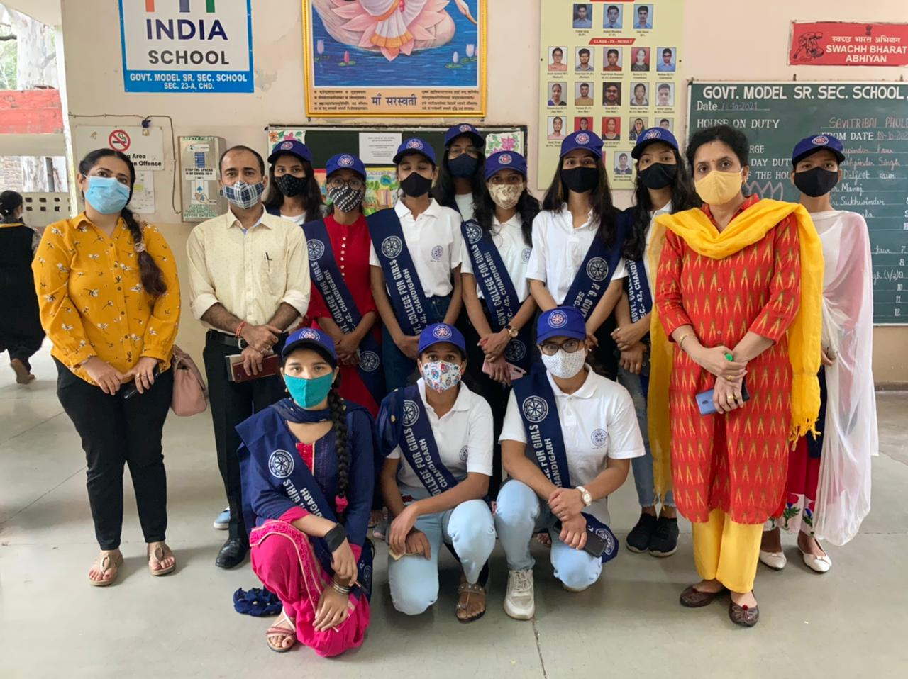
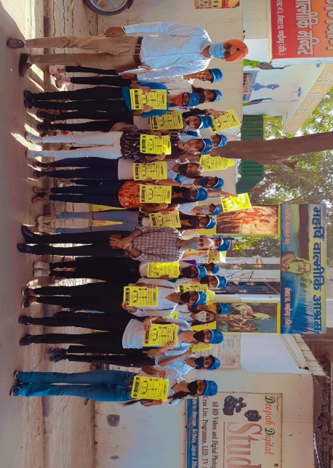
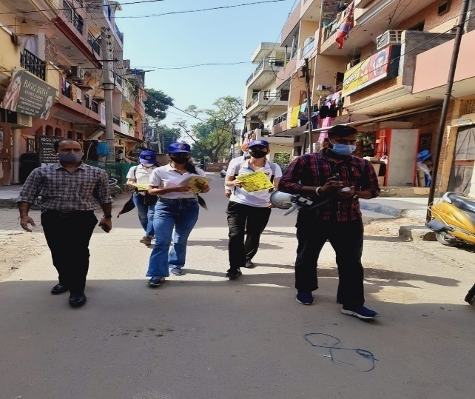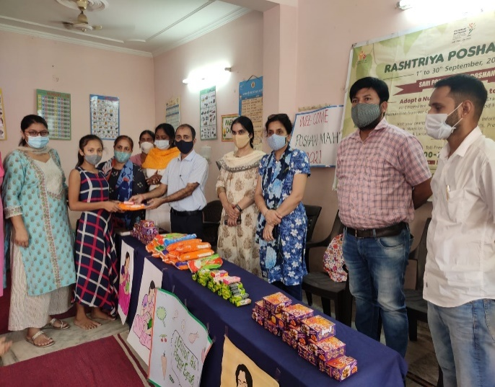
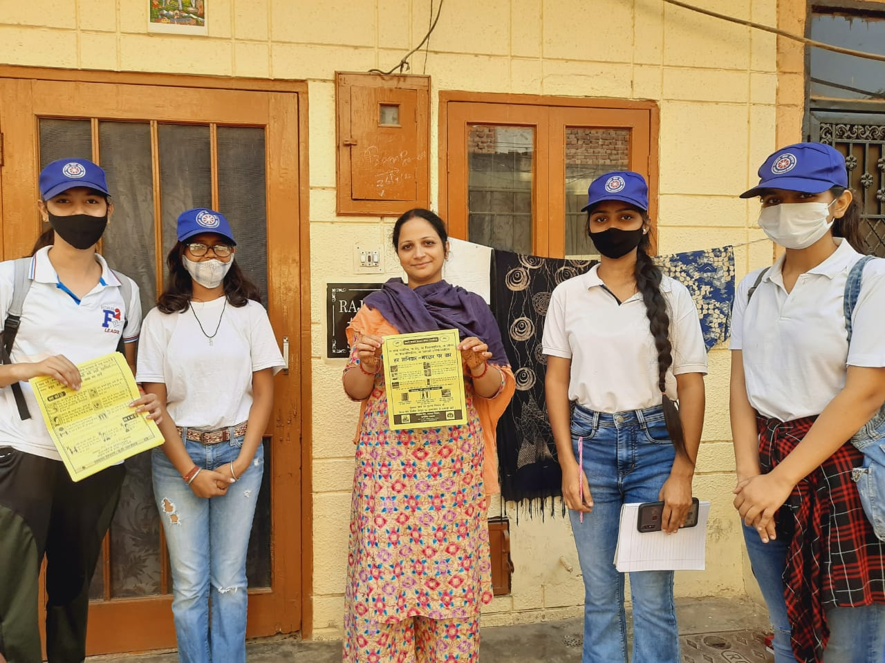

AWARENESS CAMPAIGN ON COVID-19, 27TH MAY, 2021

A webinar was held on psychological support of COVID pandemic conditions by the NSS wing of the college in collaboration with MGNCRE, Government of India. In this webinar a large number of volunteers participated and they were counselled about the situation of the pandemic. The volunteers were told that they need to keep a calm mind and help others while taking care of themselves. The mentors laid stress on the fact that how mental counselling can be a great source of help for those who are facing the situation at hand.

“Replace sympathy with empathy” was the main focus of the webinar. The volunteers were tutored as to how they should talk to someone who is facing the situation and how they must try to calm them down. Also the volunteers were asked if they could join the initiative of helping people from their respective homes itself in which a large number of volunteers came forward for help.
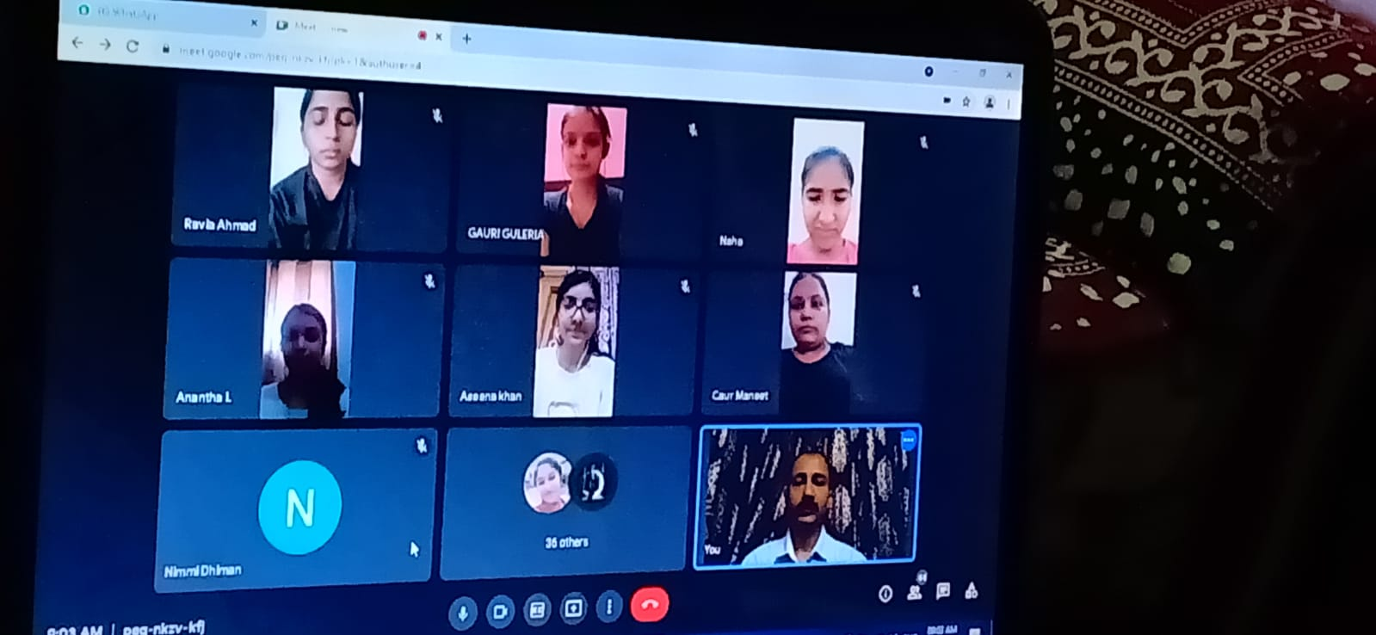
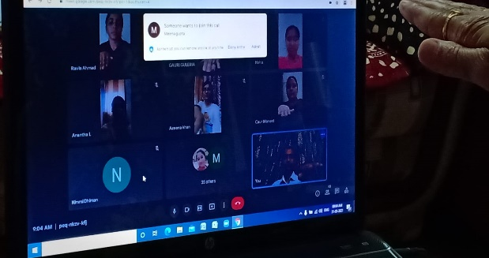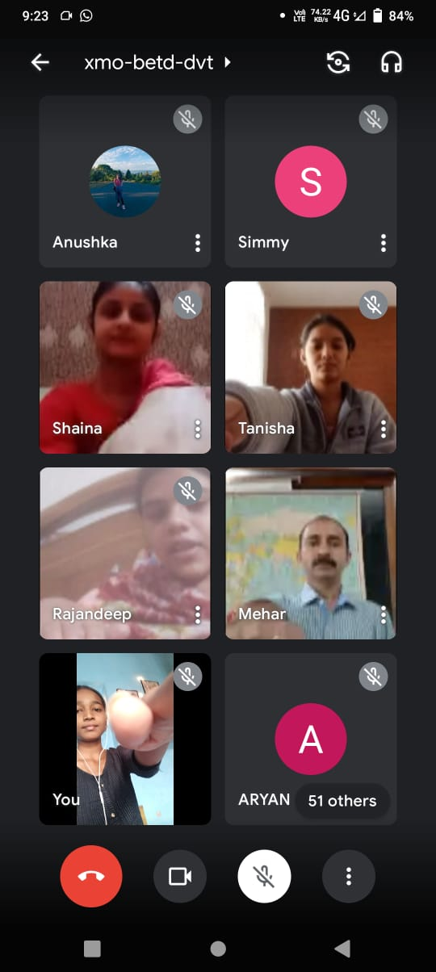
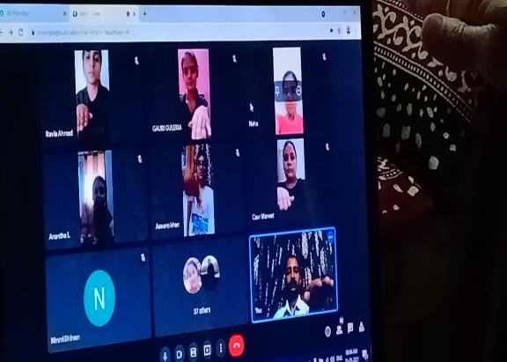

ANTI-TERRORISM DAY, 21st MAY, 2021

To mark the death anniversary of former Prime Minister, Shri Rajiv Gandhi, anti-terrorism day is celebrated every year on 21st May. On this day an online pledge taking ceremony was organized by the NSS wing of the college. In the oath taking ceremony the students along with the teachers took a pledge that they shall promote peace, social harmony, and understanding among all fellow human beings and fight the forces of disruption threatening human lives and values.

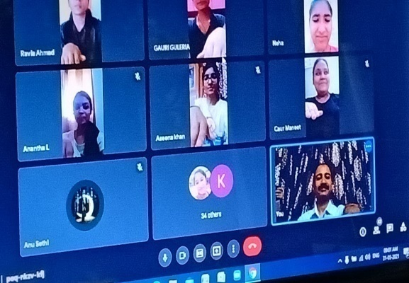
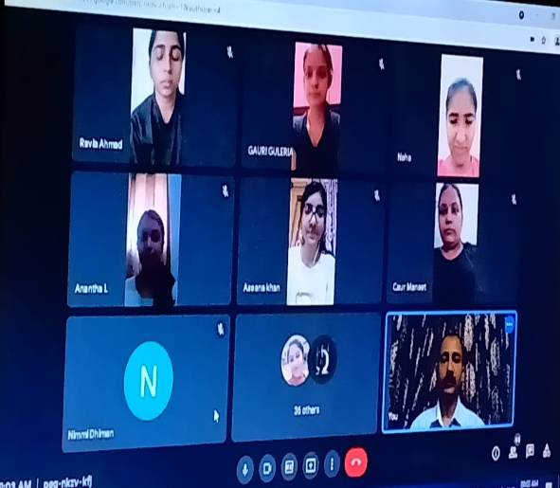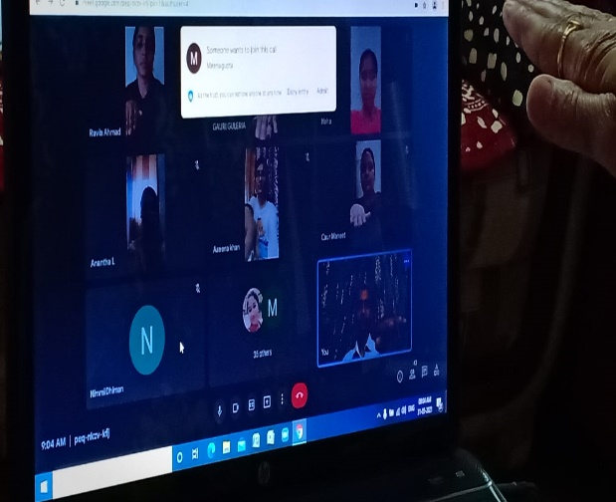
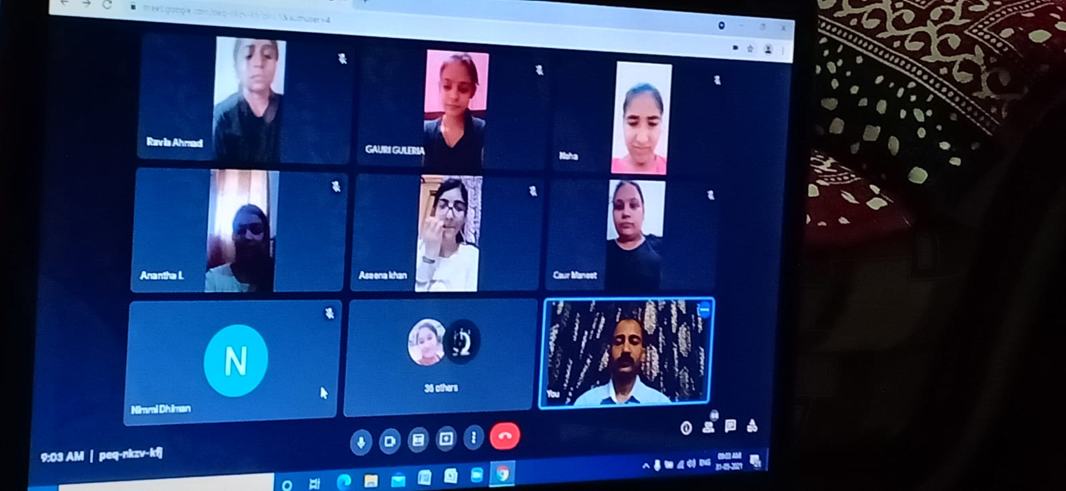
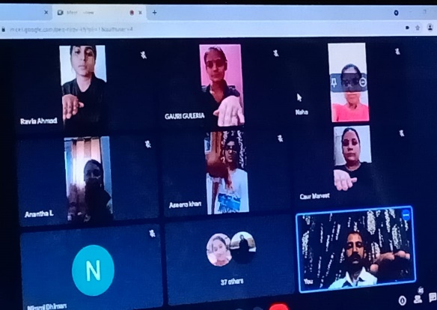
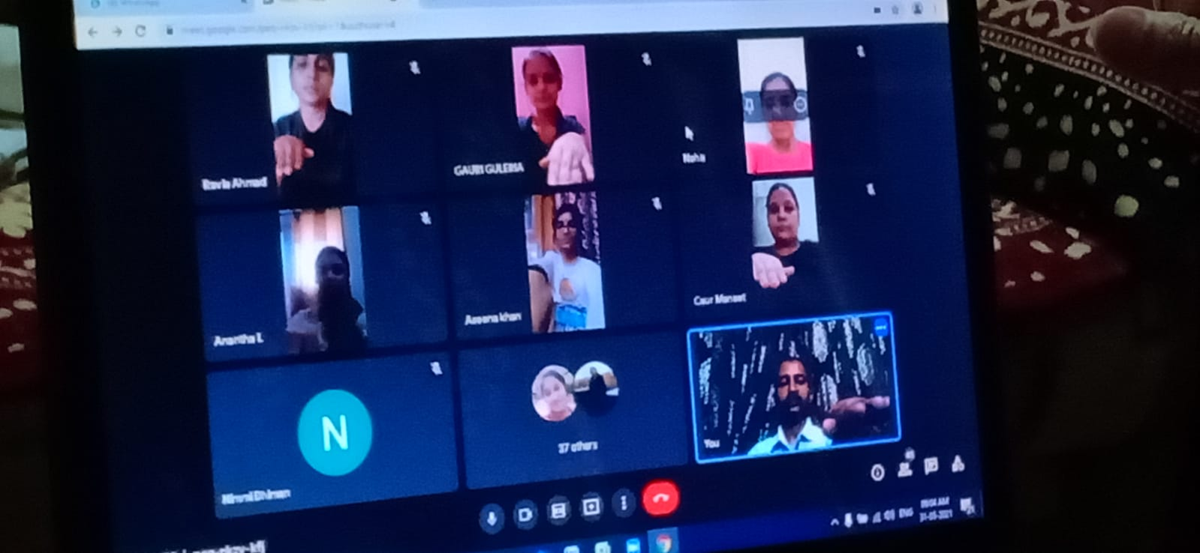

ANTI-TOBACCO DAY, 31ST MAY, 2021
In today’s era tobacco is one of the major hinderance in the growth of our nation. Not only is it taking our youth off the path of success but is also making them unhealthy. In order to commemorate this occasion a pledge taking ceremony was organized in the college premises. On this day the college staff along with the NSS volunteers gathered in the college and the college principal made the students take oath and pledge that they shall never consume any tobacco products and nor shall they let their families and friends do so. The students also pledged that they shall motivate others to lead a tobacco free life.
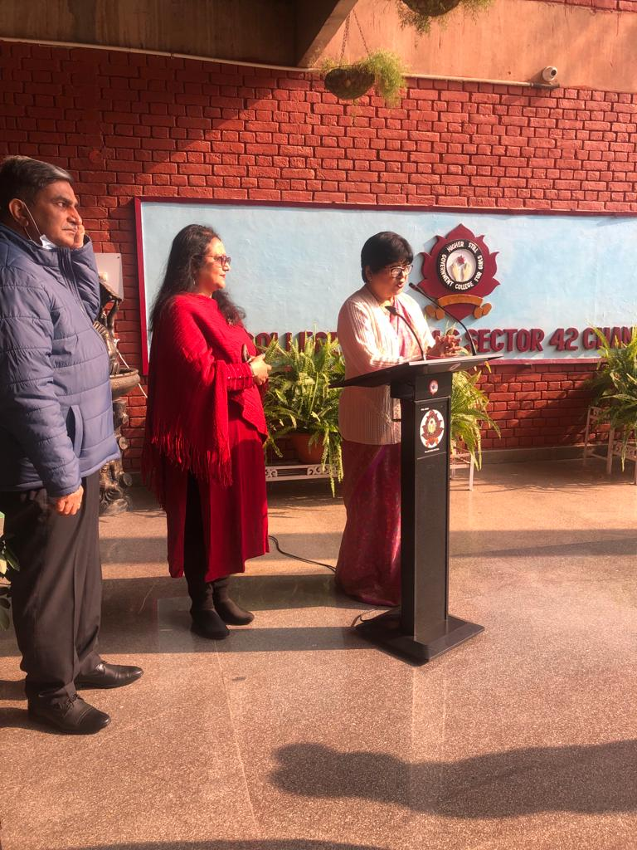
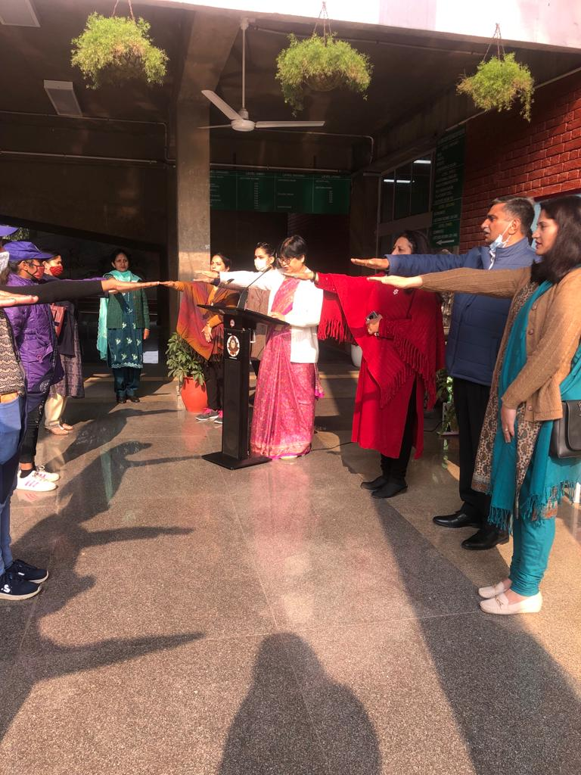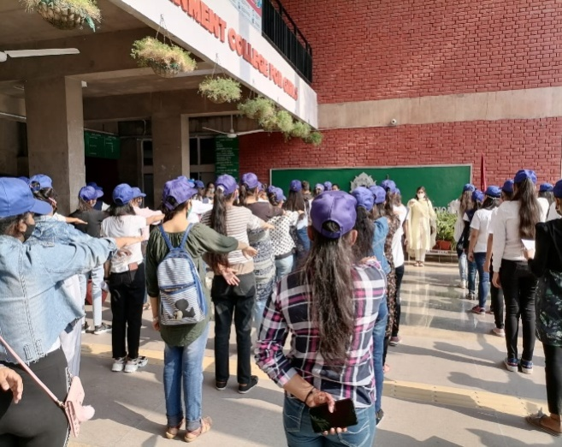
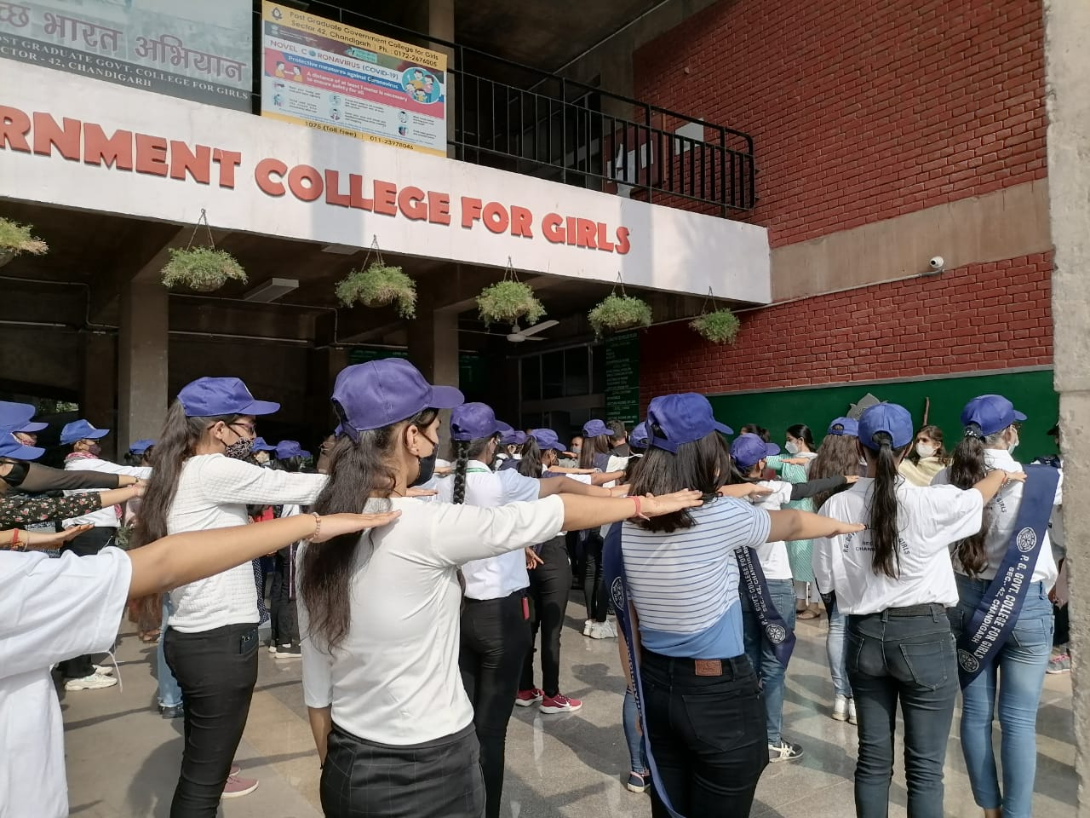
WORLD ENVIRONMENT DAY, 5TH JUNE, 2021
On the occasion of World Environment Day, the college NSS wing in collaboration with Srishti- the environment society of PGGCG-42 Chandigarh, celebrated the occasion by organizing an inter college BEST FREN AREA competition. This competition was held in online mode on the theme ECOSYSTEM RESTORATION via online mode. Entries were invited in pdf form comprising pictures of home garden or potted plants maintained at their home/ kitchen garden. Forty five students from different collages shared beautiful pictures of well maintained gardens and judgement was done on the basis of well maintenance, level of plant diversity reflected, landscaping, pot arrangement, skill of photography and clarity of pictures. E- certificates were provided to the winners.

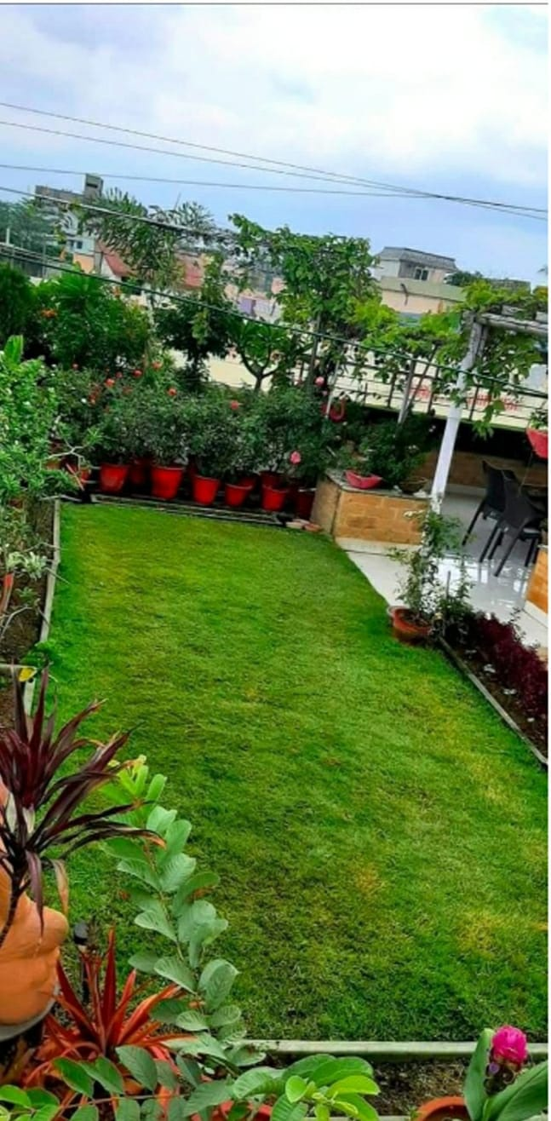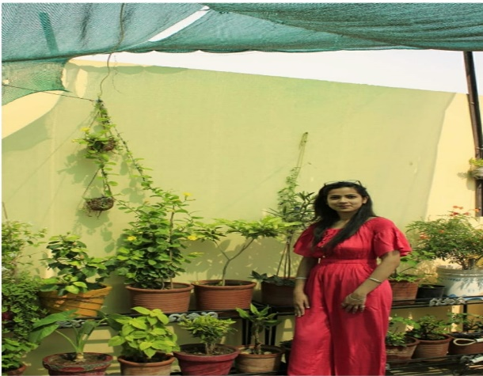
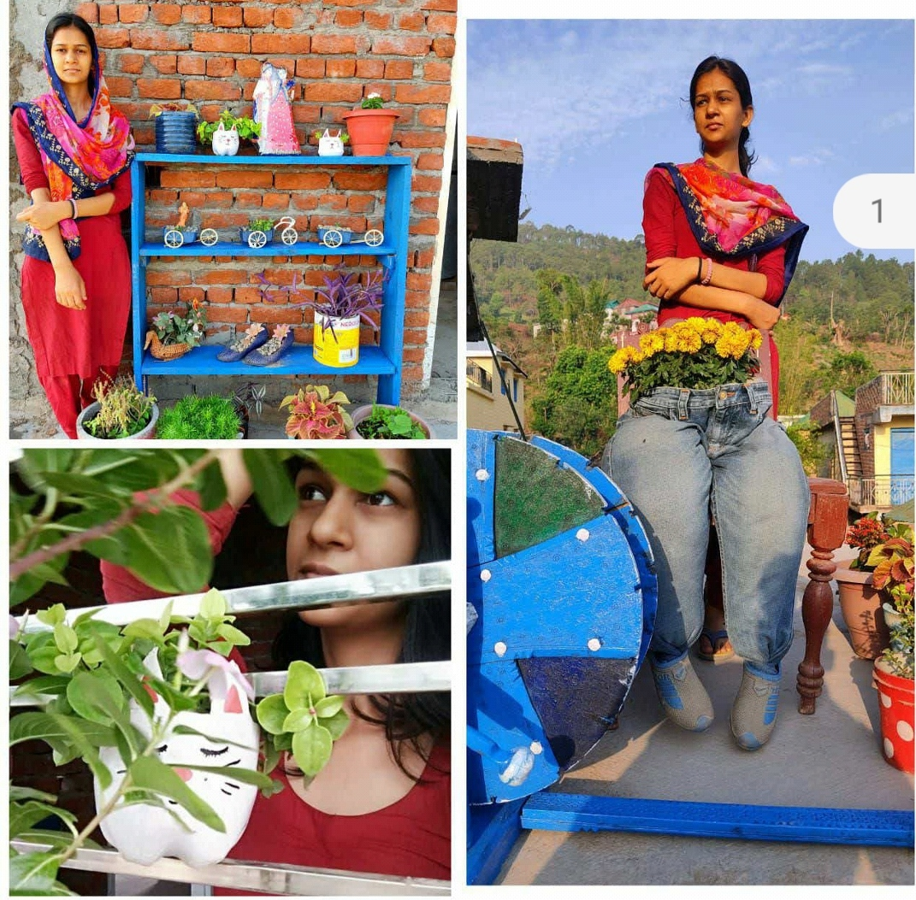
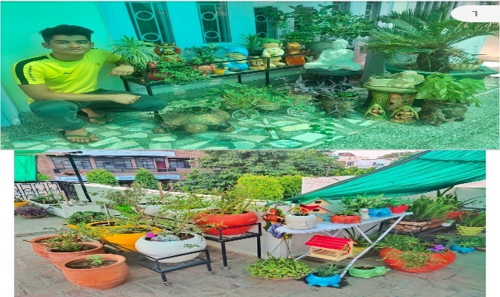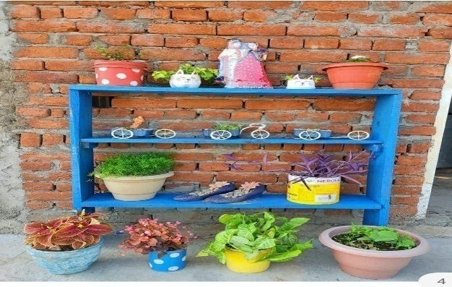

DRIVE TO HELP DISABLE PEOPLE IN RAMDARBAR BY NSS VOLUNTEERS, 28TH JULY-15TH JULY, 2021
Disabled people are people who have mental or physical limitation so they depend on someone to support them in doing their daily life needs and jobs. Although disabled people are a minority and they are normally ignored, they are still a part of the society. The statistics show that the proportion of disabled people in the world rose from 10 percent in the seventies of the last century to 15 percent so far. The number of handicapped exceeds a billion people all over the world, occupied about 15 percent of the world's population, as a result of an aging population and the increase in chronic conditions such as diabetes, heart disease, blood and psychological diseases that are related with disabilities and impairments. . To give contribution in the society, 20 volunteers were gone to Ramdarbar to help physically disabled people in dispensaries and other help center.

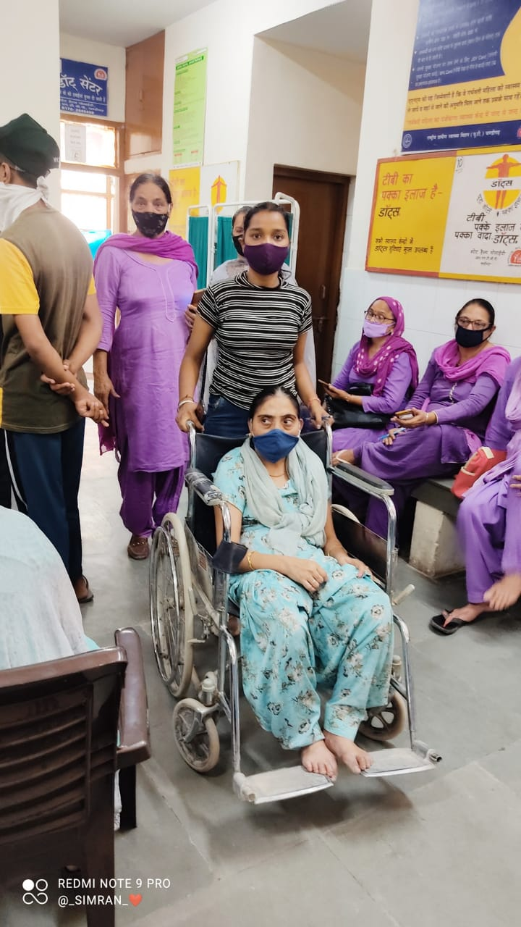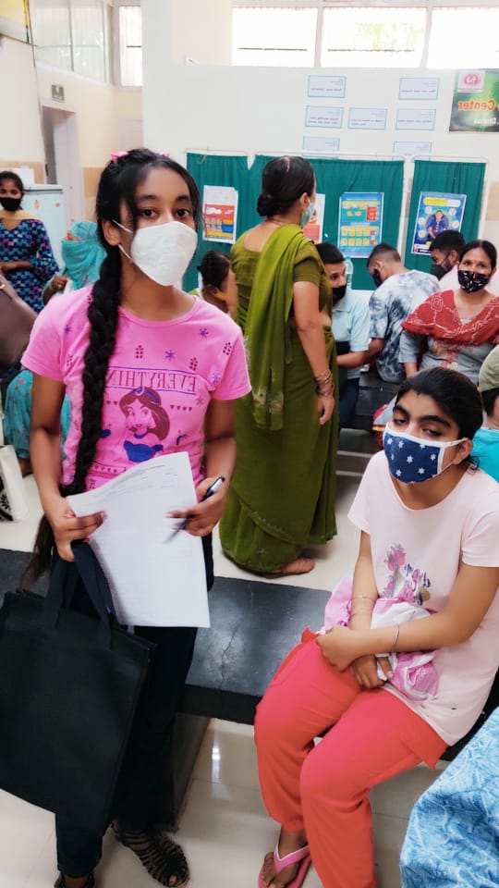

INDEPENDENCE DAY CELEBRATION, 15thAUGUST 2021
The Independence Day is celebrated on August 15 every year to commemorate India’s freedom from the British rule in 1947. After independence, India became the world's largest democracy after the UK Parliament passed the Indian Independence Act, 1947, transferring legislative sovereignty to the Indian Constituent Assembly. The Independence Day also marks the anniversary of undivided India’s partition into India and Pakistan.
On the eve of India’s independence, Jawaharlal Nehru, the then Prime minister, had said in his ‘Tryst with destiny’ speech: "At the stroke of the midnight hour, when the world sleeps, India will awake to life and freedom."
To celebrate the glory of 75th Independence Day NSS wing of Post Graduate Govt. college for Girls Sector 42, Chandigarh hosted flag raising ceremony and various other performances.
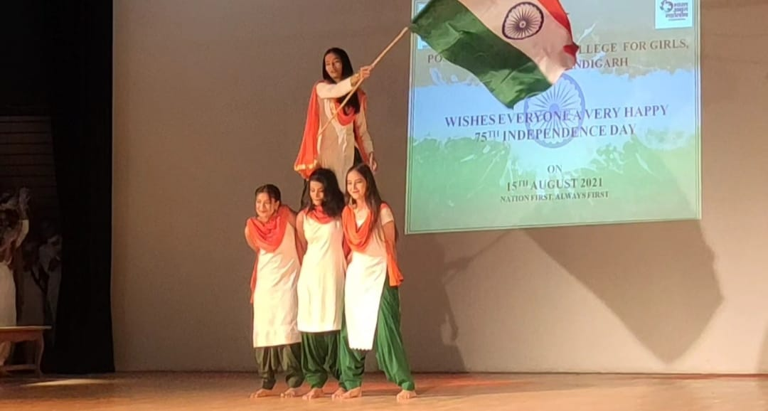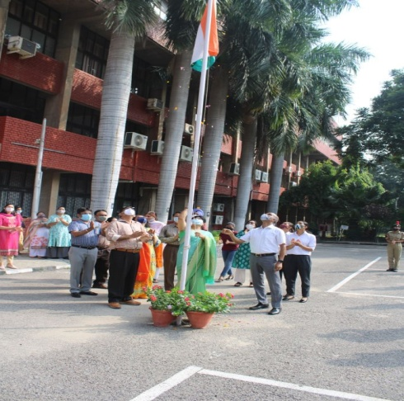
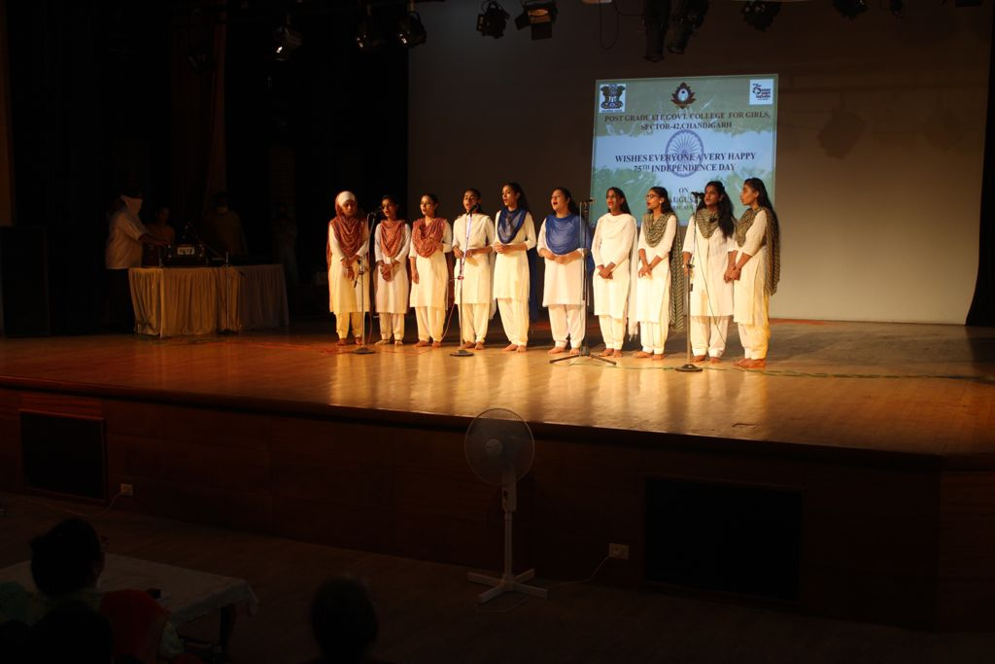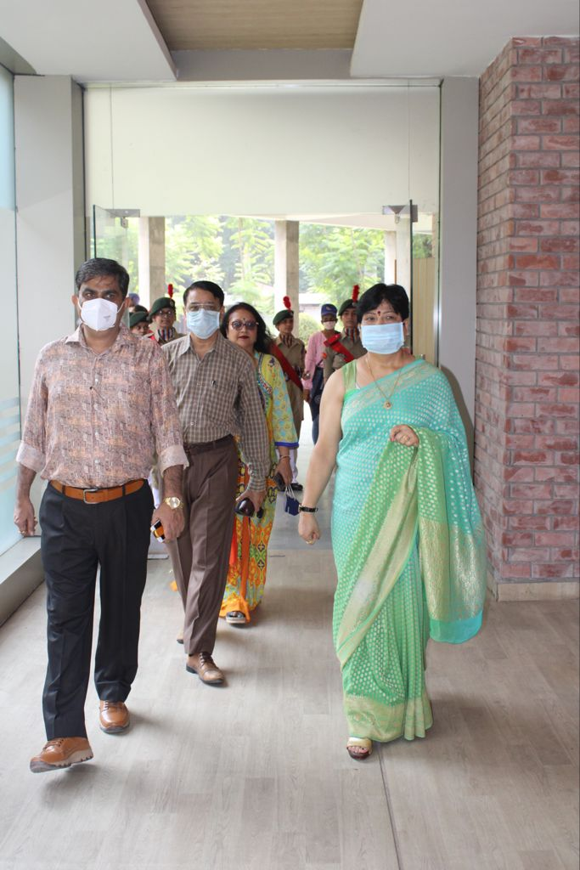

NATIONAL NUTRITION WEEK , (Poshan Abhyan)
7th September 2021
National PoshanWeek (1-7) has been celebrated by maintaining / Nurturing kitchen garden, herbal garden and fruit garden in college campus by Department of Environment Studies in collaboration with NSS unit of Post Graduate Govt. College for Girls Sector-42, Chandigarh under ‘PoshanAbhyan’.
Dr. Devinder Kaur and Dr. Manvi Malwal from the department of Botany visited the nutrition gardens with their students and NSS Volunteers and enlightened them with their Talk on "Importance of Self Grown Organic Food’. They motivated the students for taking small steps like growing and consuming organically grown fresh fruits and vegetables for healthier life. Mrs. Sunita Kumari and Dr. Ranjana Sharma from Department of Environment studies emphasized on taking herbs as health supplements to boost their immunity.
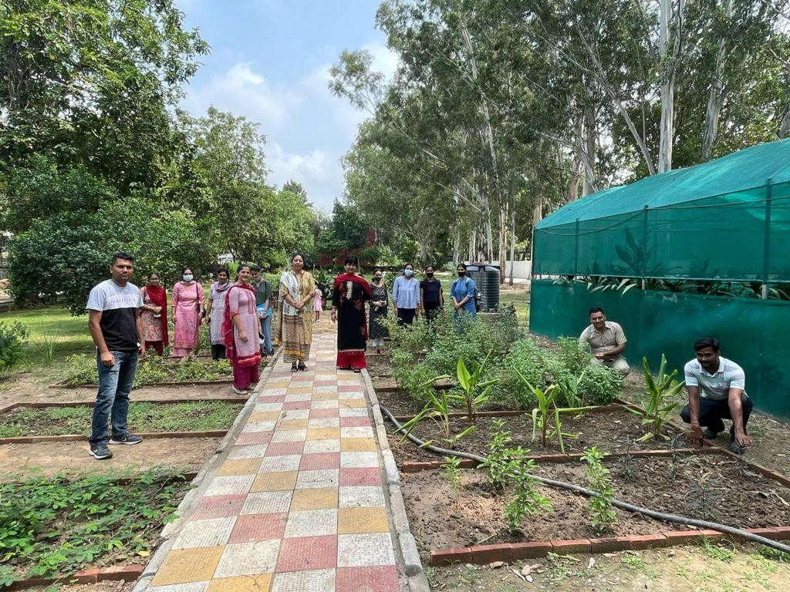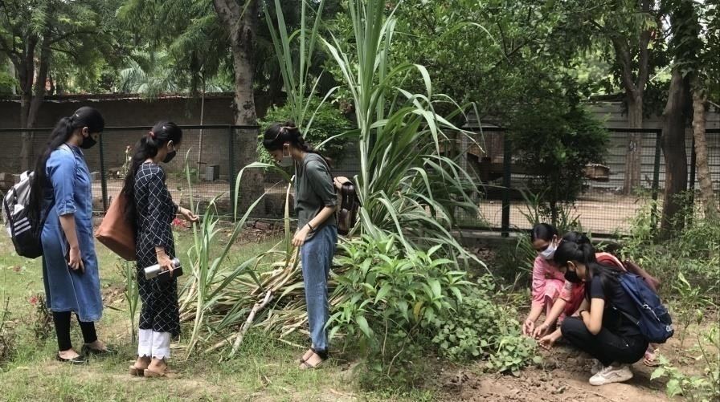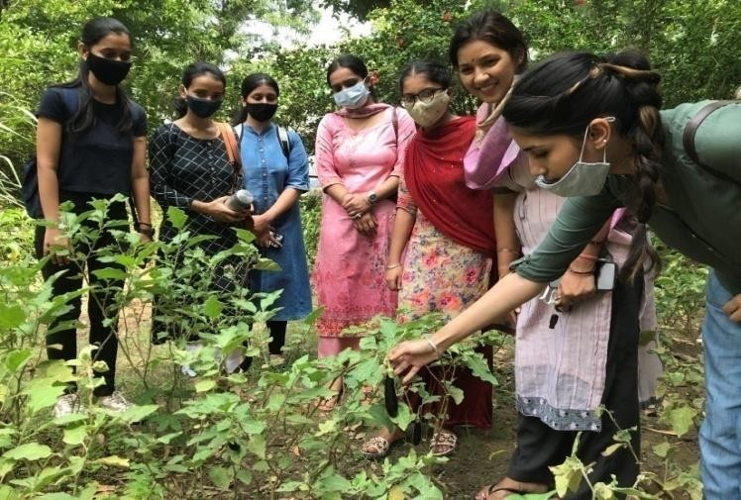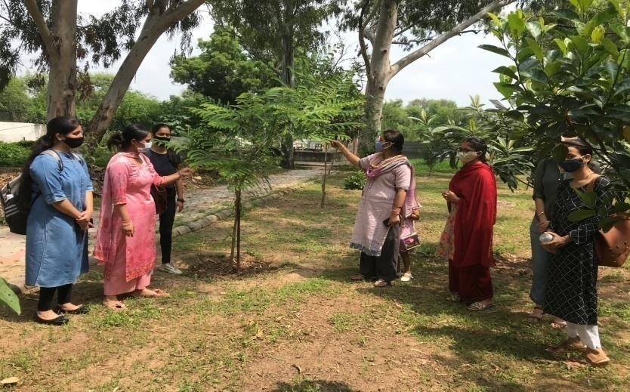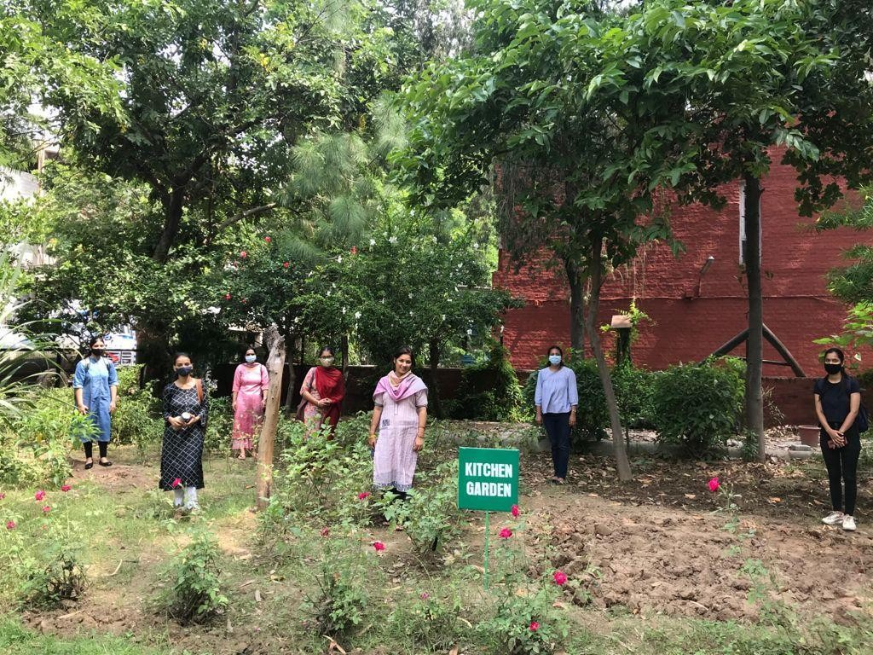Worthy Madam Principal Prof. Nisha Aggarwal supervised all the sites and also joined the venue to motivate the students, Staff members and gardeners on this occasion with her message that ‘We don’t have to eat less, we just have to eat right’ should be the mantra for the young girl students .

NATIONAL WEBINAR (15th September 2021)

The NSS wing and Department of Home Science, Post Graduate Government College for Girls, Sector 42, Chandigarh in collaboration with the Indian Dietetic Association, Chandigarh Chapter organized a National Webinar on- Healthy Walk Through Adoloscence, to celebrate National Nutrition Month, September 2021, a Jan Andolan towards Suposhit Bharat. The Principal, Prof. Dr. Nisha Aggarwal welcomed the speaker and participants. Dr. Manpreet Kaur, Head, Department of Home Science gave an overview of Poshan Maah for well being. Speaker Dr. Harjot Kaur Mann, Assistant Professor, MCM DAV College for Women, Chandigarh delivered and exhaustive and enlightening talk on the importance of healthy and nutritious meals for adolescents, the future of our Country. She gave informative tips on how to make recipes rich in nutrients such as iron, calcium, vitamin A and proteins. She motivated the participants to make nutrition their hobby for a healthy life. The question answer session, followed by the vote of thanks was conducted Mr. Mehar Chand, NSS Incharge. The webinar got an overwhelming response with around 150 participants joining it from all parts of the country.
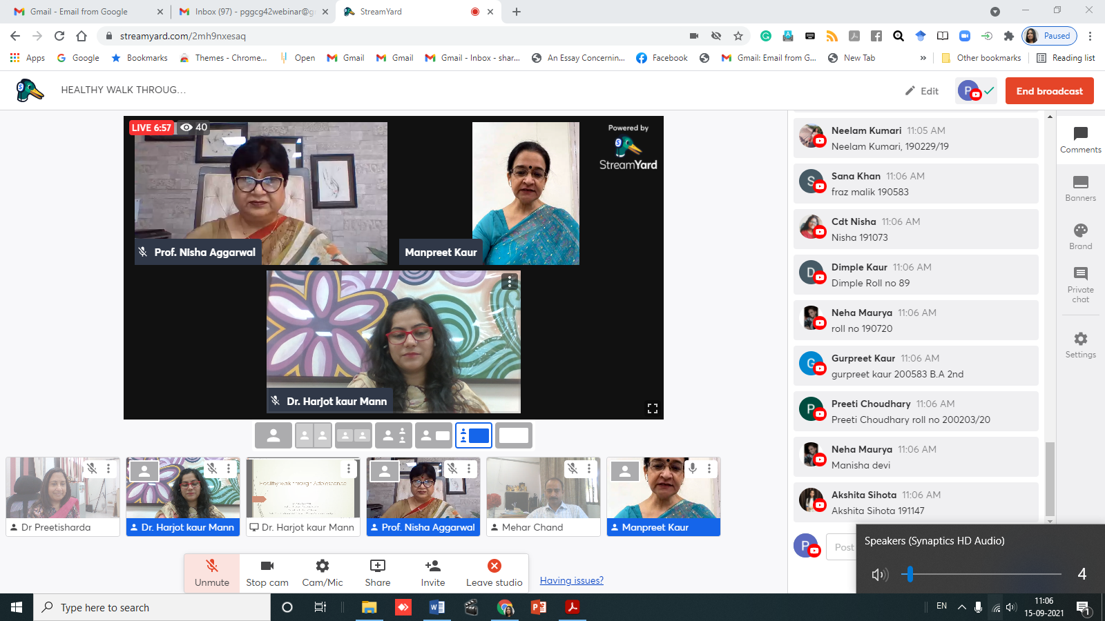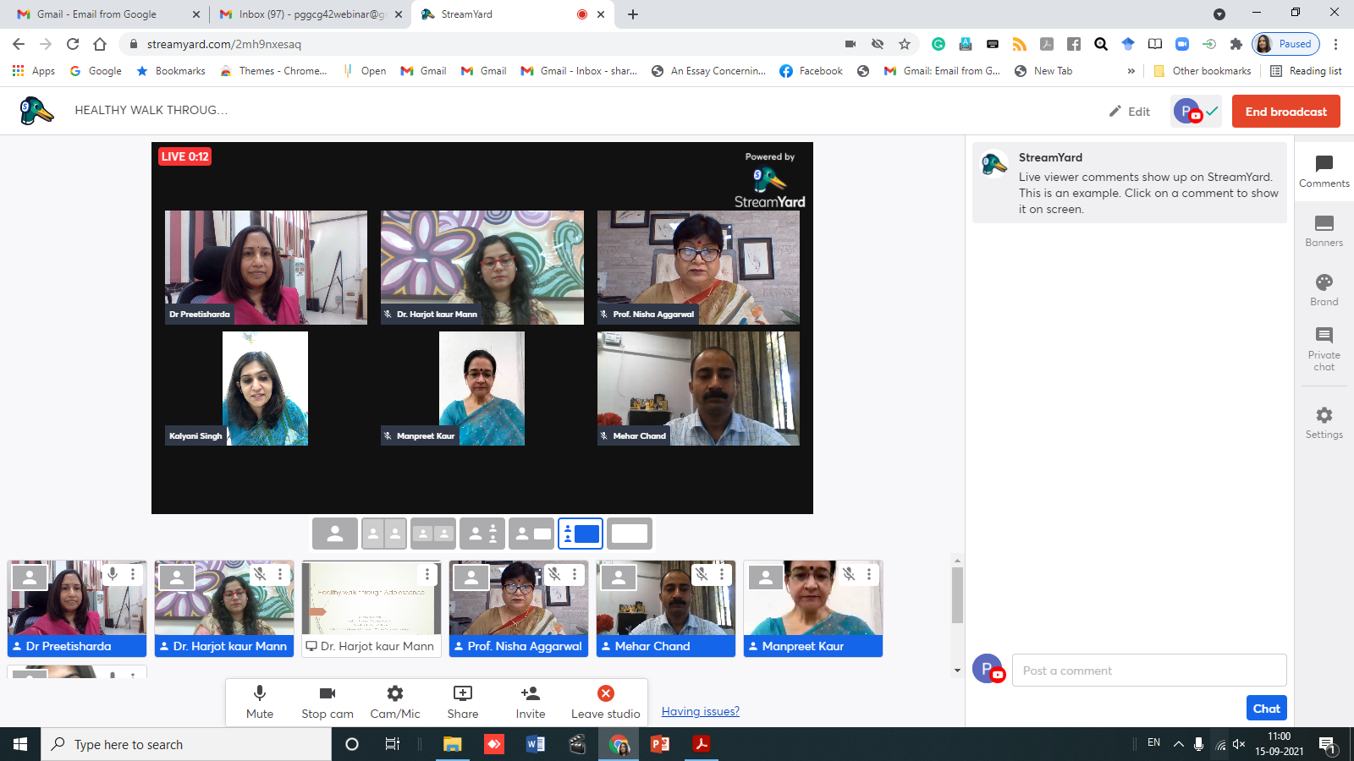
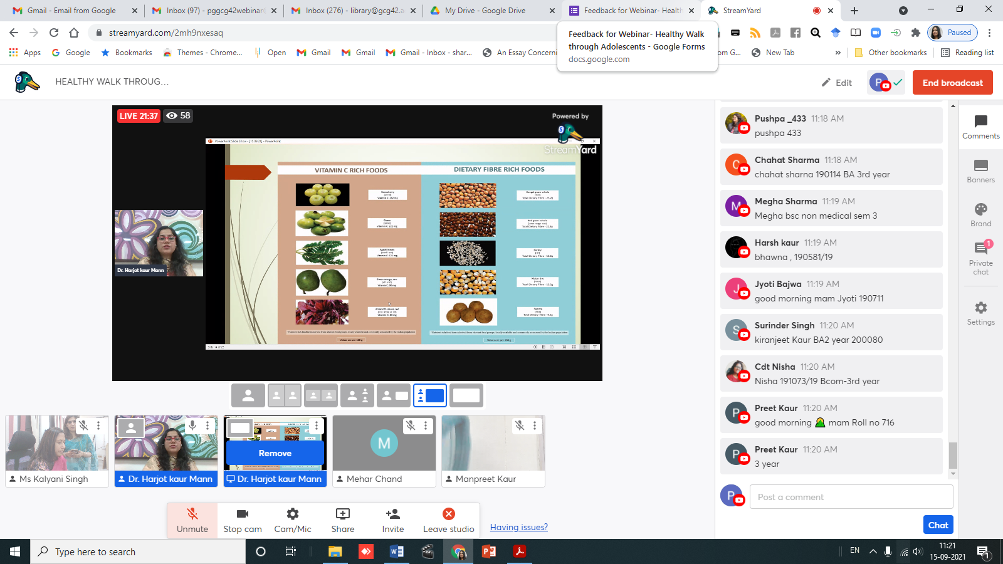

SURVEY TO ASSESS MALNUTRITION AMONG PREGNANT WOMEN AND CHILDREN (16th September 2021)

The NSS wing of Post Graduate Government College for Girls, Sector 42, Chandigarh conducted a survey in the adopted village Kajhedi to assess malnutrition among pregnant women and children. Programme Officers Mr. Mehar Chand, Dr. Ranjna Sharma and Dr. Gagandeep Gyani and NSS Volunteers visited the village and Anganwadi Centers to identify pregnant women and children below 5 years who were malnourished. It was seen that due to lack of awareness and resources these people were not able to fulfill their dietary allowances. The NSS wing educated the women how to make their meal nutritious and maintain hygiene and sanitation. They were told to incorporate fruits and vegetables along with cereal pulse combination in their daily diet. Pregnant women who were malnutritioned were also identified so that college can help them in keeping theirselves healthy during further course of their pregnancy and afterwards. It has been decided that the NSS wing along with Department of Home Science and Anganwadi workers of Kajhedi under the able guidance of Principal, Prof. Dr. Nisha Aggarwal will conduct an awareness programme in college and distribute energy and protein rich foods and fruits to them. 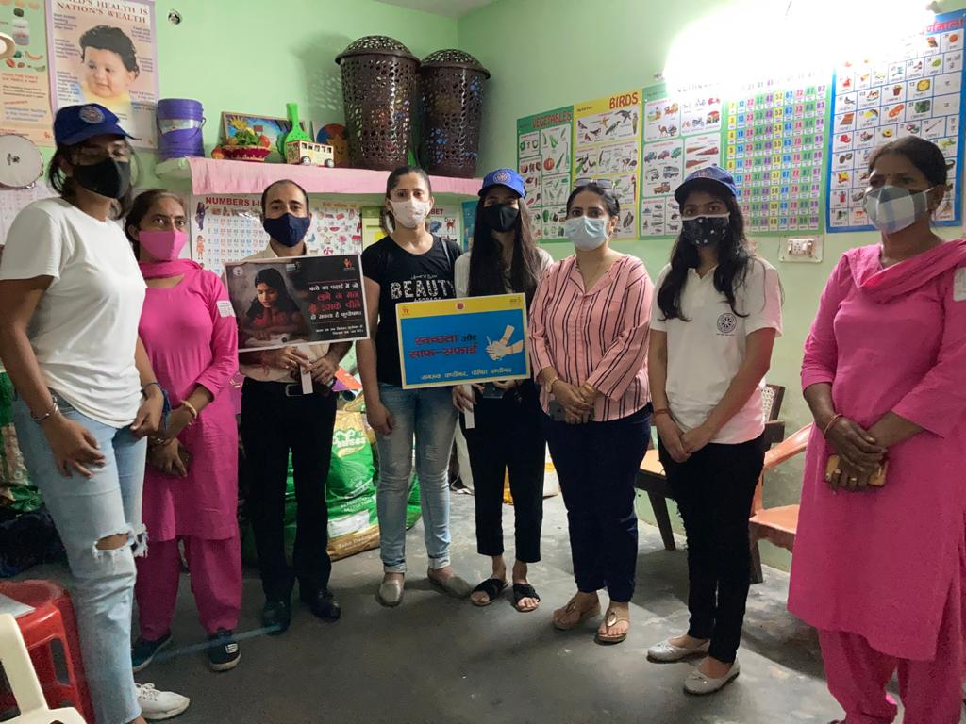 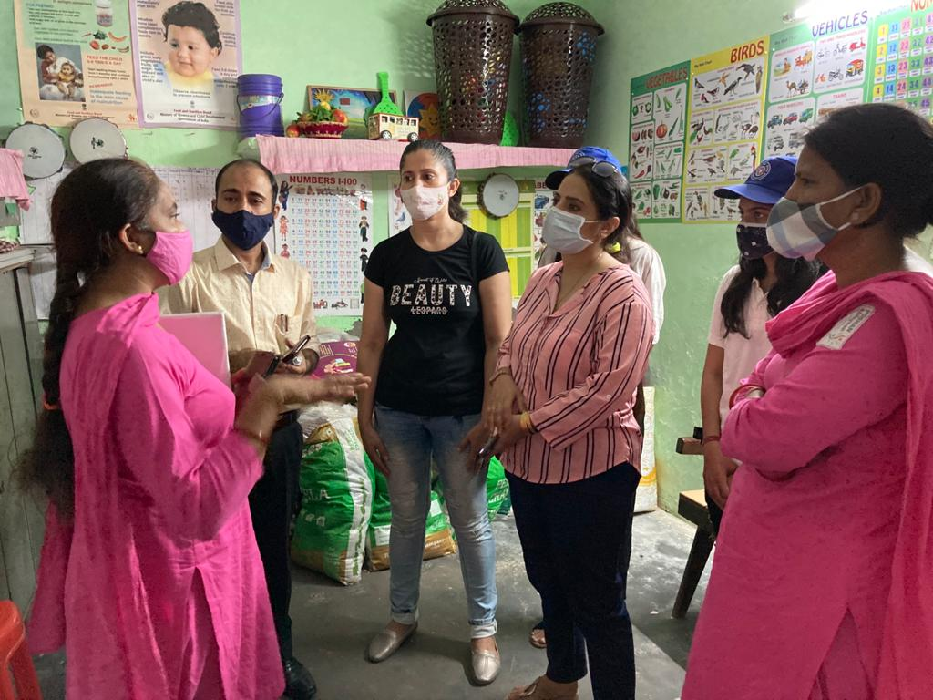
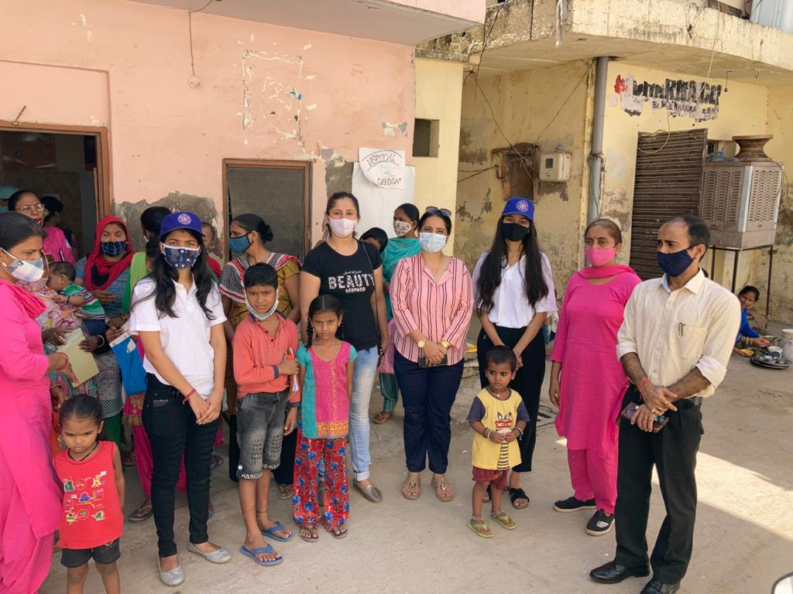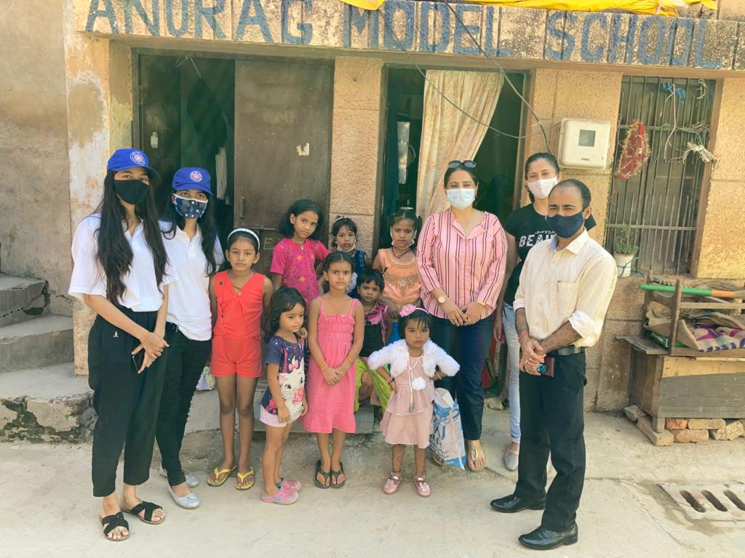
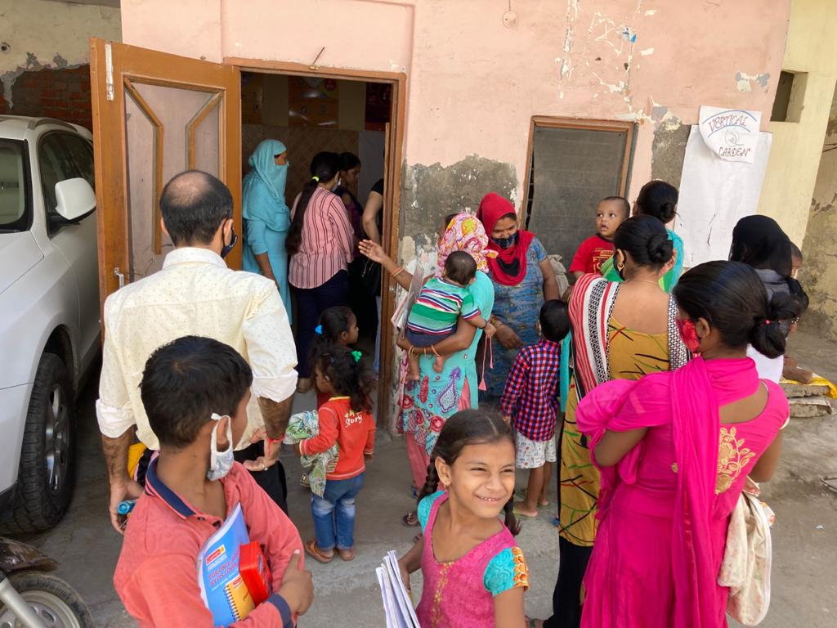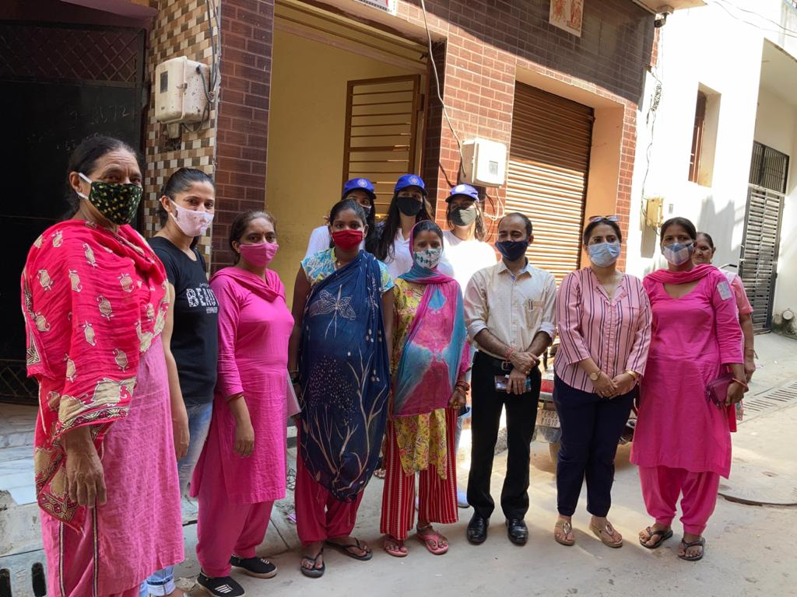
NSS DAY CELEBRATION (24th September 2021)
Keeping up with the motto of “Not me but you” NSS Wing of Post Graduate Govt. College for Girls Sector -42, Chandigarh celebrated NSS Day 24th September, 2021 by organizing offline Cookery Competition function on the theme “Healthy Recipes for Adolscencet” in collaboration with Department of Home Science. NSS Volunteers participated wholeheartedly and showcased their innovative talent of cooking different nutrition recipes such as three millet cake, Ghewar, Coconut Date Ladoos, Sohan Halwa, Nutrious rolls, etc. Principal of college Prof. Nisha Aggarwal congratulated the organizers and the volunteers for their entries and told them to not let their talent go waste. Mr. Mehar Chand NSS In charge and Programme officers appreciated the efforts of the volunteers and encouraged them and keep their gusto alive
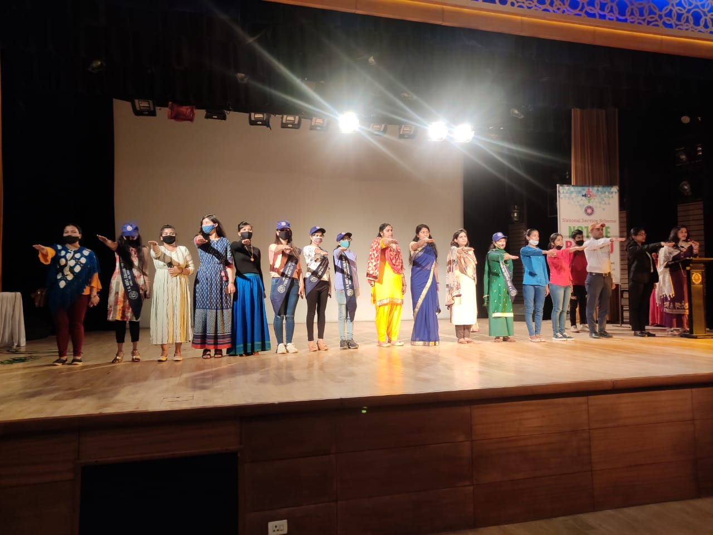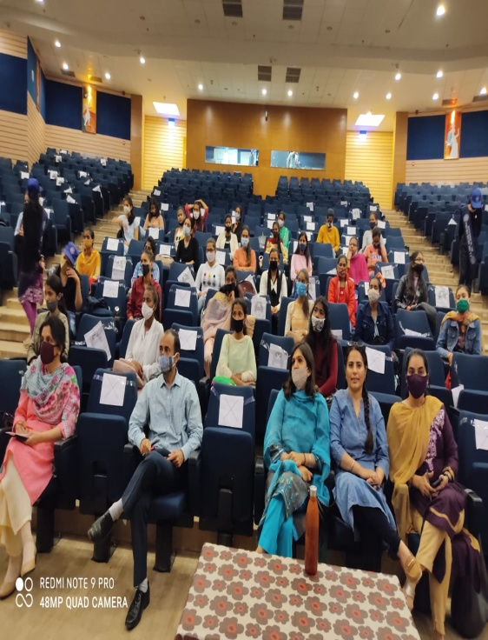
PULSE POLIO CAMPAIGN (26th-27Th SEPTEMBER 2021)
The Pulse Polio Immunization (PPI) aims at covering every individual in the country. It aspires to reach even children in remote communities through an improved social mobilisation plan. Not a single child should miss the immunization and leaving no chance of polio occurrence. To fulfill the aim NSS wing of our college sent 80 volunteers to different areas and dispensaries for Conducting pulse polio Drive.
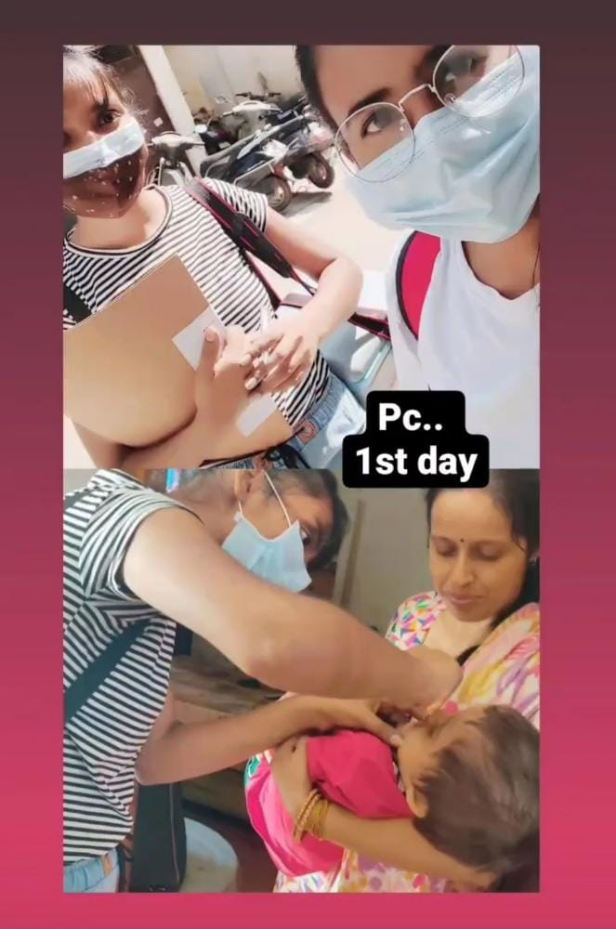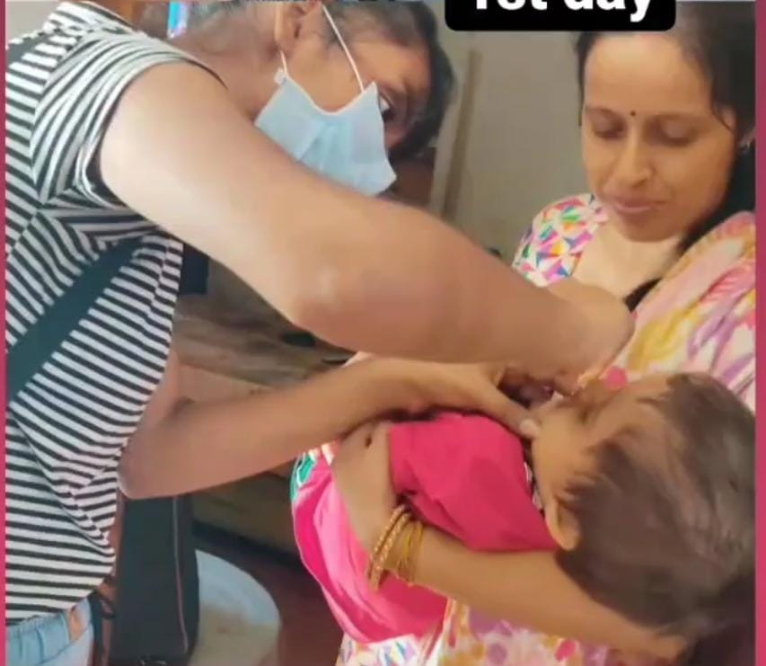
"CELEBRATION OF POSHAN MAAH" (28th September, 2021)
Under the able guidance of our worthy Principal Prof. Nisha Aggarwal NSS wing of the college in collaboration with Anganwadi workers/ Social workers organised program in College adopted Village Kajheri, Chandigarh on 28th September, 2021. In this Program a special Lecture wass delivered by Dr. Harpreet Kaur to the audiance specially malnutrion children and pregnant ladies of the village. Beside this, free nutritious pinnis, soaps and sanitary napkins had been distributed among the malnutrition adolescents and needy people of the village.

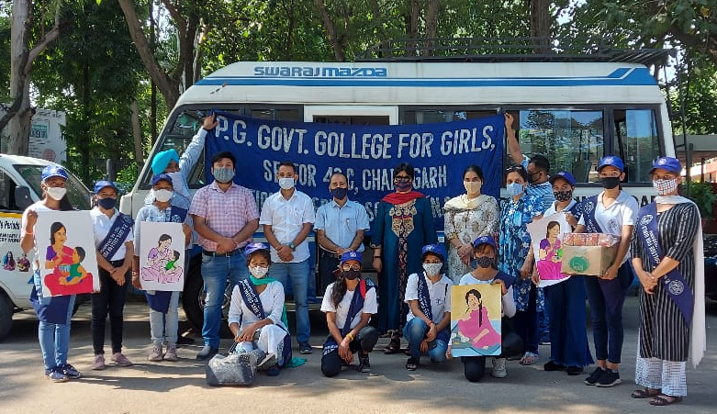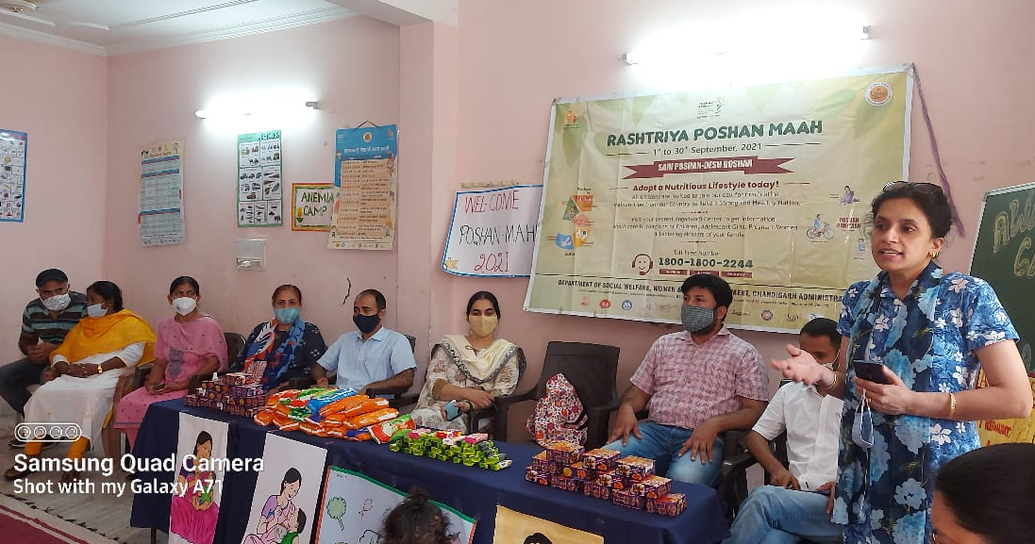
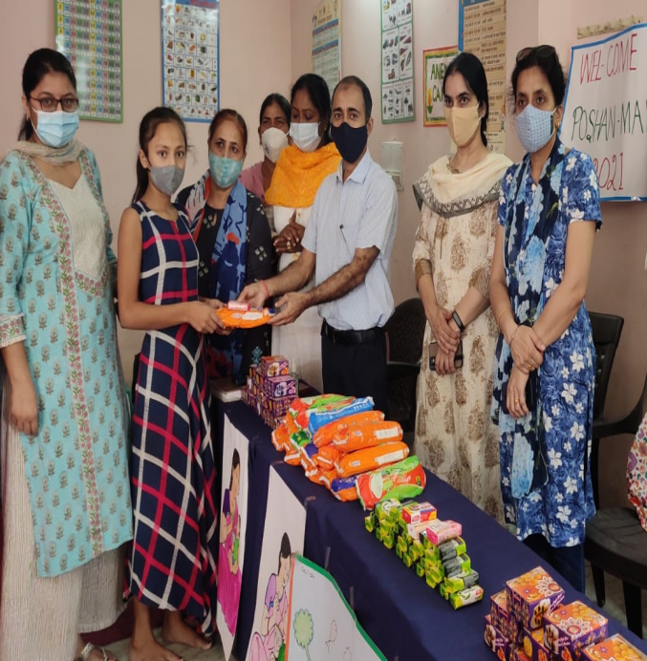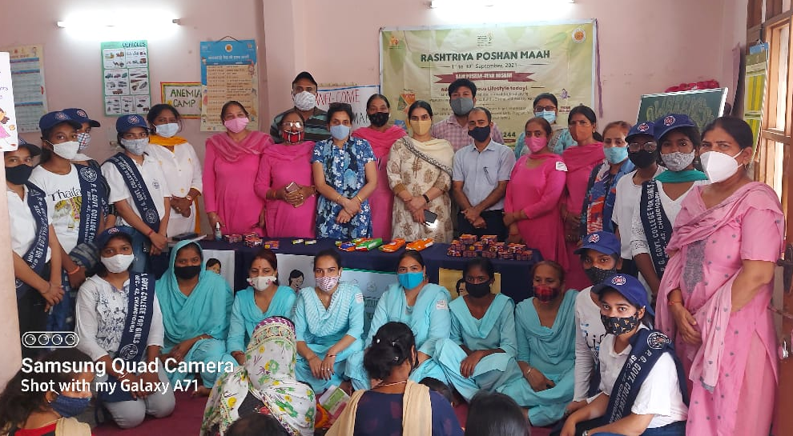
BOOKS DONATION DRIVE FOR NEEDY PEOPLE (20TH -30TH SEPTEMBER 2021)
Books are referred to as a man’s best friend. They are very beneficial for mankind and have helped it evolve. There is a powerhouse of information and knowledge. Books offer us so many things without asking for anything in return. Books leave a deep impact on us and are responsible for uplifting our mood. To distribute knowledge among needy people A Memorandum has been signed by The Principal of our College with Open Eye Foundation in which Teaching and Non Teaching Staff will Donate Books to needy people.
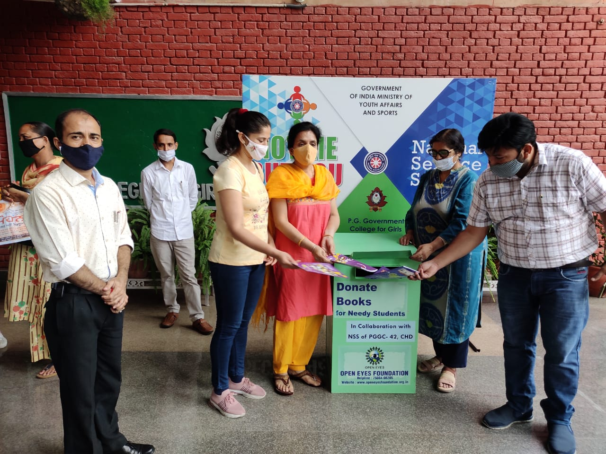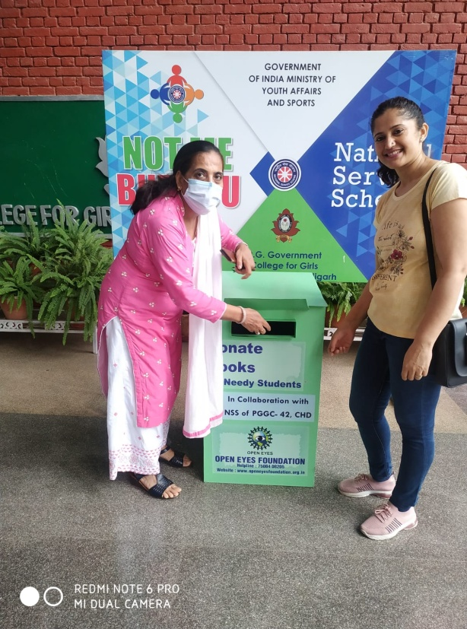

CLEANLINESS DRIVE ON OCCASION OF GANDHI JYANTI
(2ND OCTOBER 2021)
Every year on October 2, a national holiday is observed to honour his contributions to the nation. On June 15, 2007, the United Nations General Assembly declared October 2 as International Day of Nonviolence in his honour. The day honours the “universal significance of the concept of nonviolence” with the goal to “secure a culture of peace, tolerance, understanding, and nonviolence.” On The Occasion of Gandhi Jyanti, Cleanliness drive was organized by NSS Wing of our College. NSS Volunteers Clean College Campus and a team of 100 volunteers were sent to rock garden for cleaning the garden and statue.
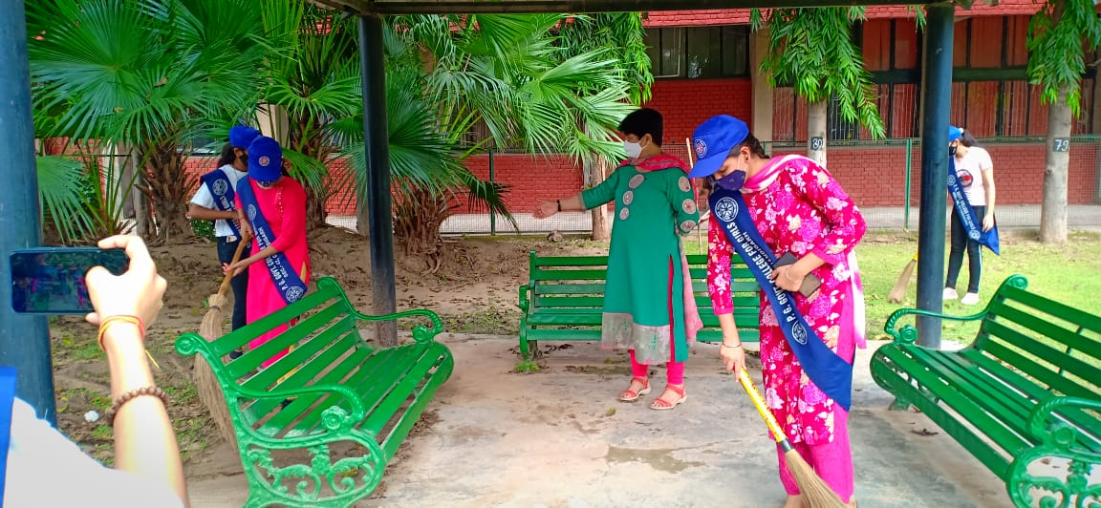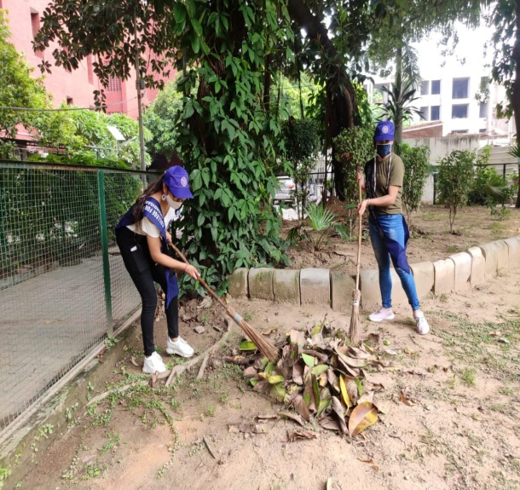
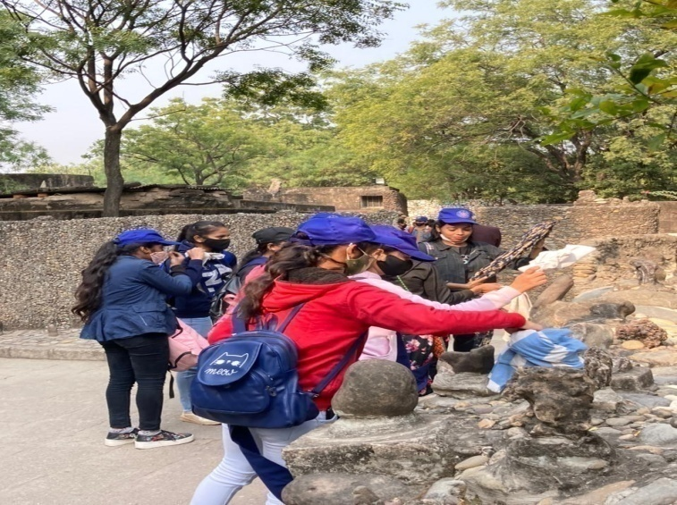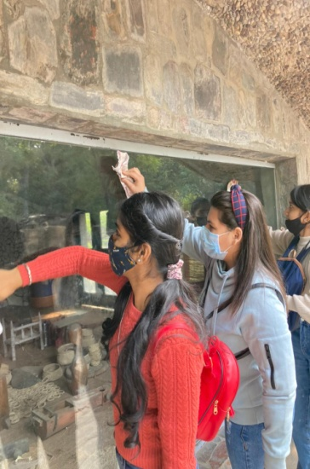

VIGILANCE AWARENESS WEEK 2021 (October 26th to November 1st 2021)
The NSS wing of Post Graduate Government College for Girls, Sector 42 Chandigarh celebrated vigilance awareness week 2020 from October 26th to November 1st, 2021, with the theme “Independent India @ 75 : Self Reliance with Integrity.” The college thrives to prevent corruption and fight against it by cultivating high moral values in students and raising public awareness regarding the existence, causes and gravity of and the threat posed by corruption.
The Vigilance awareness week celebrations were initiated with pledge taking ceremony by Principal Prof.(Dr.) Nisha Aggarwal with teaching & non-teaching staff in college, keeping in mind all the safety guidelines for covid-19. As many as 600 NSS volunteers took pledge at college premises while maintaining proper social distancing. The aim of the Pledge was to be vigilant and commit to highest standards of honesty and integrity’s at all times and support the fight against corruption.
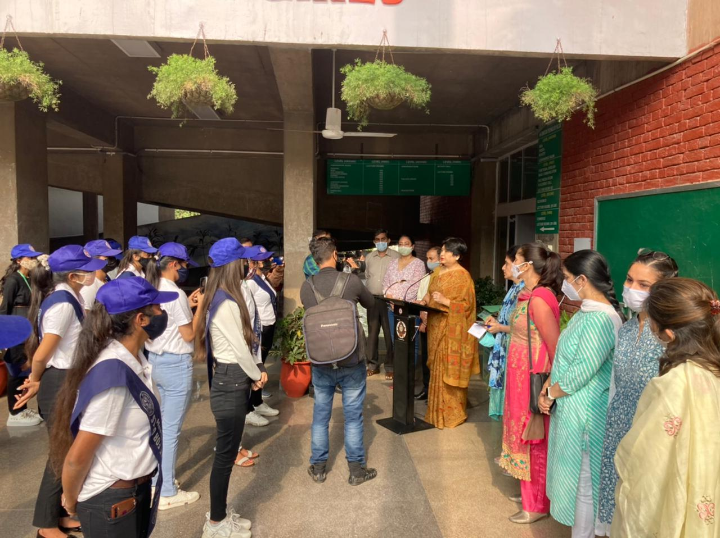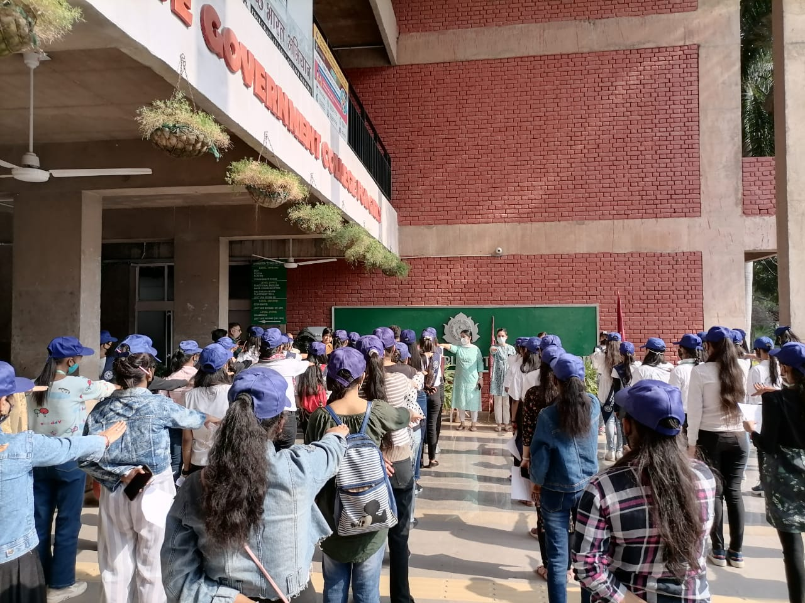
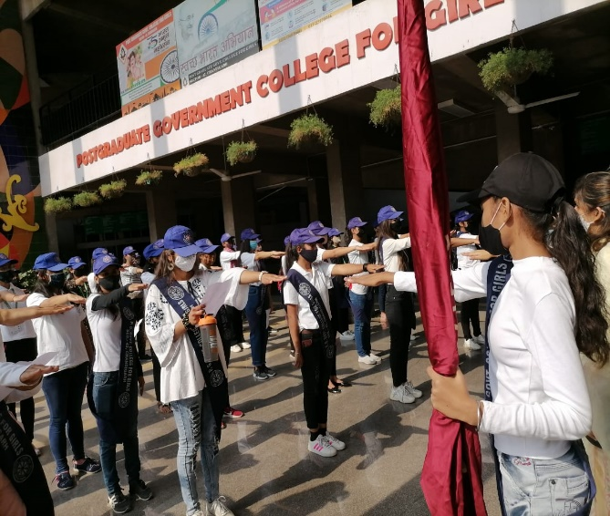

POEM RECITATION activity was also organized by the NSS wing where the students recited poems on Anti-corruption and Patriotism. They exchanged views about the current situation of corruption in Indian and the need for change in scenario.
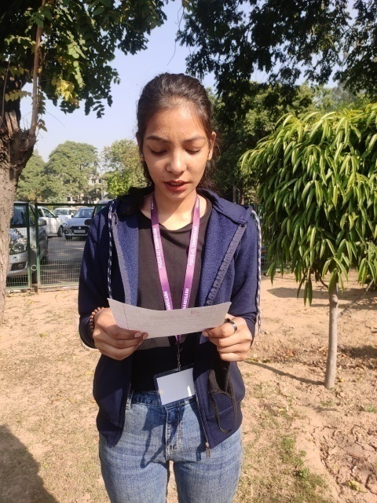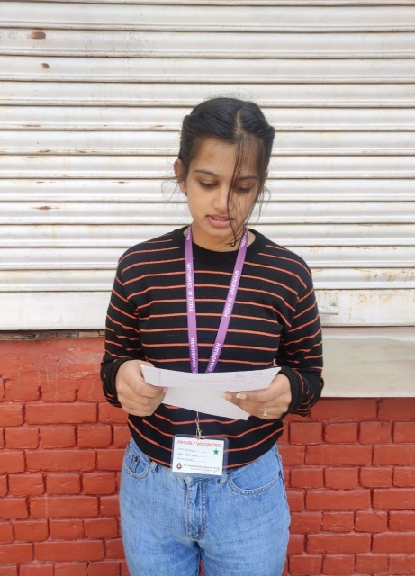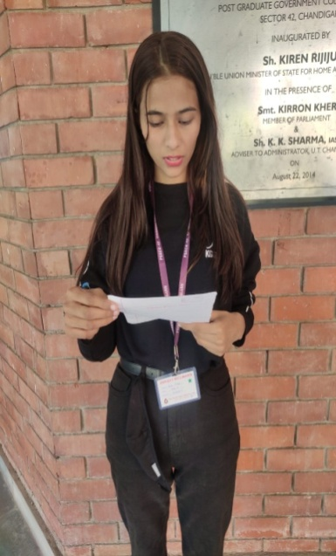
Principal Prof. Nisha Aggarwal appreciated the efforts of NSS team of the college and motivated students to take part in such activities in future too and she also advised students to implement the learnings from such activities in their life.NSS Incharge, Mr. Mehar Chand coordinated the overall celebrations of Vigilance Week and encouraged everyone to be vigilant always against any kind of corruption and to join hands to make India free from corruption

POSTER MAKING COMPETITION was organized by the Department of Fine Arts on 29th October 2021. About 21 college students from different streams participated in it through online mode. NSS Programme Officers Dr. Harpreet Kaur and Dr. Sangam supervised and judged the competition. The final results of the competition as given by judges are as follows:
PRIZE | NAME | ROLL NO. | CLASS
FIRST | Bhumika | 200061 | BA II
SECOND | Aanchal | 200012 | BA II
THIRD | Priyanka Goyal | 190294 | BA III

A RALLY of the NSS volunteers along with The Environment Society was conducted. Madam Principal flagged off the rally and talked to the students about to be vigilant always against any kind of corruption.
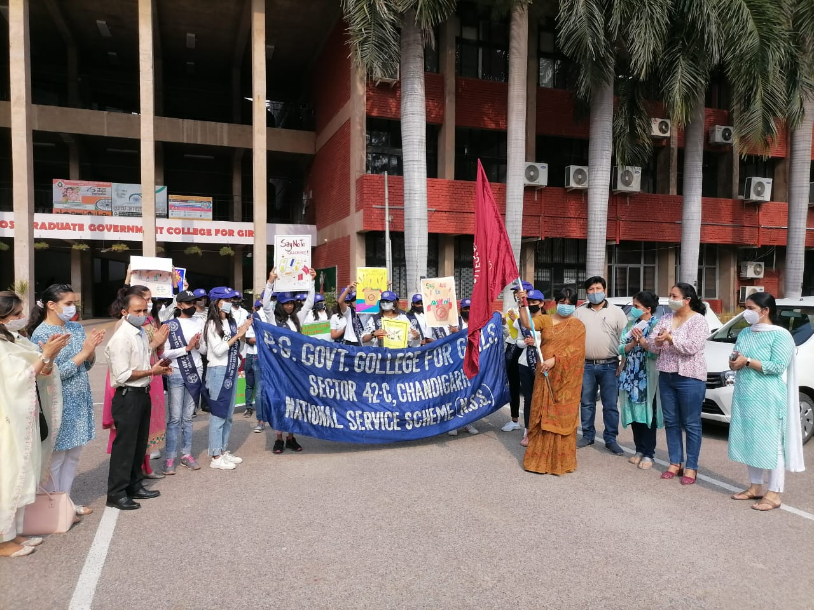
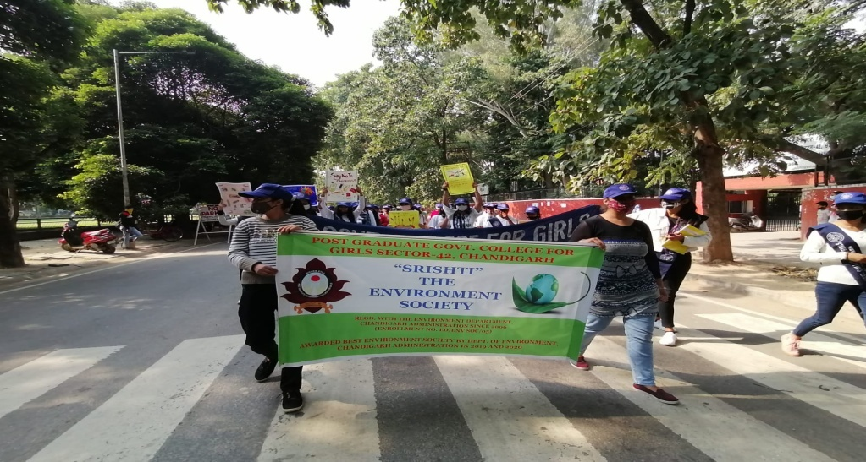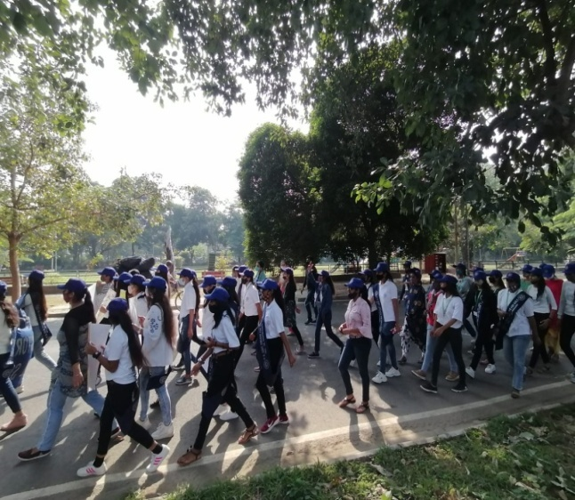

RASHTRIYA EKTA DIVAS (1st NOV 2021)
To commemorate Rastriya Ekta Diwas, hon’able education minister shri Dharmendra Pradhan has launched language learning initiatives .800 volunteers attended live webcast from their respective places.
COMMUNAL HARMONY DAY (19th - 25th NOVEMBER 2021)
Communal Harmony Week or Quami Ekta Week is to be observed in India beginning from 19th Nov-25th Nov 2021. The Home Ministry contended that various seminars and meetings should be held during the week to strengthen the bond of the nation. On this occasion all the Teaching and non- Teaching Staff took a Pledge to live together without any discrimination on the basis of caste, creed, religion and sex. Flag & stickers were also distributed among volunteers.
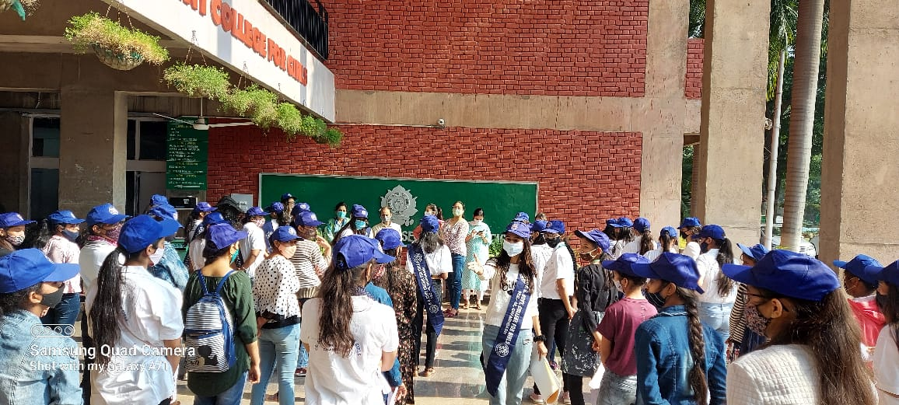
Anti Cracker Campaign (1-3 November, 202)
Action taken report of activities organized by PG. Govt. College for Girls, Sec-42, to celebrate green and eco-friendly Diwali. Following activities were organized on the above mentioned subject:
- NSS unit and Srishti the Environment Society of the College organized Anti-Cracker campaign to spread the word regarding "Green Diwali Swatch Diwali". Poster making, slogan writing, poem recitation competitions were conducted on 1st and 2nd November, 2021 in lieu of keeping the mother Earth green and pollution free. College NSS volunteers and members of Environment Society “Srishthi” participated in these competition with full enthusiasm.
- On2nd November 2021, Principal, Prof. Nisha Aggarwal addressed the students and faculty members in the morning assembly highlighting the ill-effects of ‘Cracker and other Pollution devices’ on the theme of “Green Diwali-Swachh Diwali”. She also motivated students and faculty members to plant trees and even gift green plants to your friends, relatives and neighbours on this Diwali.
- Madam Principal with all the faculty members and Students took the pledge of keeping Diwali cracker free, lighting earthen lamps and planting more trees.
- The pledge was followed by Anti-cracker rally in college and Sector 42 residential area with echoing and displaying slogans of 'Green Diwali, Safe Diwali' and 'Say No to Crackers' by about 100 college students.
- Recycled eathern diyas were exhibited and distributed among the class IV employees in collaboration with NGO Swarmani on Pre Diwali eve ie; 3rd November 2021.
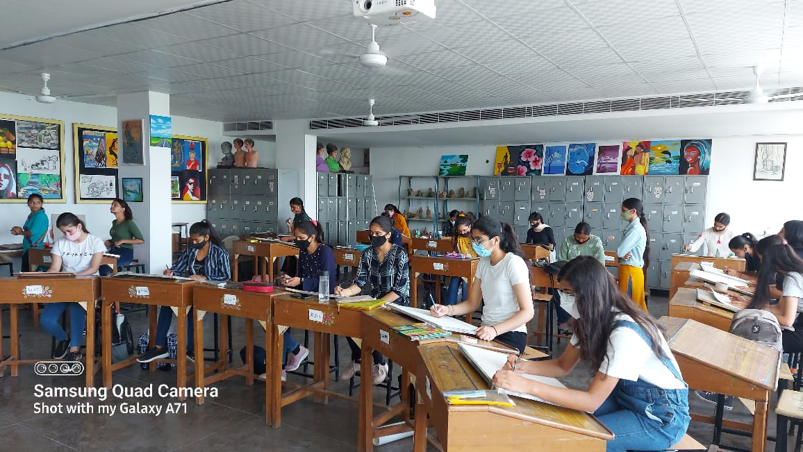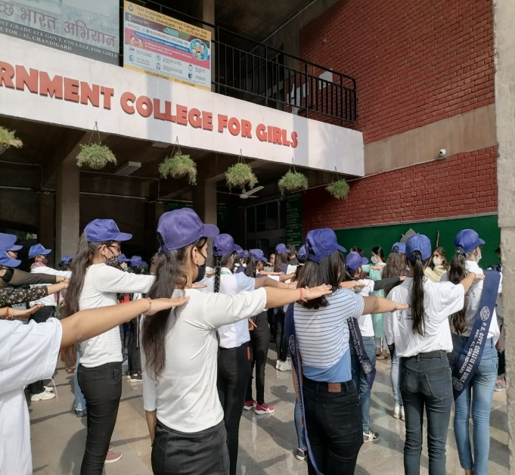
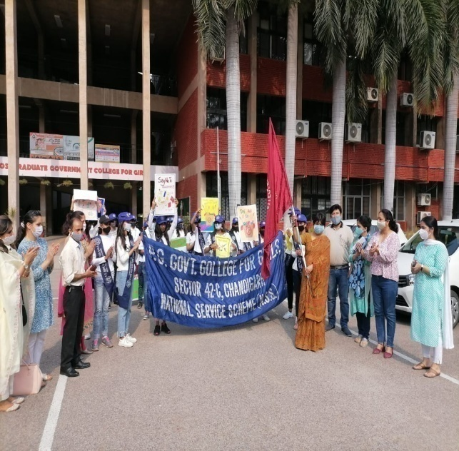
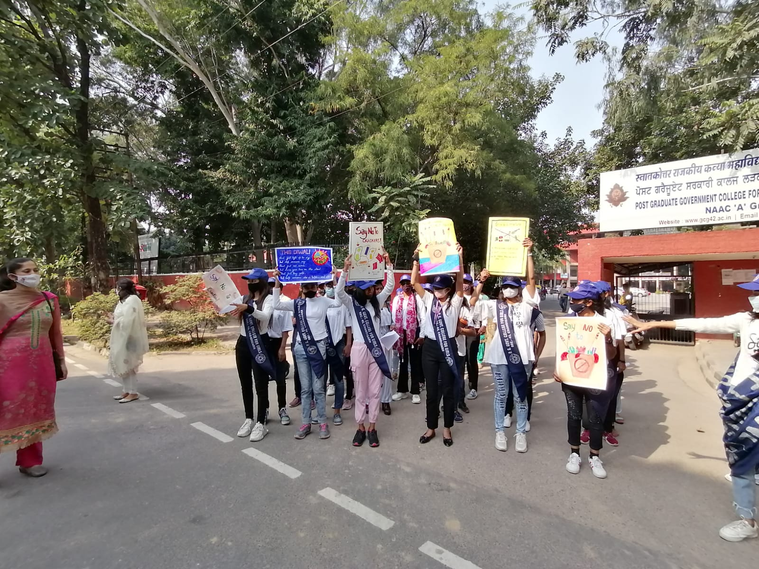
CONSTITUTION DAY (26TH NOVEMBER 2021)
To celebrate the Constitutional Day pledge administering programme, about the Preamble of the Constitution of India in the college Auditorium at 11 am was organized. All the faculty members, students and non teaching staff read the preambles after College Dean Mr. Suresh Kumar. The entire college whole heartedly took the pledge to abide by the rules and regulations mentioned in our constitution.
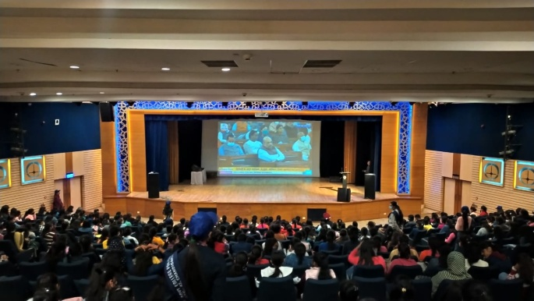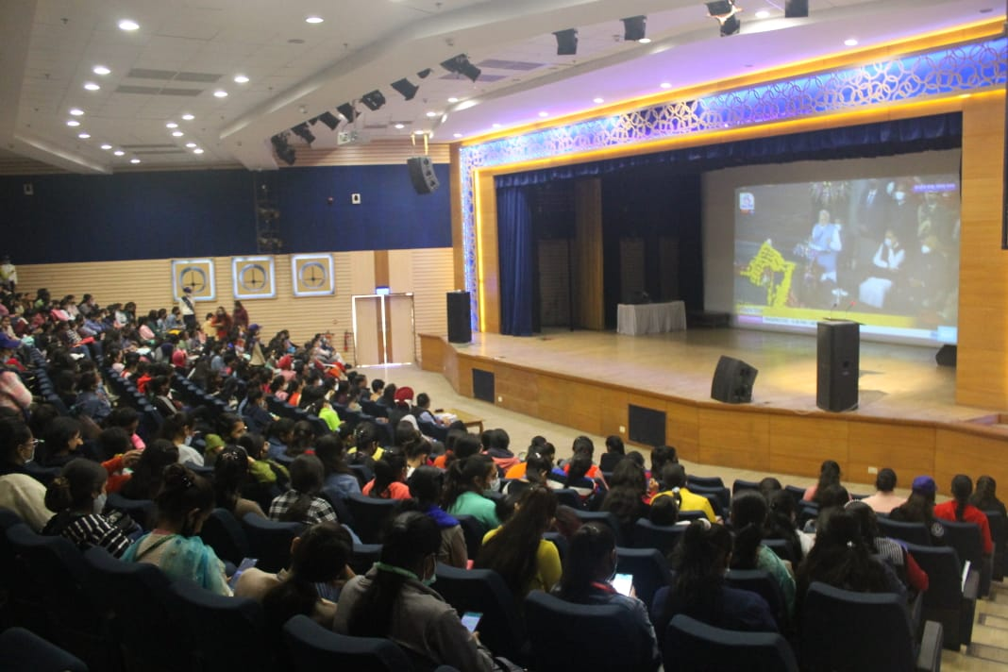
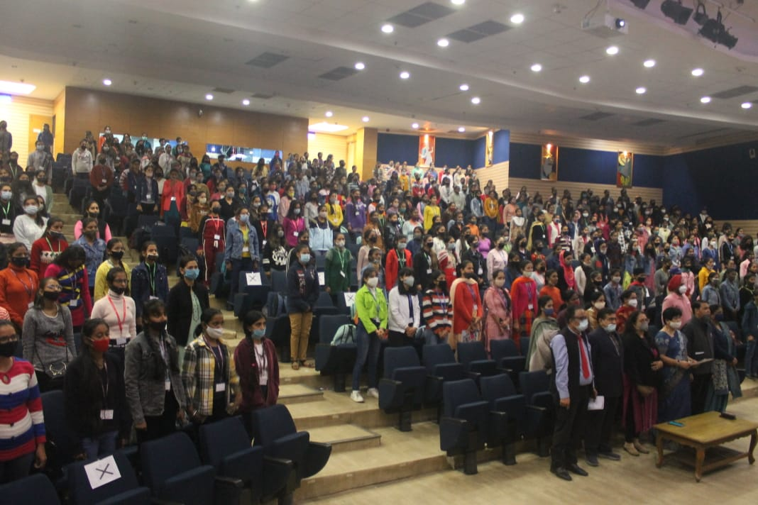

NSS SEVEN DAY SPECIAL CAMP
(4TH DECEMBER-10TH DECEMBER, 2021)
The National Service Scheme is an Indian government sponsored flagship for public service program conducted by Ministry of Youth Affairs and Sports of the Government of India. Popularly known as NSS, the scheme was launched in 1969. Its primary objective is to develop the personality and character of the student youth through community service. “Education through service and service through education” is the main purpose of NSS.
Keeping this in mind, the post graduate government college for girls, sector-42 organizes various activities in the college throughout the year under NSS so as to completely develop the personality of their students. Activities such as rainwater harvesting, book-donation camp, awareness sessions on various topics for students are organized from time to time. Along with this visits to the adopted village of the college named Khajeri. Here also the volunteers participate actively by conducting rallies and nukkad nataks.
Withholding the same spirit of service a special seven-day camp for the NSS volunteers of the college was organized from 4th December, 2021. Due to the COVID-19 protocols only day camp was organized and special care was taken to follow the protocols and incorporate social distancing. Three-time meals including breakfast, lunch and evening tea were also served to the students in the college canteen.
Day 1, 4th December2021, “INAUGURAL FUNCTION”
Filled with gusto the whole NSS team of about 204 volunteers gathered in the college auditorium, SABRAS for the inaugural function of the camp. The function started at 11:30 a.m. in the morning. The Regional Director of NSS Chandigarh, ‘Ministry of sports Affairs and youth, Government of India’, Smt. Harinder Kaur had presided over as the chief guest of the day.
The program began with green welcome of the chief guest, the guest of honor and other dignitaries. This was followed by a welcome speech by the college NSS In-charge Mr. Mehar Chand. Following this NSS song was sung by the gathering. Thereafter, a cultural program was held including Pahari Nati, Haryanvi dance and Punjabi Folk Dance.
After this, the chief guest addressed the gathering and motivated the volunteers to serve the community and develop their skills with the aid of NSS department. She stated that the volunteers must come forward in the tough times of pandemic and serve the society while keeping in mind all the protocols of COVID-19 thus ensuring their own safety. She also encouraged the students to work relentlessly towards the society and aim for the President award at the Annual National Award Ceremony. The students were also made aware about the Mega Camp, NIC and RDC of NSS.
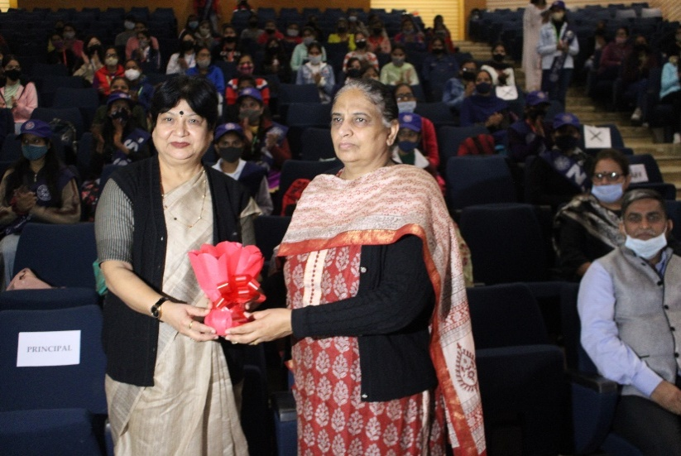
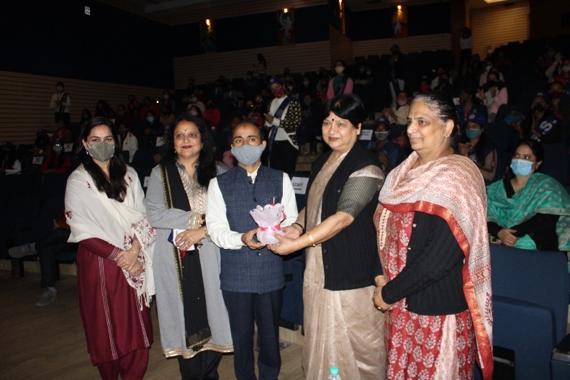
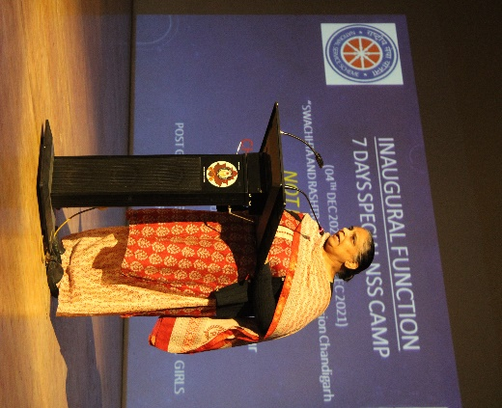

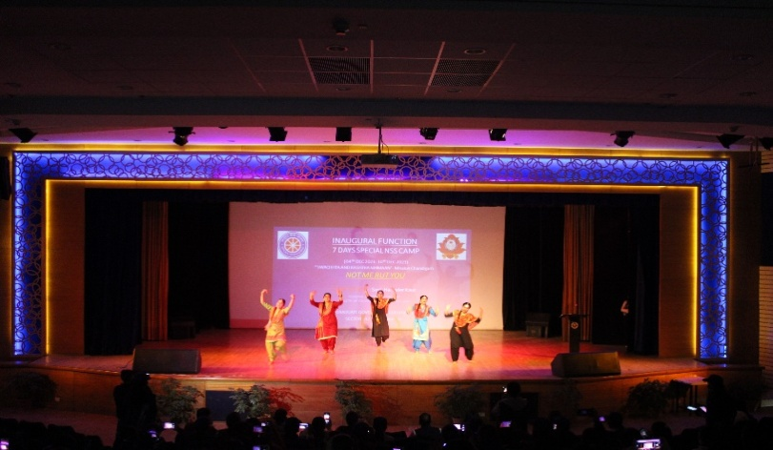

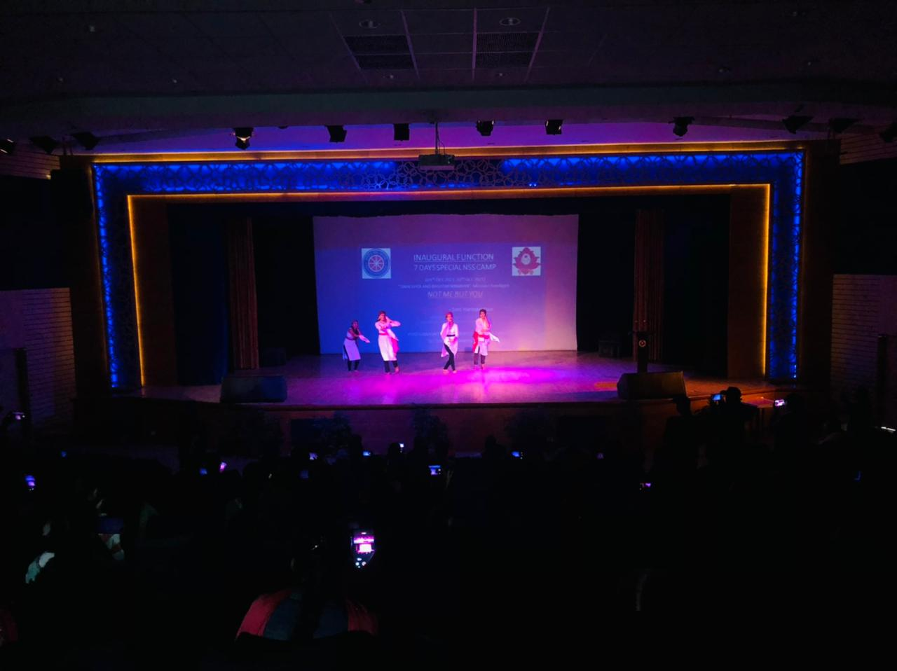
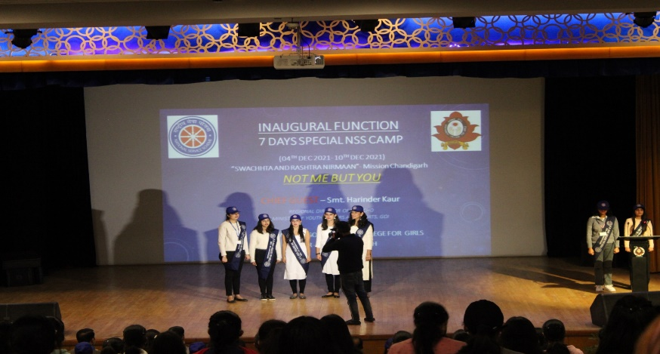

ORIENTATION PROGRAMME
In the evening of the first day, an NSS orientation program was held by the NSS in-charge Mr. Mehar Chand. High emphasis was laid on NSS Logo, “Not Me But You”. The students were made aware about the duties, responsibilities and objectives of NSS.
He explained to the students the importance and need of the National Service Scheme. He pushed the students to realize the fact that when they come out for the service of society, they must join their hands together as volunteers and forget all other differences. He also appreciated the pass-out college volunteers who have excelled in the field of social work and are an example for the present volunteers. Mr. Mehar Chand laid emphasis on the power of taking initiative and urged the students to come forward in times of need.
Apart from this he also explained the volunteers the meaning of the purpose of NSS i.e., “community service through education and education through community service.” This left the volunteers in complete enthusiasm to start the camp and thus the day came to an end on a very zealous note.

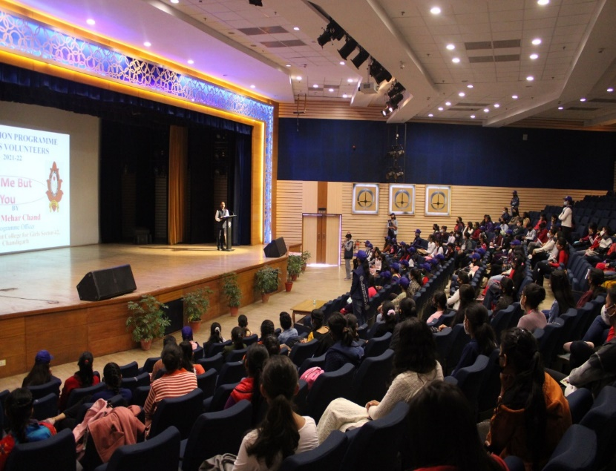
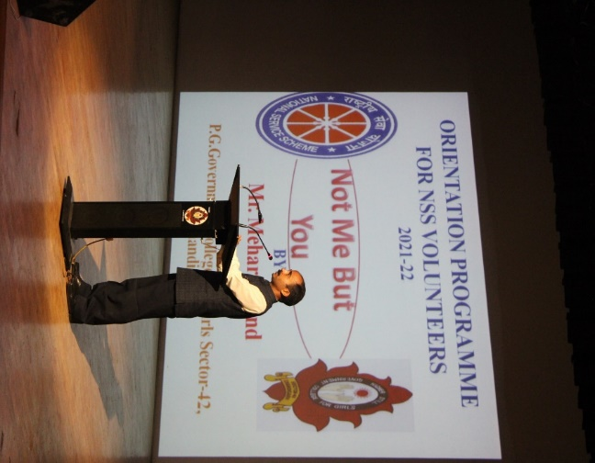

DAY-2, SELF DEFENSE CLASSES:
As it is rightly said, “healthy is an outfit that makes everyone glows”. Keeping this in mind NSS Wing of the college organized self-defense classes for the students that were organized everyday from 9:00am- 10:00am by the head constables from Sector-17 Women Police Thana.
In the self-defense sessions the volunteers were explained how important is it for the women in this era to learn self-defense to protect themselves and also others. The volunteers were explained the various ways in which crimes are taking place in India against women, the shocking part of which is the fact that in most cases of eve teasing women don’t even get to know that this heinous crime is taking place against them. The constables laid stress on the fact that most mishaps occur because women feel scared and henceforth hinder themselves from raising a voice against such incidents.
Thereby to build the physical stamina of women so that they can face tough times with confidence the volunteers were physically trained. The attention of the volunteers was brought to the fact that they cannot face these situations unless they are mentally and physically strong. Further, the volunteers were suggested to keep themselves fit by devoting atleast one hour everyday to ground activities. The sessions not only made the volunteers physically more active but also taught them to be alert and suspicious of the activities going on around them. They empowered the volunteers and gave them the confidence to take the necessary actions whenever required. This was followed by a healthy breakfast for the volunteers in the college canteen every day.
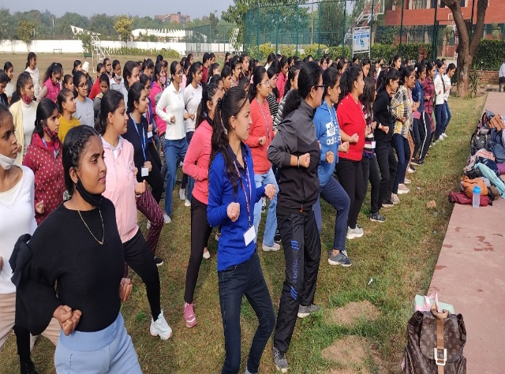
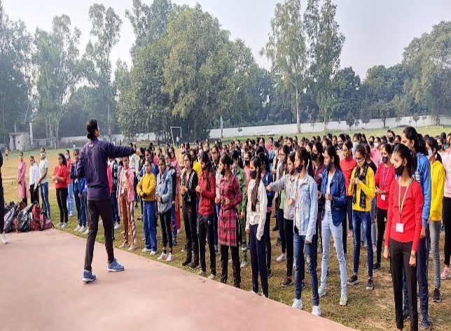
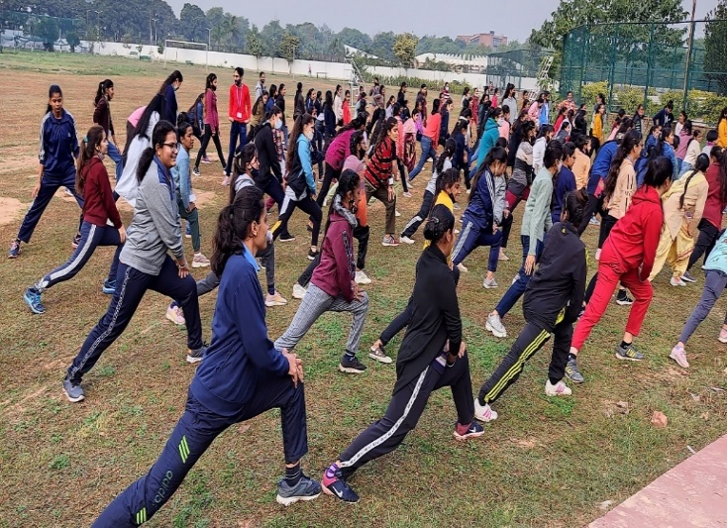
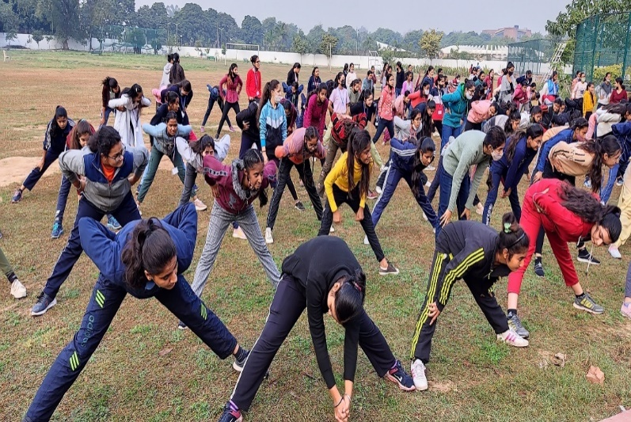

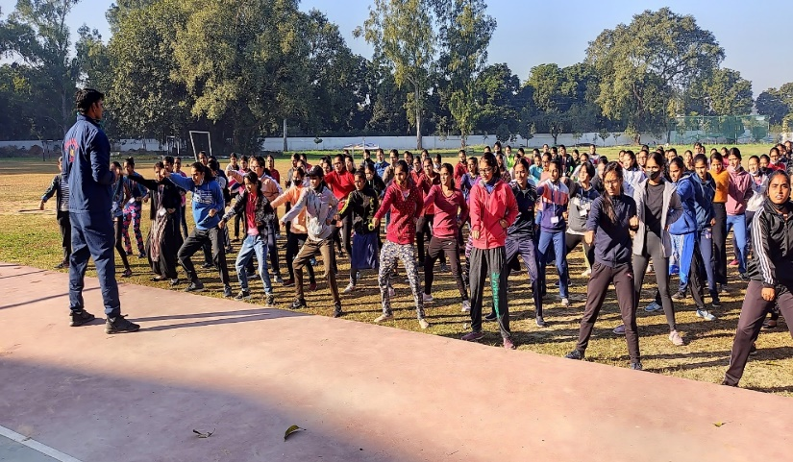
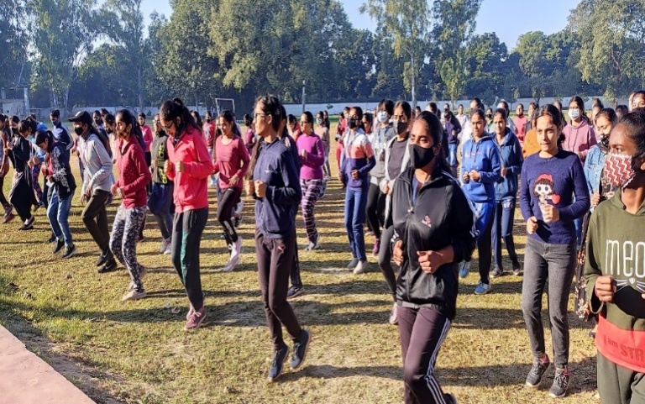

Morning Session: Theme: Organic Farming
A talk on Organic Gardening and Organic Farming was delivered by Mr. Rahul Mahajan- an environmentalist and founder of the NGO, Organic Sharing. On the event of World Soil Day, he explained to the volunteers the need and benefits of healthy and organic soil. He also urged the audience to grow organic plants at their homes or to adopt farmers for organic farming. He said that it is very vital for the upcoming generation to realize the importance of going organic.
While stressing on the need of organic farming he made the gathering realize the fact that though the foreign way of growing crops is yielding high output, but what it is taking away from us is our health and is also deteriorating the quality of our soil. Along with this he motivated the youth to do their bit by pushing them to start growing organic plants at their homes and take the initiative of organic gardening. He also told the students about the work that his foundation has done in Burail Jail, Chandigarh, wherein the prisoners grow organic crops for themselves.
Inspired by his initiative a lot of volunteers got motivated to join their hands in this initiative. They were also highly driven towards the motto of the foundation that is Learn Grow Share.
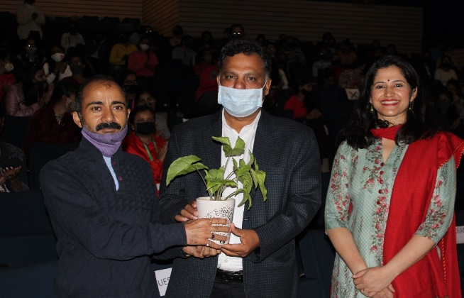
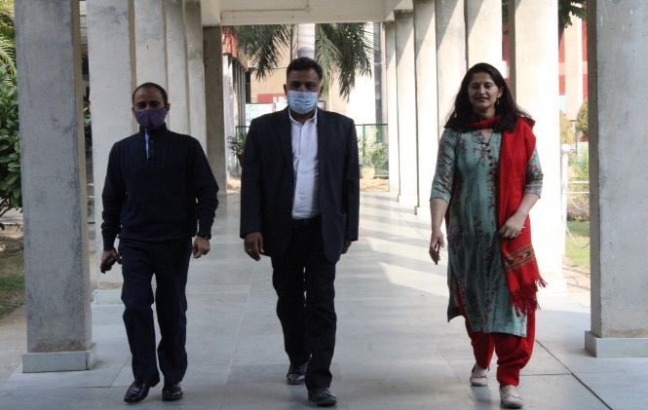
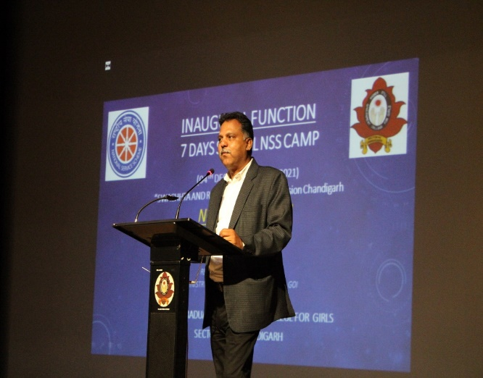
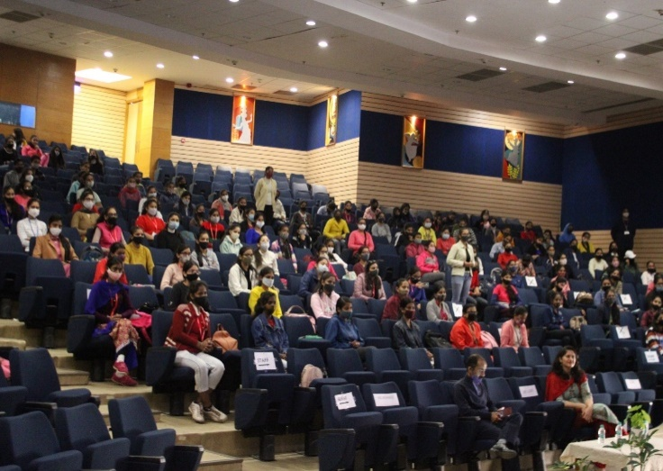

Evening Session: Theme: Health and Nutrition
It is rightly said, “an investment in health is the one with zero risk and total profit.”In the evening of the second day of our camp an interactive session was organized by professor Kalyani Singh, from the department of home science. She conducted a quiz on diet and nutrition and explained to the students the benefits of a balanced diet and lead a healthy lifestyle while incorporating all the vital nutrients in their diet.
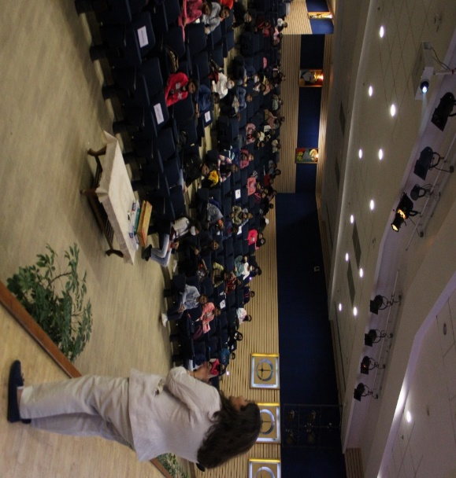
During the quiz Miss Kalyani laid explained how the various foods help the body to function. She also told the volunteers to exercise regularly for a healthy lifestyle. She also checked the volunteers protein, water and fat count and told the students how they can bring moderations in their lifestyle to balance these variants in the body. The session was extremely delightful which left the students in a full motivation to kick-start a healthy lifestyle.
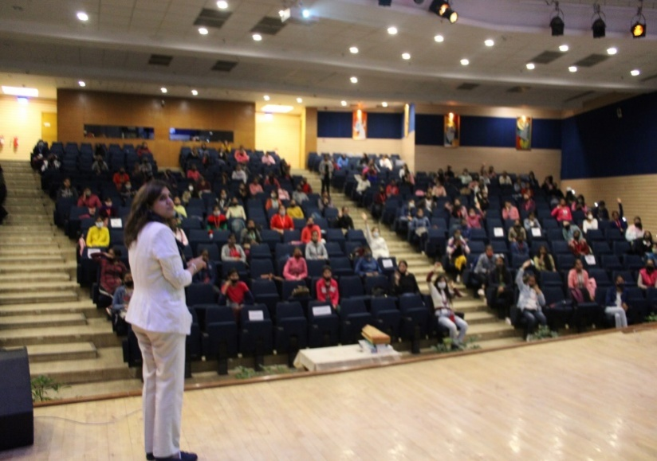
Best Out of Waste Competition
“Things are not useless, they are used less.”Along with the seminar a best out of waste competition was held in which the volunteers participated actively. The students made articles of decoration. The following volunteers won prizes in this competition:
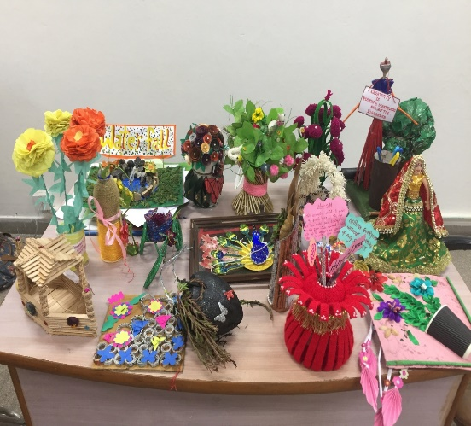
1. Kumari Anjali
B.A 3rd year (Roll No. 190682)
2. Pragati Pal
B.C.A 3rd year (Roll No.191548)
3. Anjali
B.A. 1st year (Roll No.210453) and
Rosy B.A. 2nd year (Roll No. 200345)
DAY-3, Morning session: Theme: Blood Donation Awareness Session
“One does not need to be a doctor in order to save a life.” An awareness session on blood donation was organized by Dr. Ravneet Kaur, professor and Head of Department of Transfusion Medicine, Government Medical College, Chandigarh. During the session the volunteers were made aware of the different types of blood donors. Dr. Ravneet urged the students to donate blood for those in need and not to hesitate in blood donation if they are fit to donate blood.
She also explained the volunteers that blood should be donated as per the need of the hospital and laid stress on the fact that paid donors are banned in India. She brought to light all the precautionary measures that are taken by the medical staff in order to collect blood for the blood banks. Recalling the times when COVID-19 was at its peak, she brought into light the various difficulties that were faced by blood banks due to lack of owners.
She motivated the students to come forward in such times of need and trust the medical staff regarding their safety. Explaining the importance of donating blood, she laid stress on the fact that while donating blood the donors must take into consideration the various parameters of their health and always inform the doctor about ailments if they have any; or else it could harm the patient who needs the blood. This session was very informative and it drove the students to donate blood as it could save the life of a person. The volunteers got really motivated to serve the society by donating blood.
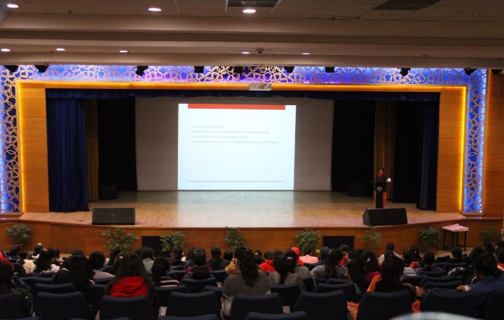
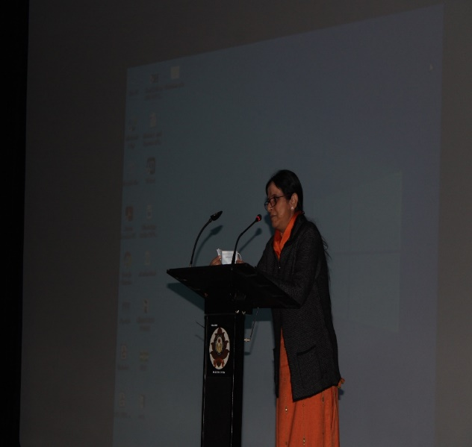

EVENING SESSION: Theme: Personality Development and Winning Attitude
In the evening a session on personality development was organized by the college assistant professor Dr. Ranjana Sharma Garg. In this era of competition, she explained the need of personality development. One needs to develop their personality in order to stand out and make an impact. She shared various incidents from her own life which led to the shaping of her personality.
A huge emphasis was laid on self-love. She said that a person who loves themselves can achieve whatever they want. She narrated that self love not only builds a person’s confidence but also drives the person with full passion towards their dreams.
An important part of this seminar was that Dr. Ranjna laid stress on the fact that one must always keep growing in their life and be motivated towards living a good quality life. And she also urged the students to be motivated and keep growing their personality and grooming themselves in order to feel happy and content with the life that they will lead. She quoted various famous authors on life and the one that was closest to her heart was, “Be the change that you want to see in the world.”She inspired students to choose a path for themselves and work hard for it day in and day out in order to achieve the highest possible goals in the fields of their interest. The volunteers went back with zeal in their hearts and motivation in their minds to work hard to achieve the goals of their life.
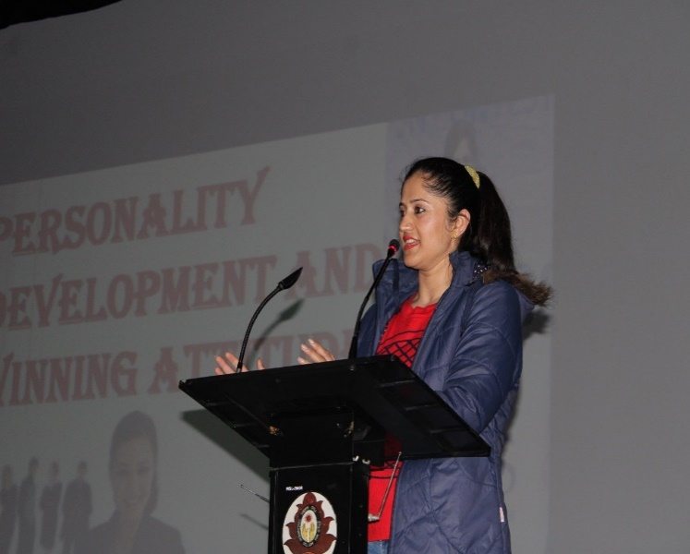
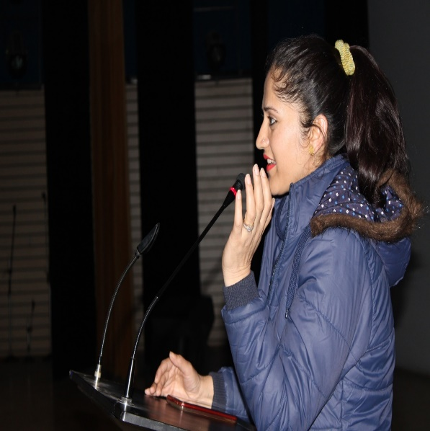
Poster Making and Slogan Writing Competition:
“Silent art speaks more than loud words.”On this day a poster making and slogan writing competition was held for the volunteers in the multimedia room. The theme for slogan writing and poster making was, “Voter Awareness”. The following volunteers bagged prizes in this competition.

Poster Making:
1. Komal Kumari
B.A IT 3rd year (Roll No. 190965)
2. Shikha
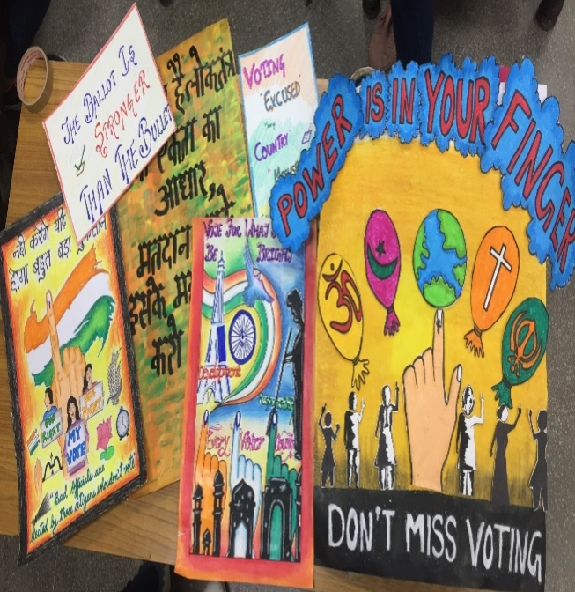
B.A. IT 1ST year (Roll No. 210951)
3. Smita Horo
B.Com 3rd year (Roll No. 191182)
Slogan Writing Competition
1. Gudia
B.A. 2nd year (Roll No. 200371)
2. Megha
B.Sc. 2nd year (Roll No.202027)
3. Muskan Chechai
B.Sc. 2nd year (Roll No. 202095)
DAY-4, MORNING SESSION: Theme: Reproductive Health and Sexual Wellness
The morning session of the fourth day of the NSS camp began with the discussion on Reproductive Health and Sexual Wellness for the volunteers. It was organized by Dr. Veena Gupta, Medical Officer and Member of Family Planning Association of India, Mohali Branch. She elucidated the importance of hygiene in women in order to maintain their reproductive health. In a country like ours this is the topic that needs to be spoken of the most but sadly it is one topic that people are most likely to turn their back upon.
She along with her team put in place the various myths related to women and insisted them to maintain good hygiene and a good reproductive health. They also persuaded the volunteers to come out and speak up about these topics and spread awareness. She motivated the volunteers to come forward and educate the society about breaking the myths. They also highlighted the various kinds of diseases that can spread in girls if they don’t take their reproductive health seriously.
The session was made interactive by organizing a question-answer session wherein they tried to educate the volunteers on the topics of concern. The volunteers found this session extremely useful and informative and felt more confident about their bodies. Their knowledge was also enhanced about their own bodies.

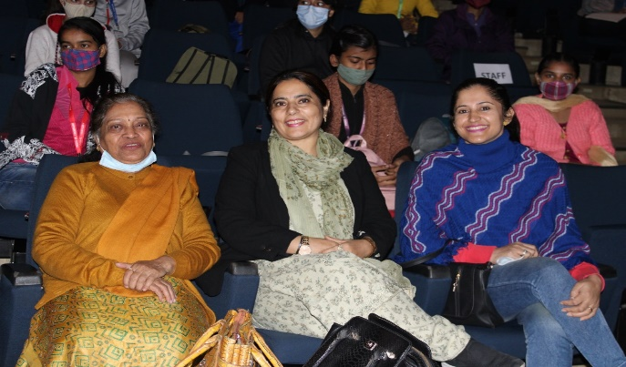
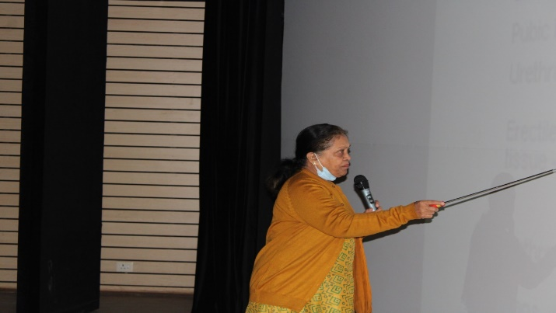

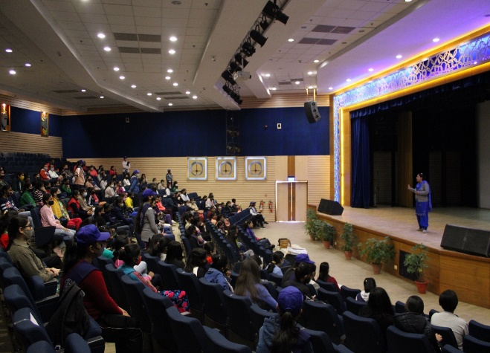
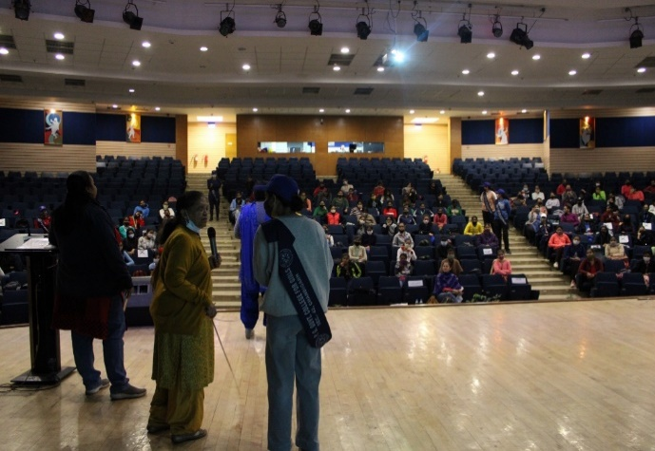
EVENING SESSION:Theme: Skill Development Seminar
In the evening session of day four a session was held on skill development by Mr. Paramjit Singh Regional Director for Entrepreneurship, Sector-35 Chandigarh. He laid emphasis on importance of skill development among youth so as to become economically independent. He conducted a motivation session by bringing to light in numerous real- life examples of budding and successful entrepreneurs and encouraged the students to start from the scratch and reach the zenith.
He brought into light the fact that these days it is extremely important to become financially independent and henceforth one must continuously develop their hard skills so as to get jobs or to be self-employed. By explaining various examples, he encouraged the students that they should come forward and be confident to start their own business.
He emphasized the fact that one should keep on developing their hobbies and talents since in this techo world there is no talent that shall go wasted. He inspired the students to always keep working in the direction of their goals and to not stop unless they reach their goals. He told the students to not be afraid of working hard. This workshop clearly served as a great counselling session for the volunteers thus bringing about a lot of clarity among the students about their career and their financial life ahead.
Mehndi Competition:
“Mehandi is not just an art, it is our tradition and it reflects our culture.”The volunteers were encouraged to showcase their talents by organizing a mehndi competition. This was conducted in the college premises and the students who won prizes in the mehndi competition are:
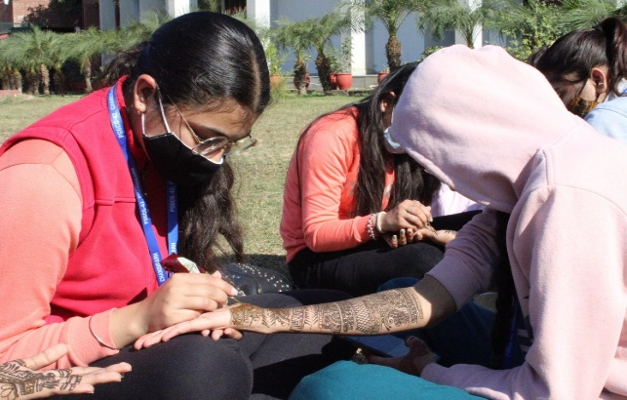
1. Pragati Pal
BCA 3rd year (Roll No.191548)
2. Smita Horo
B.com 3rd (Roll No. 191182)
3. Aanchal Pathania
B.A. 3rd year (190459)

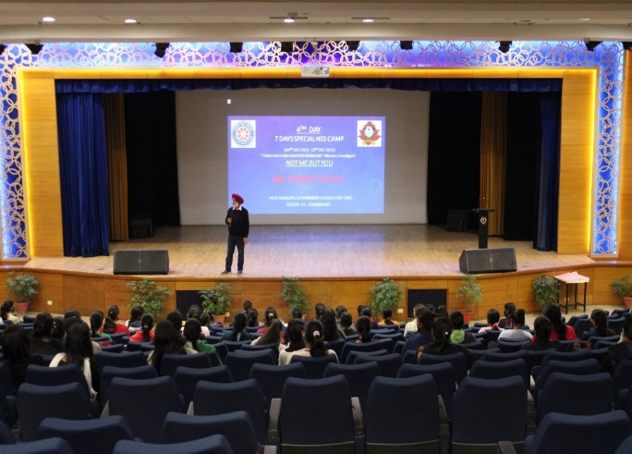
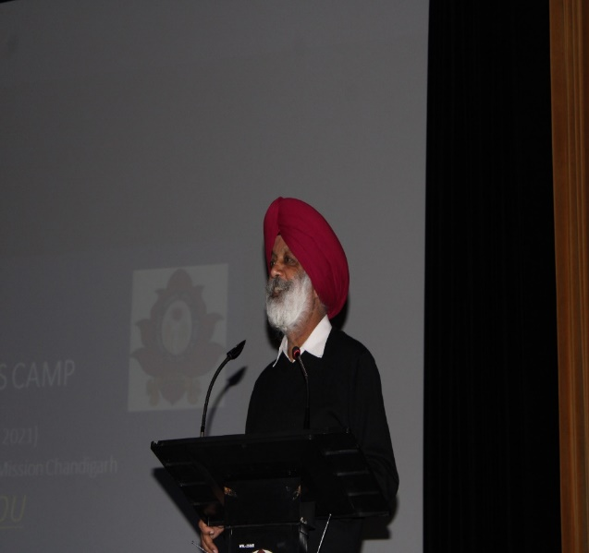
Mr. Paramjit Singh Regional Director for Entrepreneurship

DAY-5 MORNING SESSION: Theme: Soft Skill Development Among Students
On day five of the NSS a seminar on soft skill development by the placement cell of Chandigarh Group of Colleges, Landran. The Guest Speaker, Miss Urmila introduced the importance of soft skills among the students and urged the students to be the architects of their own lives. She laid utmost stress on the saying, “an investment in knowledge pays the best interest.” The volunteers were motivated to not only think but also take action towards the goal in which they feel motivated. She said that the career that a person is going to choose must be defined by who the person is and not by what is the trend. She added that no matter how many hard skills one possesses, the real difference is made by the soft skills one has. Henceforth, one must constantly work in this arena.
After this Miss Bunny Sharma introduced the volunteers to the concept of SWOT analysis. She laid stress on the fact that this type of analysis must be conducted by everyone in order to know more about themselves and to choose a correct career path for themselves. The SWOT analysis is the best tool for self-introspection and it helps an individual to know their strengths, work on their weaknesses, grab the opportunities and stay safe from the threats.
Thereafter, Miss Poonam Bhanbhara introduced the students to the importance of teaching as a career and motivated the students to pursue it as an occupation. She explained that teaching could be a good career choice for the youngsters as it is the profession with highest responsibility and it is the profession that builds all the other professions. Henceforth, this seminar was very encouraging and inspiring for the students and they reciprocated with a positive feedback.

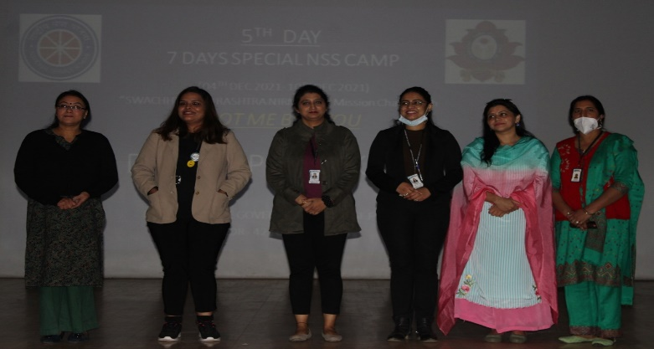
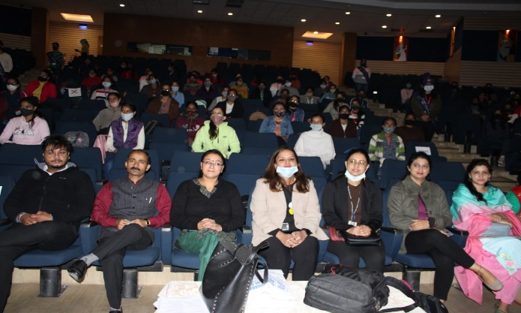
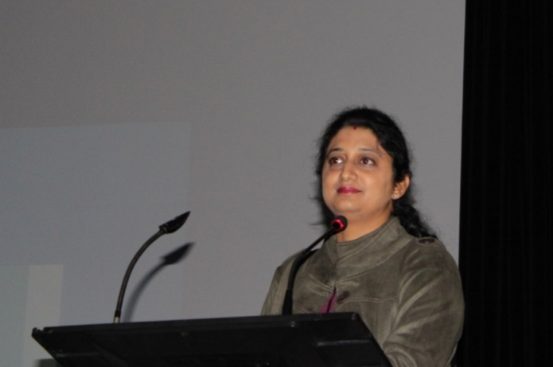
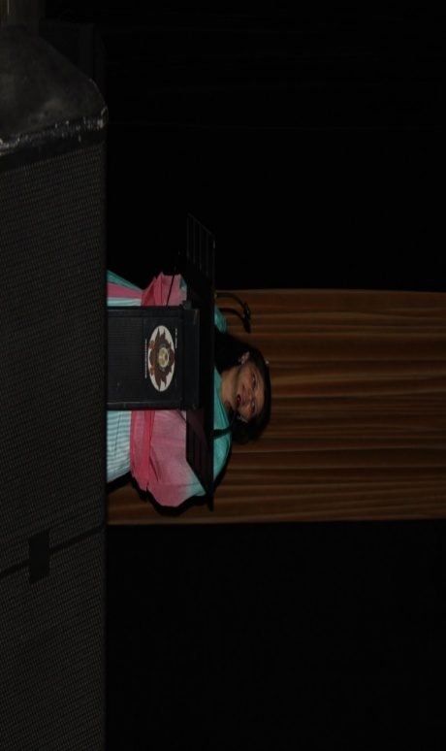
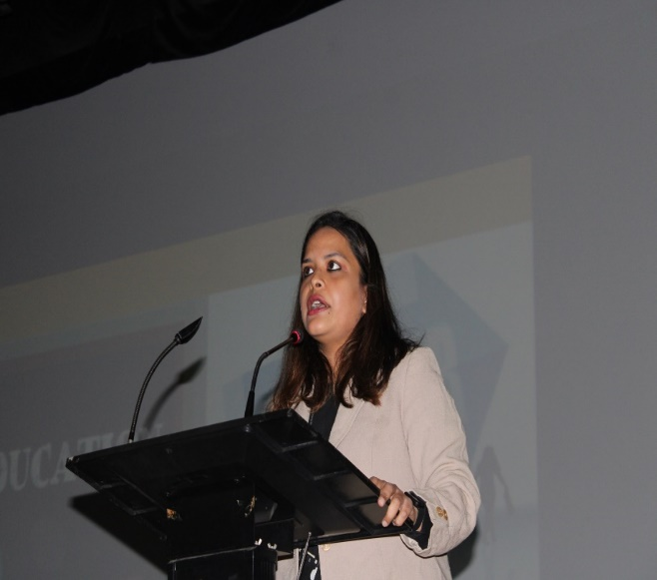
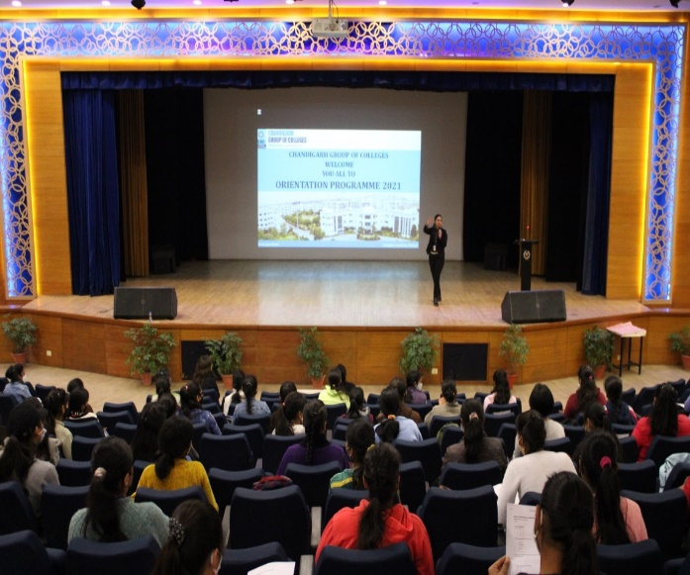

EVENING SESSION: Theme: Guru Teg Bhadur Jayanti:
In the evening the students were enlightened about Guru Tegh Bahadur Jayanti by Mrs. Harpreet Kaur. She enlightened the students about the sacrifices made by Guru Tegh Bahadar and she inspired the volunteers to walk on the path of social welfare in order to make their life fruitful.
She laid stress on the fact that one should always be humble and helpful in the society. Also, she brought into light the fact that no act of kindness, no matter how small is ever wasted. She urged the volunteers to take a step ahead and come forward to help the society in every little way they can.
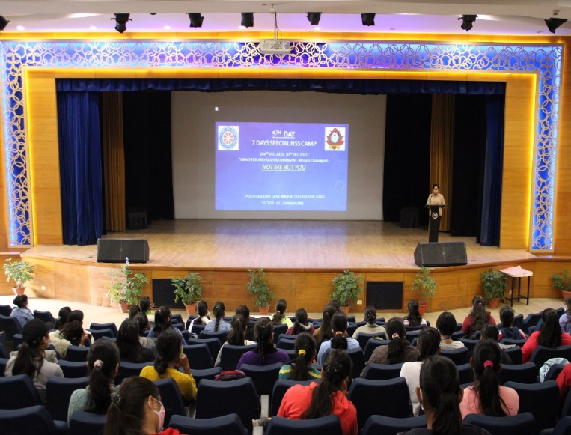
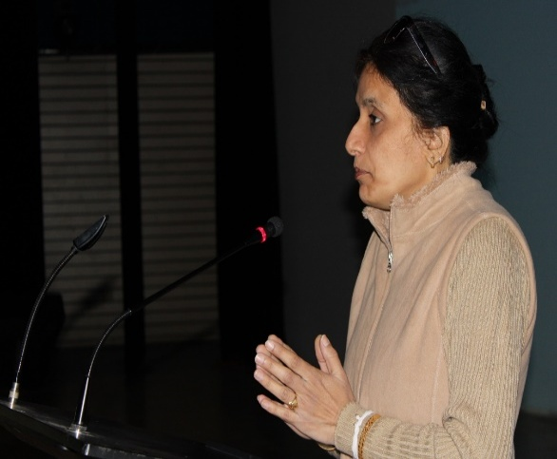

DAY-6 MORNING SESSION: Theme: DATRI Foundation Bone Marrow Transplant
“Act Now And Give a Life”. An awareness session was conducted by Miss Anuradha Tandon among the students about the life threatening disease Thalassemia. She discussed how this disease is affecting the life of patients by giving real life examples of their patients. She explained the problems faced by the patients of blood cancer both financially and in their day to day lives.
Later on, she explained the donation process of the blood stem cells. She also explained the students the power of helping others and ensured the crowd that their identity shall be kept totally confidential while this process. She also elucidated the fact that it is very difficult to find a match for the transplant and inspired the students to get themselves registered as a donor for the patients. She was successful in her motive to drive the gathering towards the plight of the thalassemia patients as many volunteers got themselves registered as donors by giving their samples and thereby summing up the session.
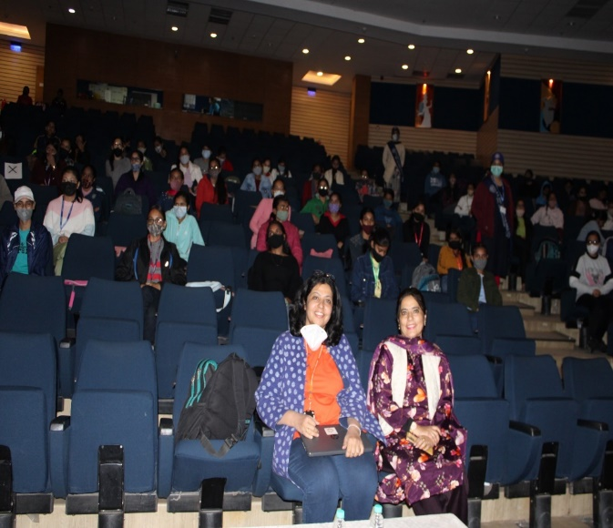
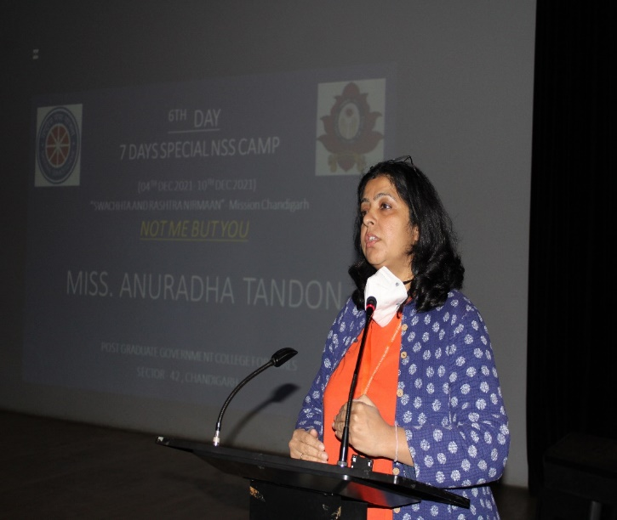

EVENING SESSION, THEME: OPEN EYES FOUNDATION:
To promote social welfare Mr. Sandeep a Social Welfare Officer from ‘OPENEYES FOUNDATION’ interacted with volunteers and share, how his NGO took initiative of ‘Open Libraries’ and ‘Educational Huts’ to promote premium education among needy juvenile. He also promoted the initiative of‘RADDI SE SIKSHA’ by collecting old books from students and provide them to deprived children.
In addition to this he also works for the upliftment and welfare of women in the backward and remote areas by providing them with sanitary pads. He has also installed a book collection box in the college premises so that the college students can do their bit in educating the children. Emphasizing on the importance of education, he concluded by encouraging students to donate old books, stationery and by educating for love.

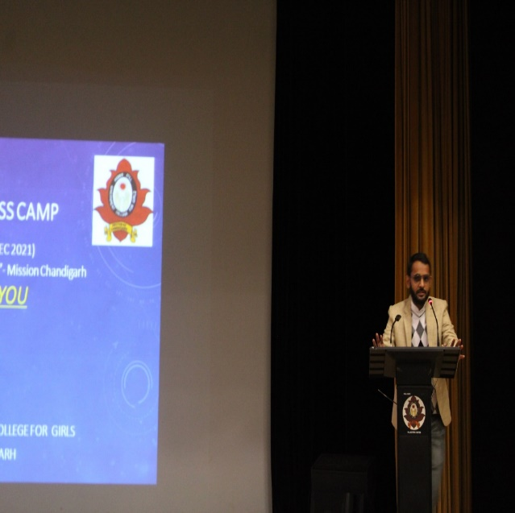
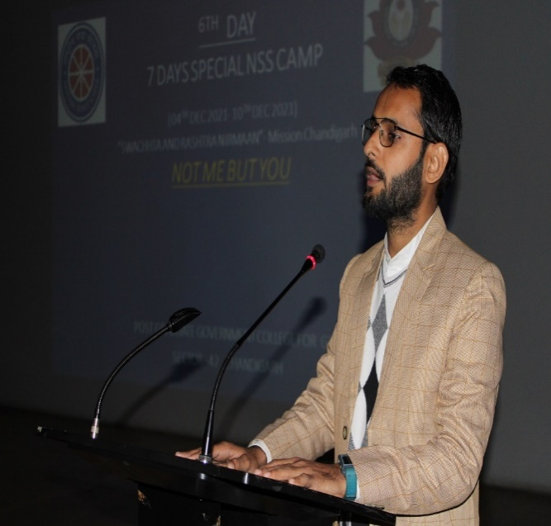

MEALS BEING SERVED TO THE STUDENTS IN THE NSS CAMP:
As “A healthy outside starts from the inside”. Healthy Breakfast, Lunch and Evening snacks were also served to students throughout the camp days. These meals were nutritious and delicious at the same time. The best part about the food served in the camp was that it instilled the value of sharing and caring as well as community serving.
In the camp the students, themselves took the responsibility to serve food and also helped the canteen workers in cooking food. Sitting and eating together was the best part of the day. This instilled the value of, the family that prays together, eats together, and stays together.

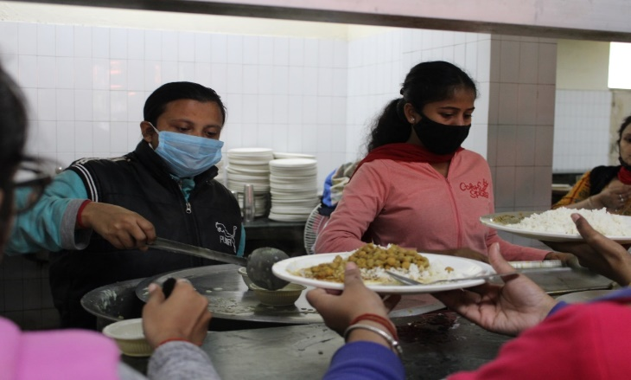
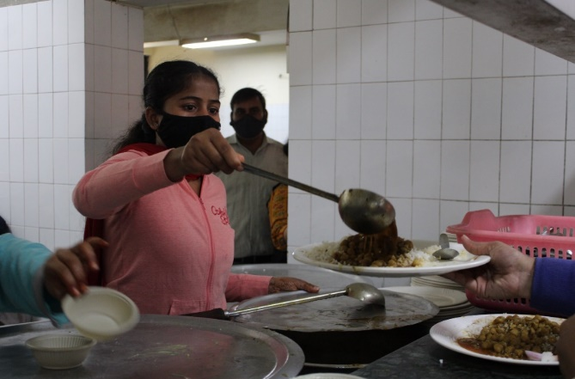

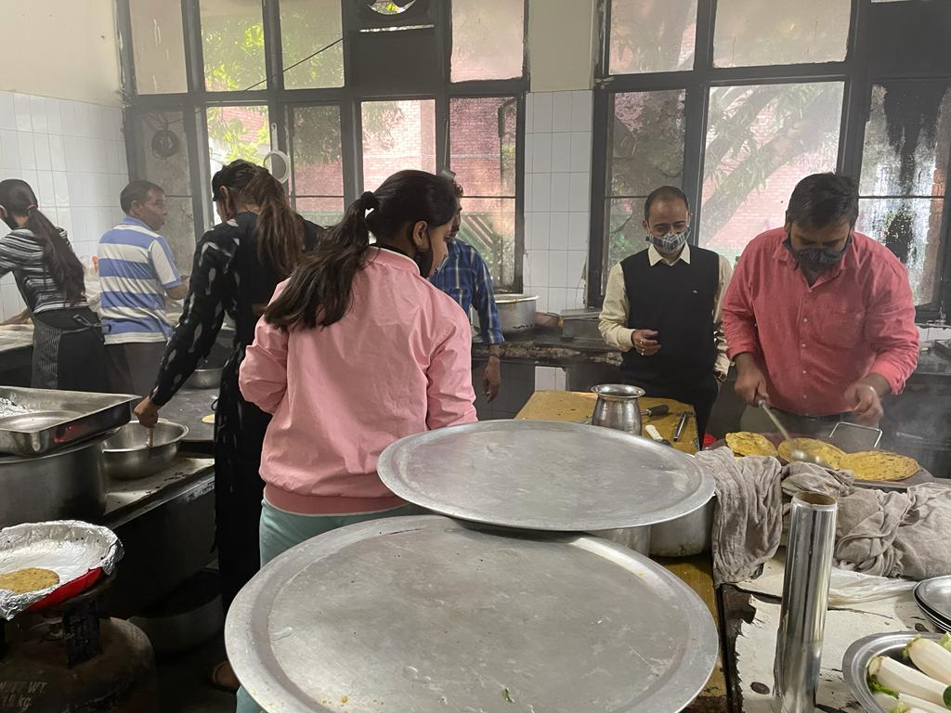
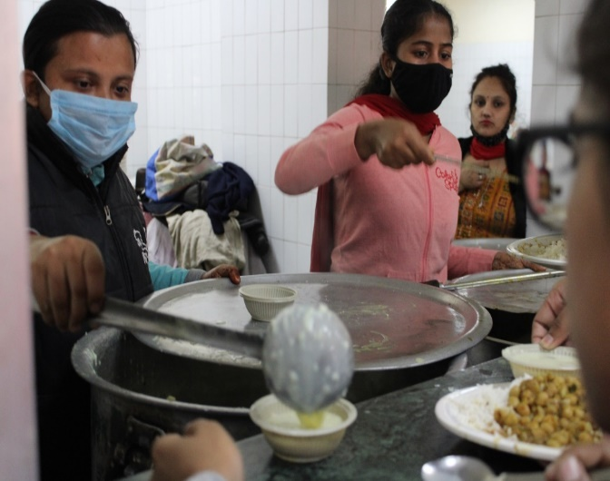
DAY-7, VALEDICTORY FUNCTION
The seven day special NSS Camp came to an end with the valedictory function. Dr. Gaurav Gaur, Senator Panjab University had graced the occasion with his benign presence. He was welcomed by the college Principal Dr. Nisha Aggarwal by offering a green plant. A cultural program was put up in front of chief guest which included bhangra, giddha, classical dance, fusion dance, patriotic song, etc. This was followed by reading the report of all activities that were held during this camp and thereafter the chief guest speech took place.
The Chief Guest, Dr. Gaurav Gaur addressed the gathering by encouraging them to actively work for social causes. He laid emphasis on the fact that we as NSS volunteers must work with the people and not for the people. He laid stress on the fact that this society belongs to all of us and we all must put equal amount of effort in order to bring the society to a higher level. He also said that we have to start from the grassroot level and that cleanliness is one of our major concern as the rank of Chandigarh, the city beautiful has drastically fallen down. He motivated the students to put in efforts to clean the city as much as possible and aim to bring the city in at least top ten clean cities of India.
Besides he congratulated the NSS in charges of the college for inviting such eminent resource persons to train and develop the students. He also motivated the students to put into use all the information all that they have learnt in this camp. Dr. Gaurav also added that since the old age population is increasing in the country and thereby NSS is aiming at increasing the number of old age homes; at the same time he left the gathering with a question that do we really need to have old age homes in a country like ours.
Apart from this, he highly appreciated the students and congratulated them on putting up a great job. He also motivated them to devote time to community service and reminded the students that it is the camp that had ended and not our duties society. He concluded the speech with the words,

“phal ke liye ess duniya ma ik karam toh krna padhta hai,
Rabb toh bss lakire deta hai
rang toh khud bharna padhtahai”

After this price distribution ceremony was held wherein the winners of various competitions and the volunteers of different committees of NSS were suitably awarded. The college principal Dr. Nisha Aggarwal also appreciated the effort of NSS team to make this camp a huge success and thus camp came to a happy ending.
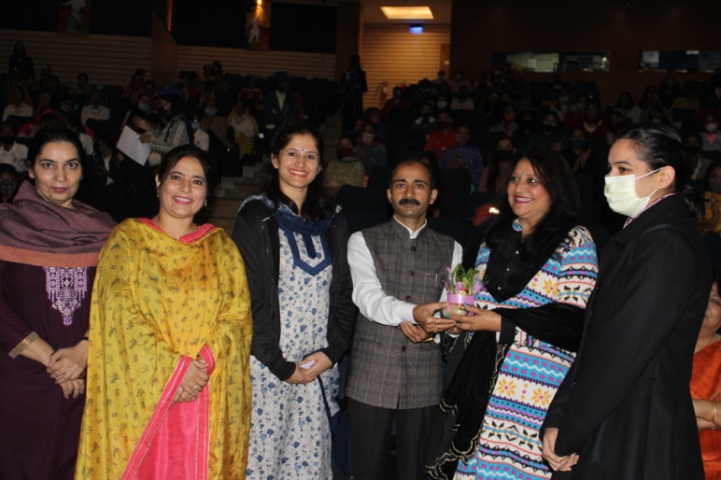
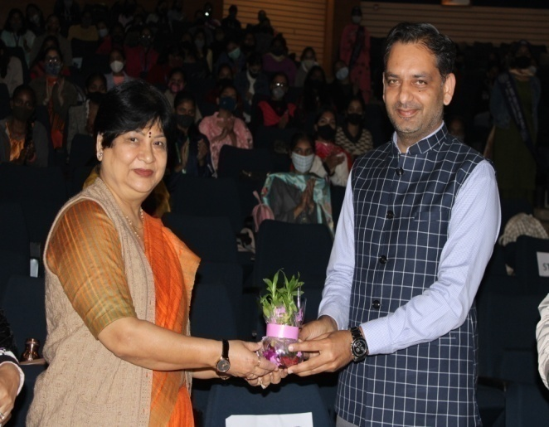
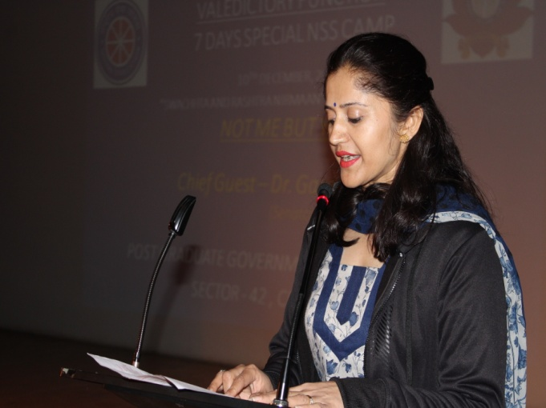
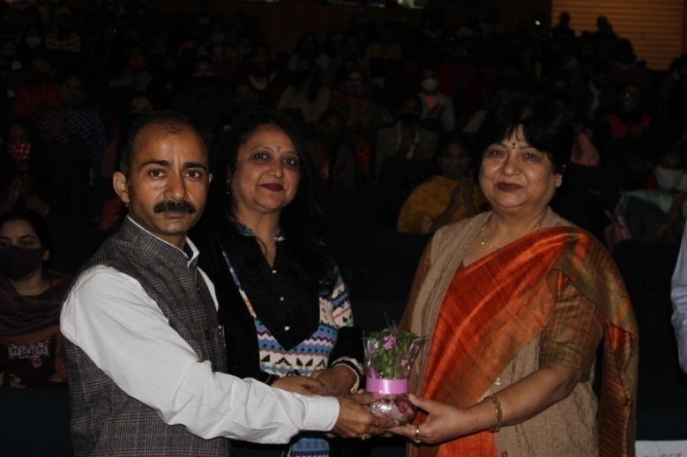

 | ReplyForward

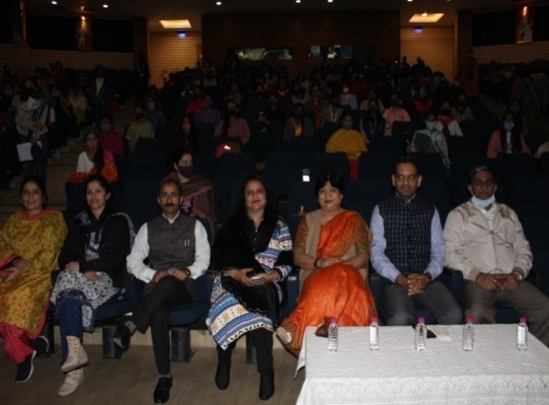
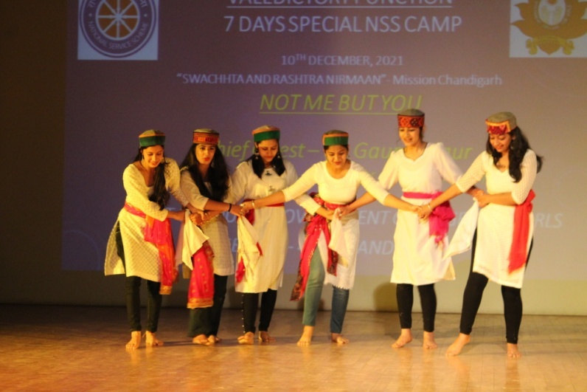

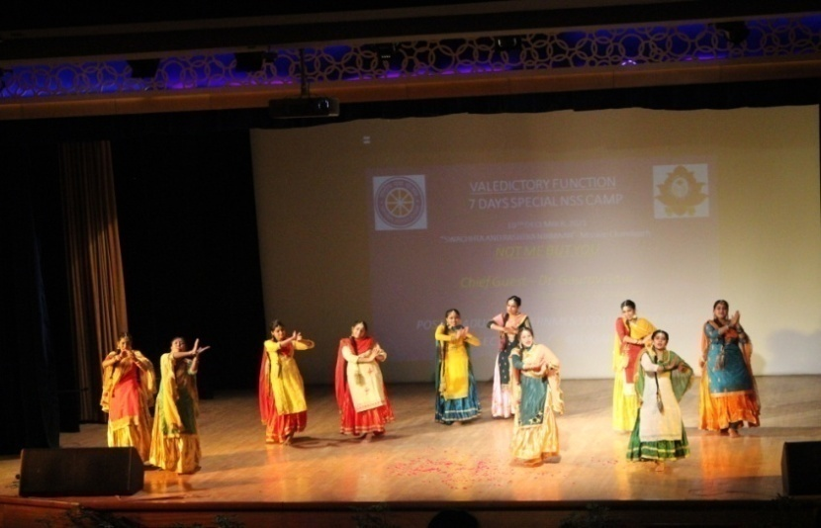
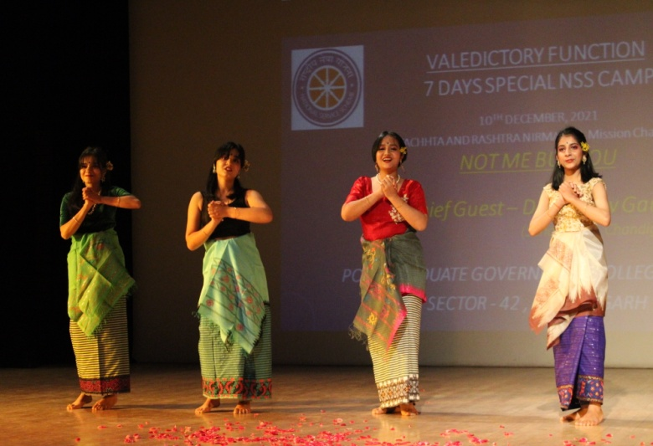

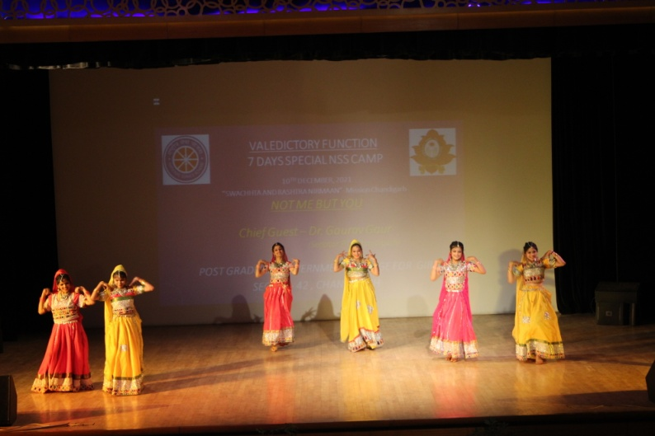
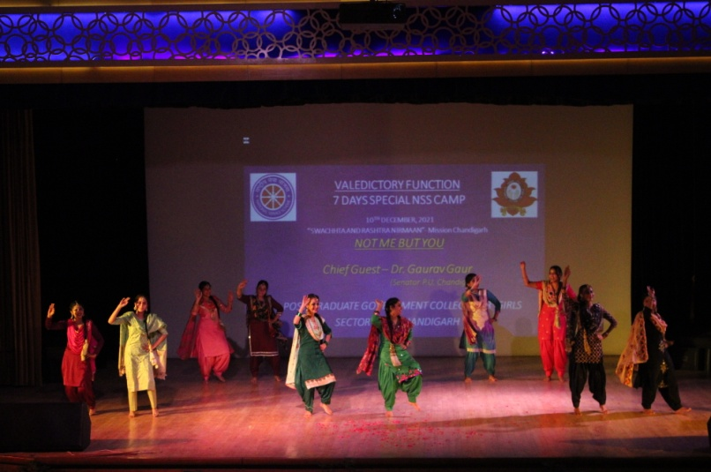

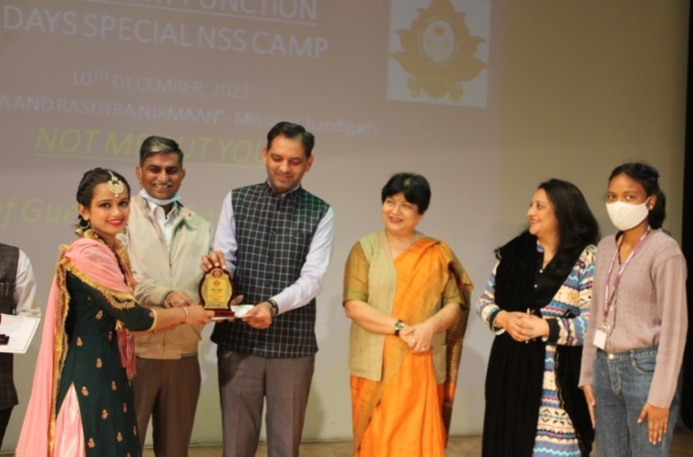
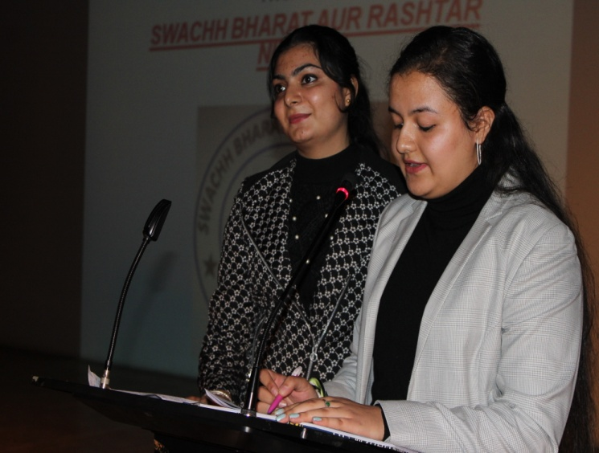

Activities Conducted During the Electoral Week Celebrations
(13th - 15TH December, 2021)

DATE | NAME of the activities organized | In campus/ out campus | Nos. of participants | Name of the resource person/ Guest, if any | Name of the winners | Brief write up the about activity | Remarks
13-12-21 | Pledge taking | In campus | 250 | Prof.( Dr.) Nisha Aggarwal | NA | College teaching, non teaching staff, and NSS volunteers took the pledge to vote and spread awareness among the voters. | Activity was successfully completed and photographs of the event are attached as annexure 1.
13-12-21 | Poster making | In campus | 50 | Prof.( Dr.) Nisha Aggarwal | 1st- Komal kumari (BA IT 3rd year, 1909652nd-Shikha,BA IT 1st year, 210951)3RD- Smita, Bcom. 3rd year, 191182) | This activity was conducted for the awareness of voters. | Activity was successfully completed and photographs of the activities are attached as annexure 2.
13-12-21 | Registration Desk for the enrollment of students above18 years to make voter cards (10a.m. - 2 p.m.) | In campus | 60 | Prof.( Dr.) Nisha Aggarwal | NA | Activity was conducted for enrollment of new voters for coming elections in Chandigarh. | Activity was successfully completed and photographs of the event are attached as annexure 3.

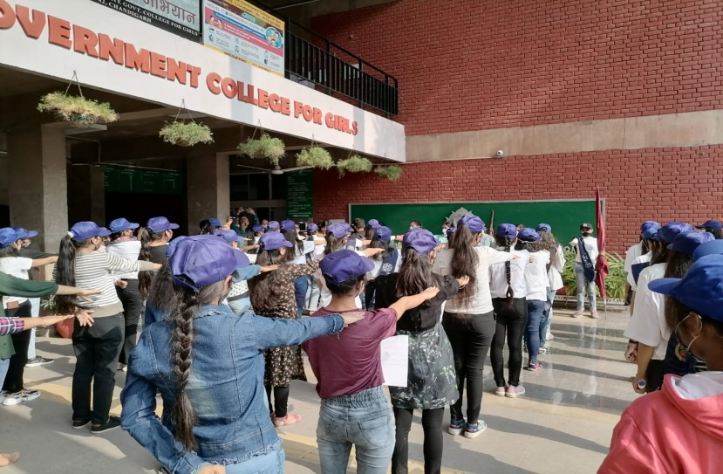
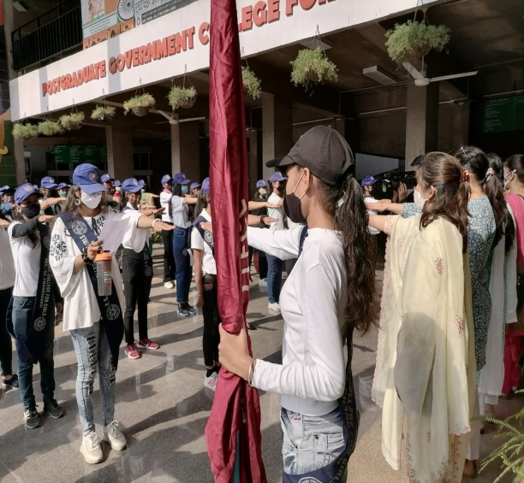
ANNEXURE -1
ANNEXURE -2
DATE | NAME of the activities organized | In campus/ out campus | Nos. of participants | Name of the resource person/ Guest, if any | Name of the winners | Brief write up the about activity | Remarks
14-12-21 | Lecture on Awareness about Voting rights and wards in Chandigarh | In campus | 280 | Dr. Nemi Chand Associate Prof., Public Admn. | NA | Lecture was delivered on the Importance of Elections, Democracy and Voting. | Activity was successfully completed and photographs of the event are attached as annexure 4.
 | Essay Writing Competition | In campus | 18 | Prof.(Dr.) Nisha Aggarwal | 1st- Megha Sharma (202027, B Sc. Non med. 2)  2nd- Hemlata Sharma( 202313, B Sc. CS 2) | This activity was conducted for the awareness of students for their duties and rights. | Activity was successfully completed.
 | Quiz | In Campus | 20 | Dr. Prabal, Asst. Prof., Economics | 1st- Neha (191177, Bcom, 3rd year)  2nd- Muskan (202343, BA 2nd) | This activity was conducted for the awareness of students. | Activity was successfully completed.
 | Declamation | In campus | 15 | Ms Kalyani , Asst. Prof., Home Science | Jiya Sharma  (BA 1ST Year, 210048) | This activity was conducted for the awareness of students | Activity was successfully completed.
 | Registration Desk for the enrollment of students above18 years to make voter cards (10a.m. - 2 p.m.) | In campus | 20 | Prof.( Dr.) Nisha Aggarwal | NA | Activity was conducted for enrollment of new voters for coming elections in Chandigarh | Activity was successfully completed and photographs of the event are attached as annexure 5.
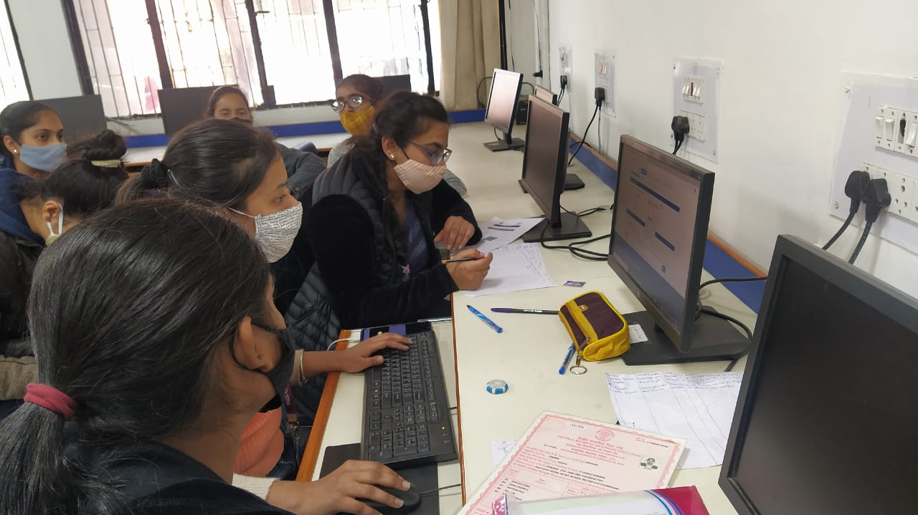
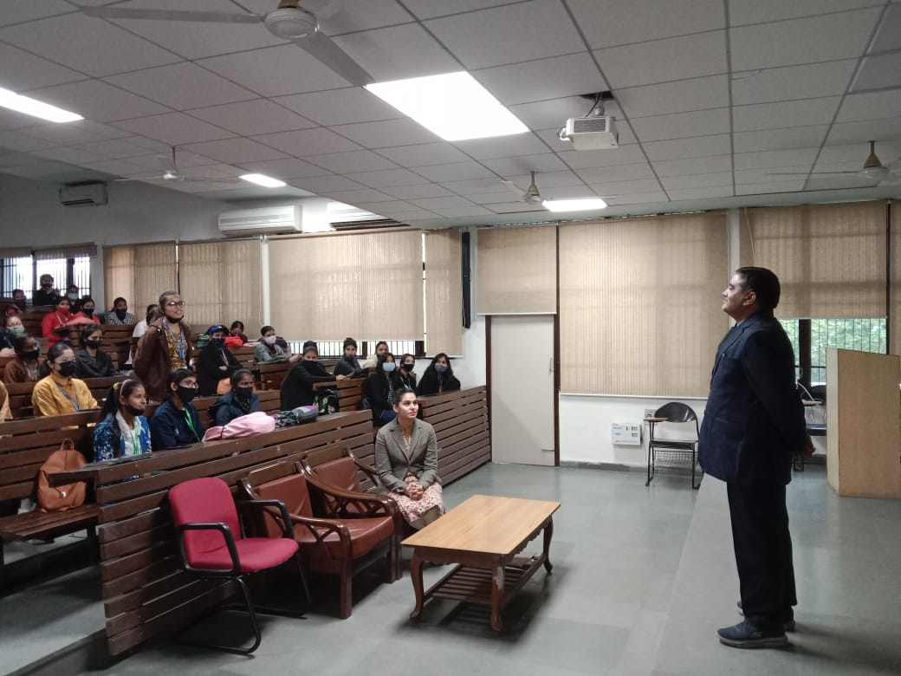

DATE | NAME of the activities organized | In campus/ out campus | Nos. of participants | Name of the resource person/ Guest, if any | Name of the winners | Brief write up the about activity | Remarks
15-12-21 | Awareness rally ( in adopted village- kajheri) | Out campus | 150 | Mr. Suresh Kumar (Dean) | NA | This activity was conducted for the awareness of voters | Activity was successfully completed and photographs of the event are attached as annexure 6.
15-12-21 | Nukkad Natak ( In College and adopted Village – kajheri) | In and out campus | 8 | Mr. Malkeet | NA | This activity was conducted for the awareness of voters | Activity was successfully completed and photographs of the event are attached as annexure 7.
15-12-21 | Registration Desk for the enrollment of students above18 years to make voter cards (10a.m. - 2 p.m.) | In Campus | 150 | Prof.( Dr.) Nisha Aggarwal | NA | This activity was conducted for the awareness of voters | Activity was successfully completed and photographs of the event are attached as annexure 8.

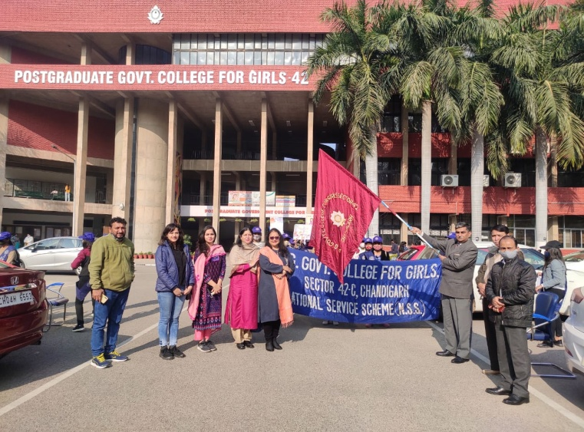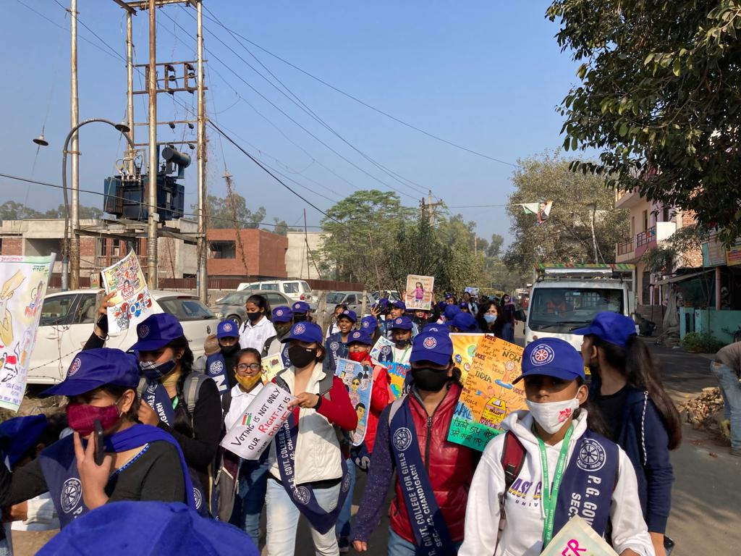
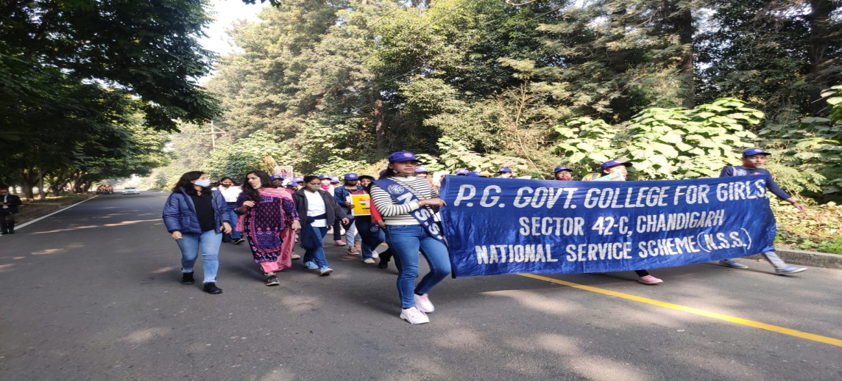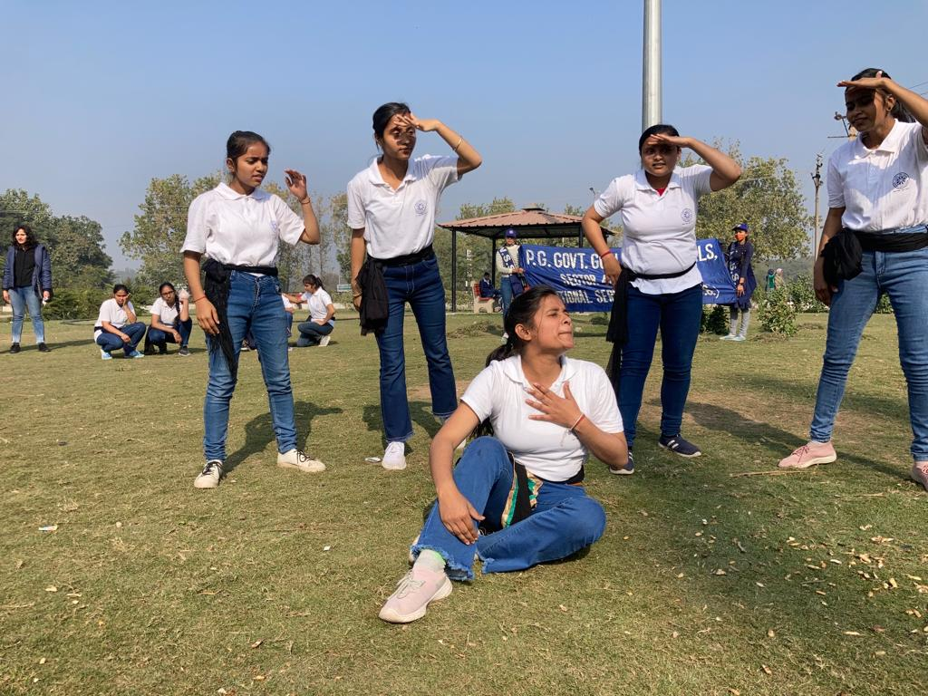
ANNEXURE -6, 7

STATE LEVEL COMPETITION ORGANISED BY DEPARTMENT OF HIGHER EDUCATION AND STSTE ELECTION COMMISION
18TH DECEMBER 2021
While there are some who genuinely cast their vote, many people sit back and relax on voting day, and others are cajoled into voting for particular candidates. The importance of voting is lost amongst the hustle and bustle of city life. While everyone sits and complains about this and that, and makes suggestions that the government should change this and that, the elections come and go without half the population paying attention. The short listed students participated in the declamation contest and quiz competition which was organised By the State election commission, Chandigarh, UT administration.Quiz competition won 3rd price
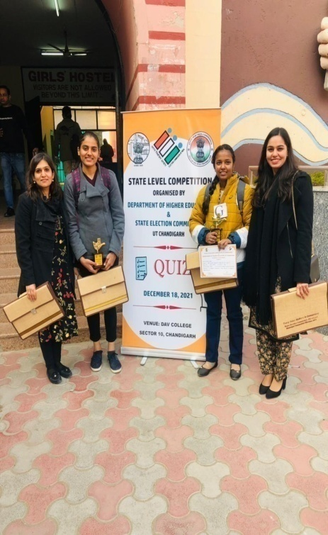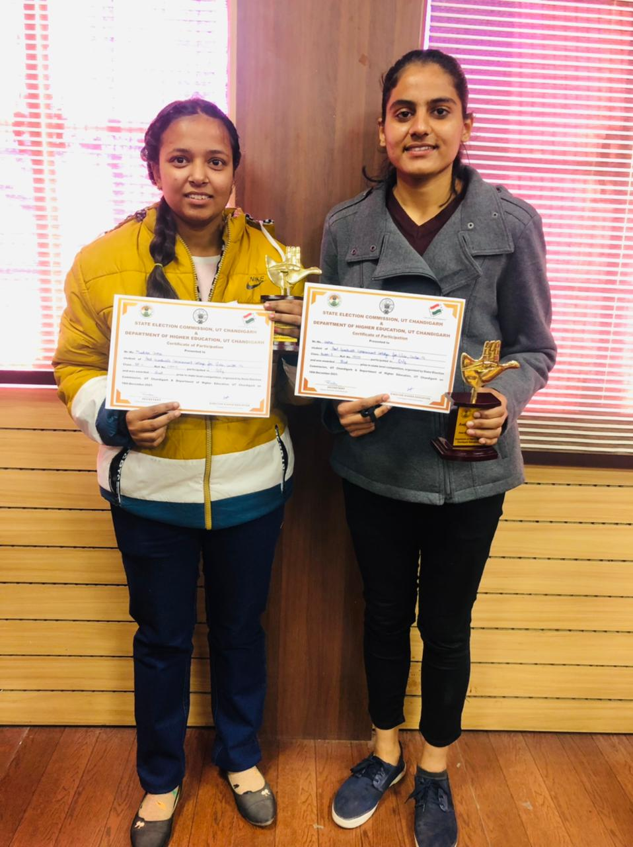

Cleanliness Drive in Rock Garden (14th December 2021)
The birthday of Nek Chand Saini, the creator of Rock Garden, was celebrated at the Rock Garden on 14th December 2021 by conducting Cleanliness drive By NSS volunteers of PGGCG-42, Chandigarh in Collaboration with NGO: Organic Sharing. Mr. Rahul Mahajan addressed the volunteers in rock Garden regarding the importance of cleanliness of Heritage sites, followed by cleaning of statues made out of waste by Nek Chand ji in This Garden, distribution of Refreshment and certificates. The NSS Volunteers were accompanied by Mr. Mehar Chand, Incharge NSS of the college.

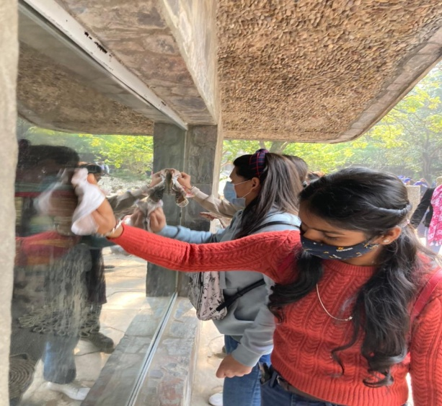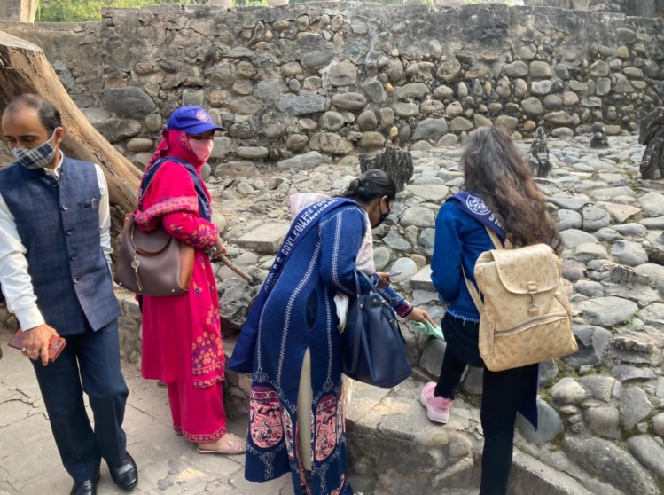
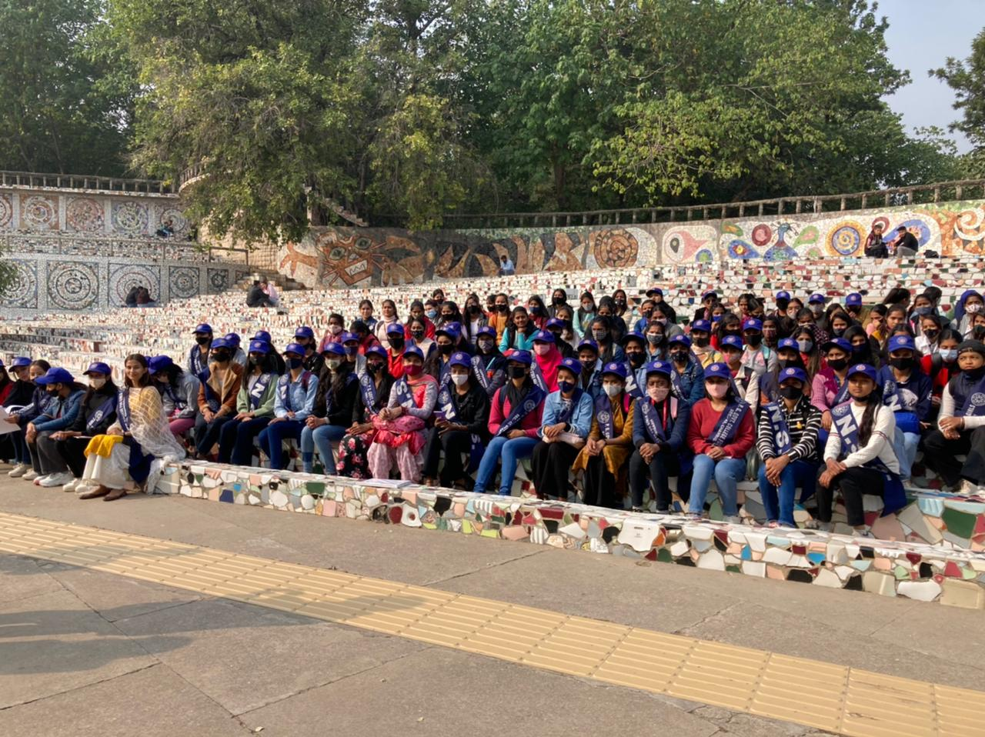

STREET PLAY COMPETITION (27th DECEMBER 2021)
Cleanliness is not other’s responsibility. It is our own responsibility. It is very important to have a healthy living so basic cleanliness is significant in life. It is as essential as we need food, water and clothes to live. Absence of cleanliness leads to various types of diseases, illness and breeding places for flies, mosquitoes and cockroaches. As rank of Chandigarh on the basis of cleanliness has fallen down. In order to aware citizen about the cleaniness municipal corporation of Chandigarh has organised various nukkad natak competition on the theme swachh sarwrekshan was held in different areas.

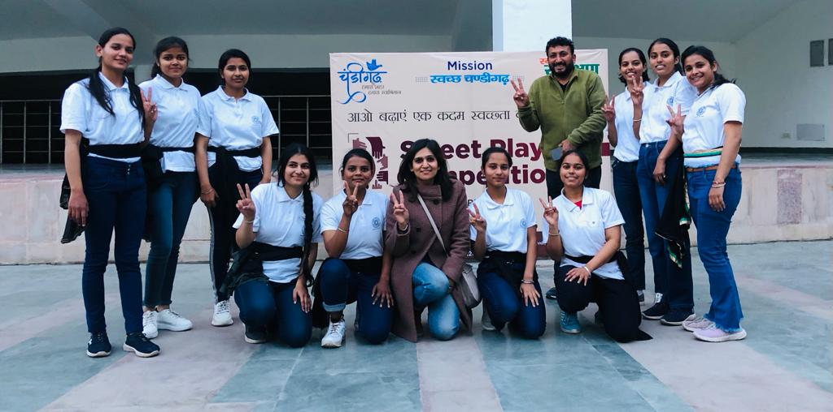

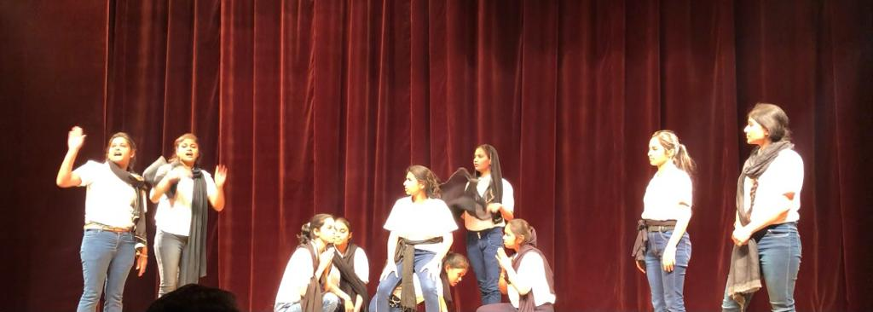

DISTRICT LEVEL PROMOTION OF ART AND CULTURE PROGRAMME, (29TH DECEMBER 2021)
Folk cultures are the backbones that shape and mold every individual during their lifetime. It is a blend of traditions and skills, foods, beliefs, heritage and shared values that are taught and/or passed down from generation to generation providing a common identity or direction for people within a family or community. With our modern day technology and ever changing society, it is important to keep folk cultures alive and not allow them to slip away. As Rose stated, “It is the harmonic convenience of our food, our music, our creativity, our eccentricity, our neighborhoods, and our joy of living.NSS wing of pggcg-42 in collaboration with Nehru yuva Kendra organised a district level competition To promote folk art and culture among the youth, following are the winner of various events.
Name of event | 1st position | 2nd position | 3rd position
Solo dance | Divya (BA-2nd ) | Bhumika (BA-2nd) | Palak Rana (BSC-3rd)
Solo singing | Gagandeep kaur(BCA-3RD) | Anshika (BA-3RD) | Rekhadeep kaur (MA-2nd)
Group dance | Aditi nakoti(BA-2nd)  Changjilan Ngangom (BA-2nd)  Shagun Sharma (BA-2nd)  Moirangthem chrishtina devi (BA-3RD) | Simran gupta (BCOM-3rd)  Mamta (BA-3rd)  Lakshmi nainwal (BA-3rd)  Veena kumari (BCOM-3rd)  Renu (BA-3rd) | South Indian dance by students of Nehru yuva kendra
Group singing | Gagandeep kaur (BCA-3rd)  Harsh preet kaur (BCA-3rd) | Aantha Lakshmi m.k. (BA-2nd)  Taranpreet kaur (BA-2nd)  Taniya Sharma (BA-2nd) | Jaswinder kaur (BA-1st)  Gungun Dutt  (BA-1st)

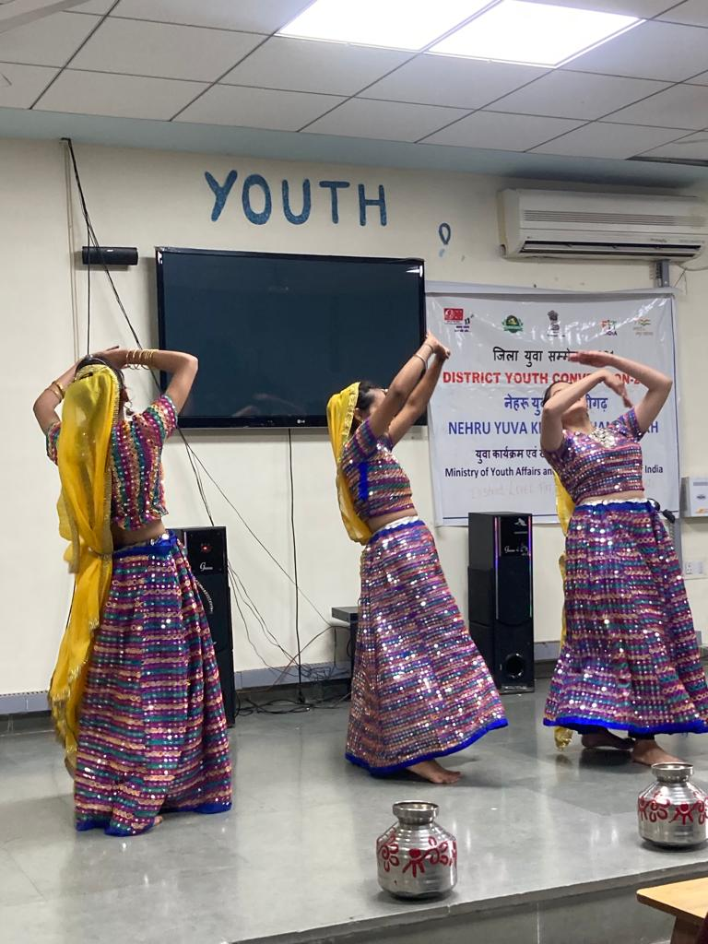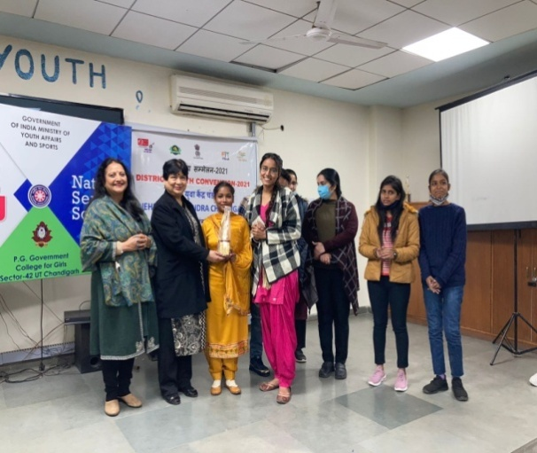
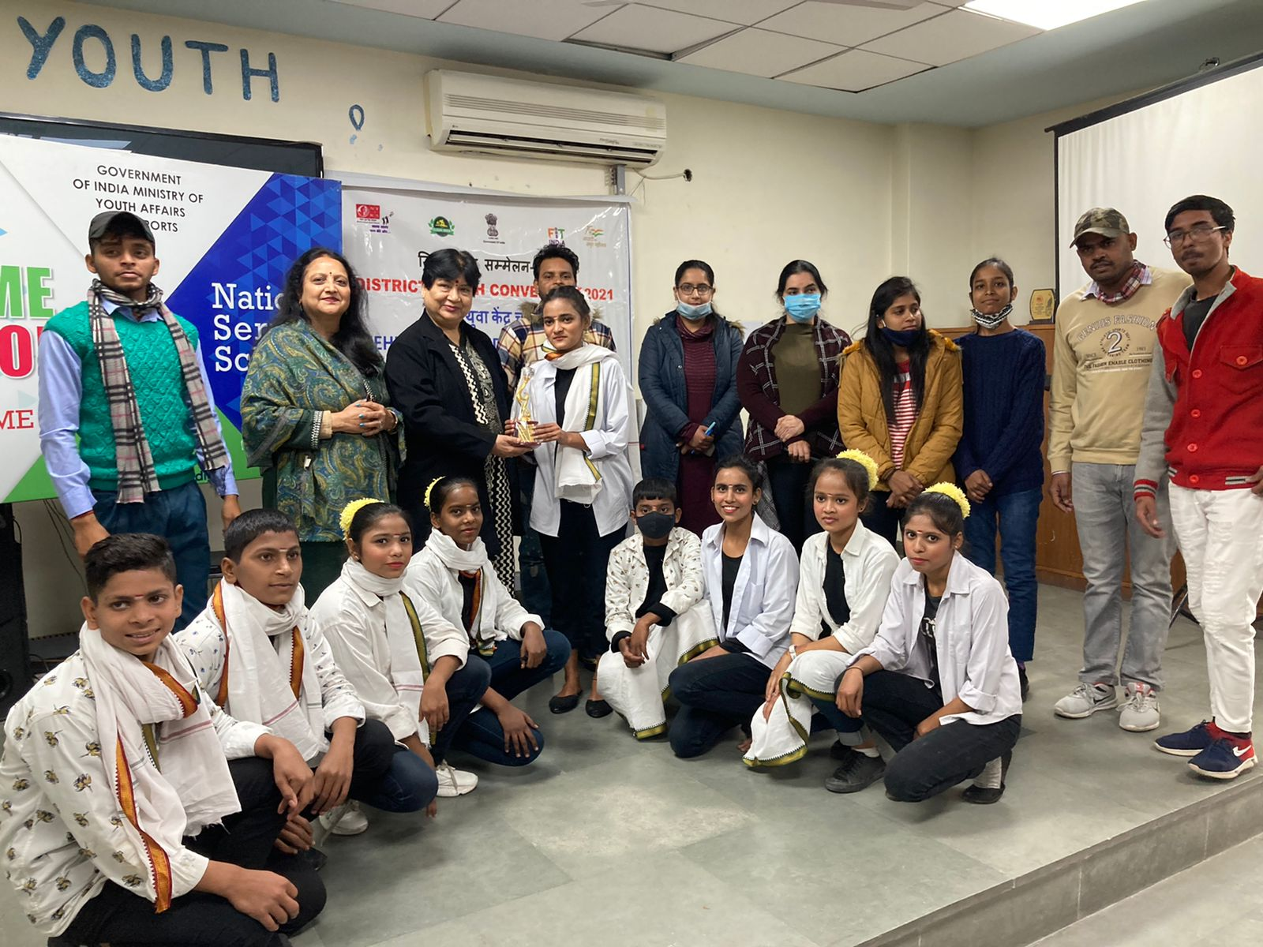
75TH CRORE SURYA NAMASKAR PROJECT TO MARK AMRIT MAHOTSAV (January 4, 2022)

NSS wing of Post Graduate Government College for Girls, Sector 42, Chandigarh organized 75th Crore Surya Namaskar Project to mark Amrit Mahotsav Celebration. College Principal Prof. Nisha Aggarwal was the Chief Guest for the event. She motivated students to practice Surya Namaskar daily, and she stressed upon organizing such events on regular basis for teaching and non- teaching staff for the development healthy mind and body. Prof Sudhir Hindwan, Overall Convener of Azadi Ka Amrit MahotsavIndia@75 under the Aegis of Ministry of Education appreciated the great efforts made to make the event a mega success.
Dr. Ram Niwas, the Convener of the event explained that Surya Namaskar tones the entire body, helps with weight loss, and strengthens muscles and joints. Aarti (Gold medalist inAsian Yoga Championship and Pooja Heer (yoga and wellness Coach) made wonderful presentation followed by students and faculty members in great number. Speaking on the occasion Dr. Vikas Sharma (Dept. of Bio-Infotech) spoke on the inside out benefits of doing Surya namaskar every day. More than 100 teaching and non-teaching faculty and students participated in this mega event.
Mr. Jagan Nath the Vice Principal of the college Dr. Deepika Kansal, the HOD of Chemistry Dept., Dr. Shifali, Dr Nemi Chand, Mr. Mehar Chand Dr Gurpreet Kaur-In Charge of the NSS and Ms. Kalyani Singh-In Charge-Publicity and a prominet member of Core Committee, Dr. Preeti Sharda, Librarian of the college were also present on the occasion. Participants wholeheartedly completed the Surya Namaskars. Prof. Ram Niwas (Head, Deptt of physical education) gave the vote of thanks.

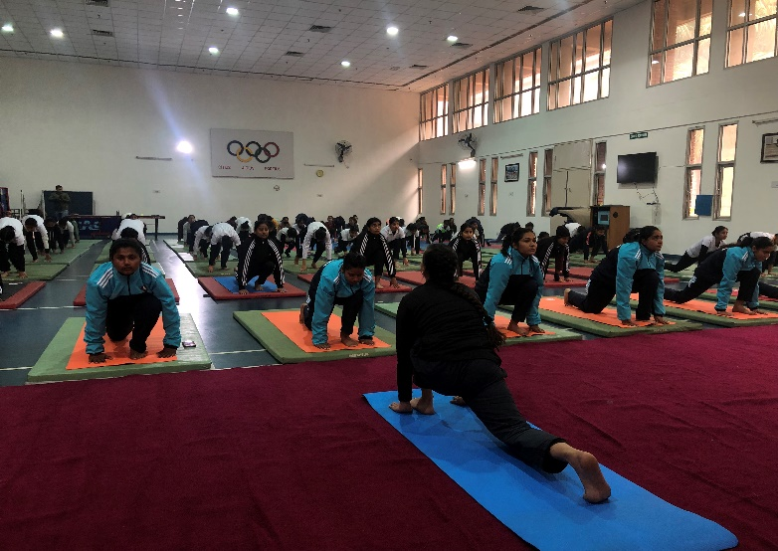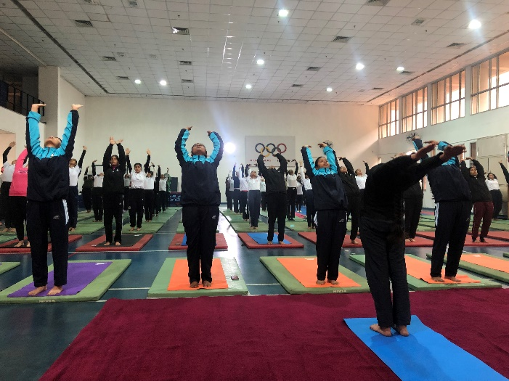

Swastha Balak- Balika Spardha, (10th January, 2022)
The Swasth Balak- Balika Spardha is a campaign held for height and weight measurement of upto 6 year old children. This campaign is conducted to promote the value of nutrition and good health of the children of the age group of upto 6 years. In regard to this the Ministry of Women and Child Development organised a Swastha Balak- Balika Spardha so as to mobilize sustained community participation for health and nutrition issues across the country.
Henceforth, the NSS Wing of Post Graduate Government College for Girls, Sector- 42 held a Swasth Balak- Balika Spardha in their adopted village Kajheri. The college Principal motivated the NSS Programme Officers and the NSS volunteers so as to hold this drive. Therefore, on 10th January, 2022 the NSS volunteers along with the Programme Officers held a drive to their adopted village Kajheri. In this drive, the volunteers came forward in full gusto and enthusiasm and organised many playful activities such as kho-kho, pick the handkerchief, passing the parcel, etc. were organized for the children of the village. Along with this the height and weight of the children was also recorded. The NSS in-charge of the college also gave the children eatables and the children felt delighted. This campaign helped the students to inculcate the value of giving and the joy of sharing. All the volunteers enjoyed their time in the village and also contributed their best in the campaign. This campaign was a really fruitful one and gave true meaning to the saying- “physical fitness is the pre-requisite of happiness.”

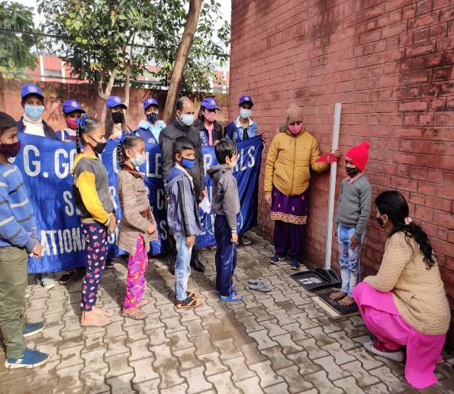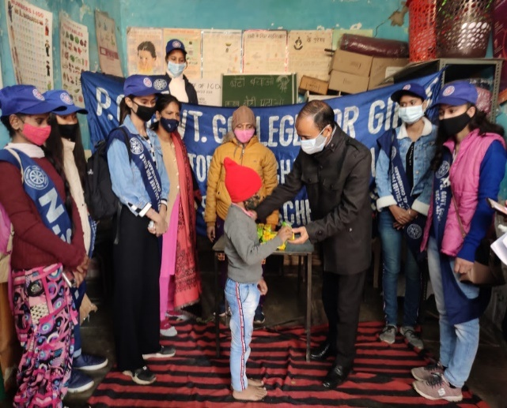
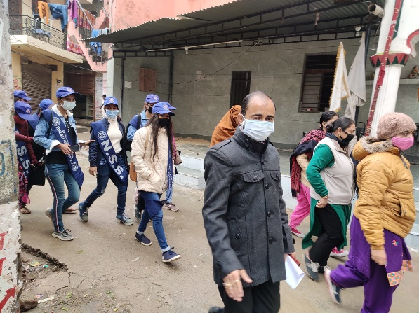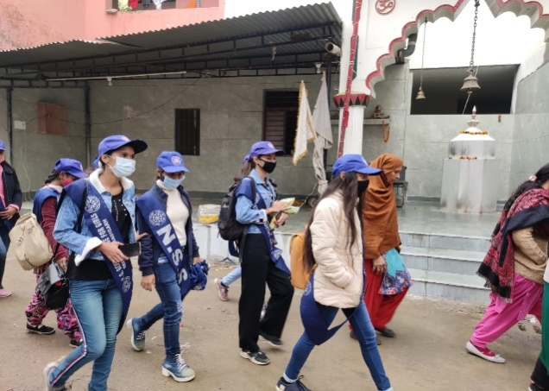
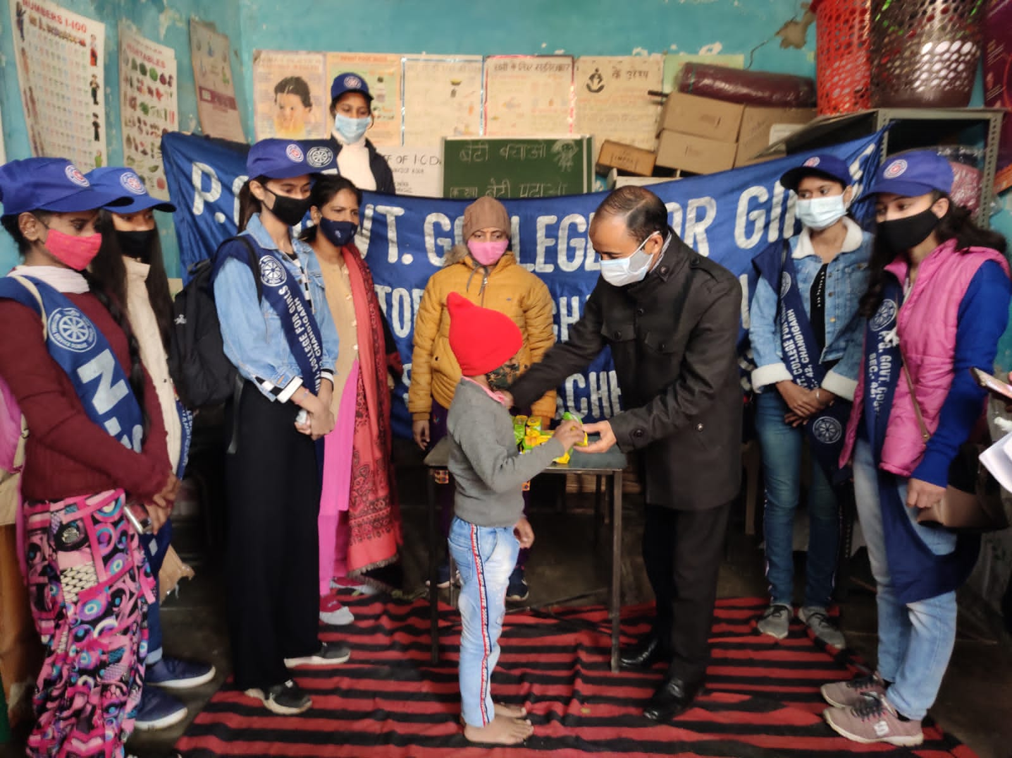
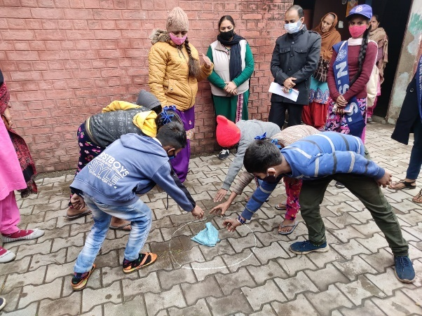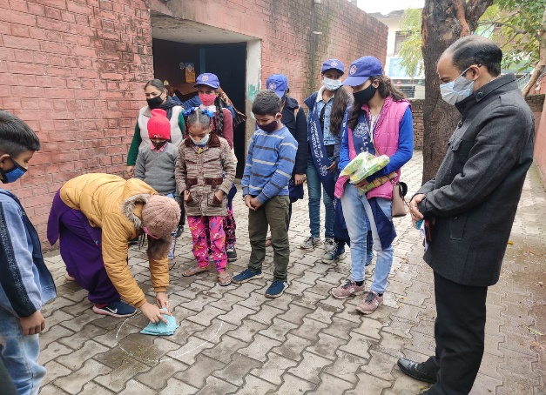
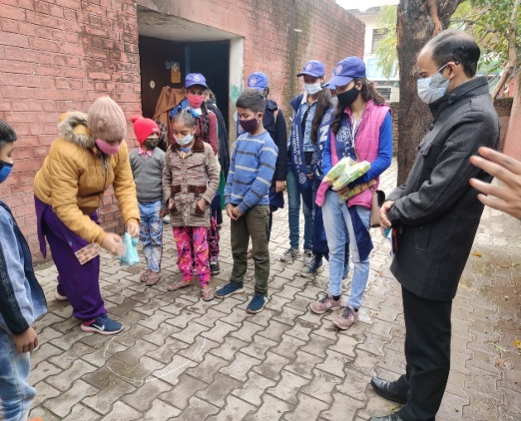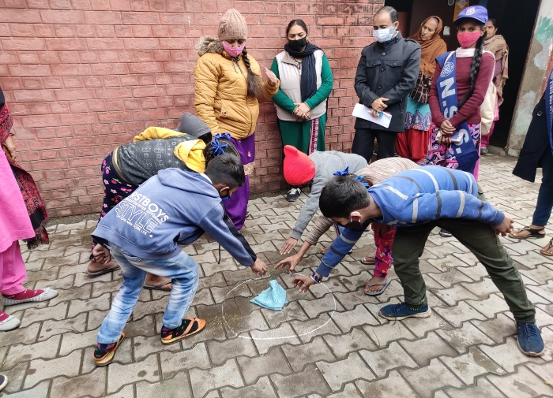
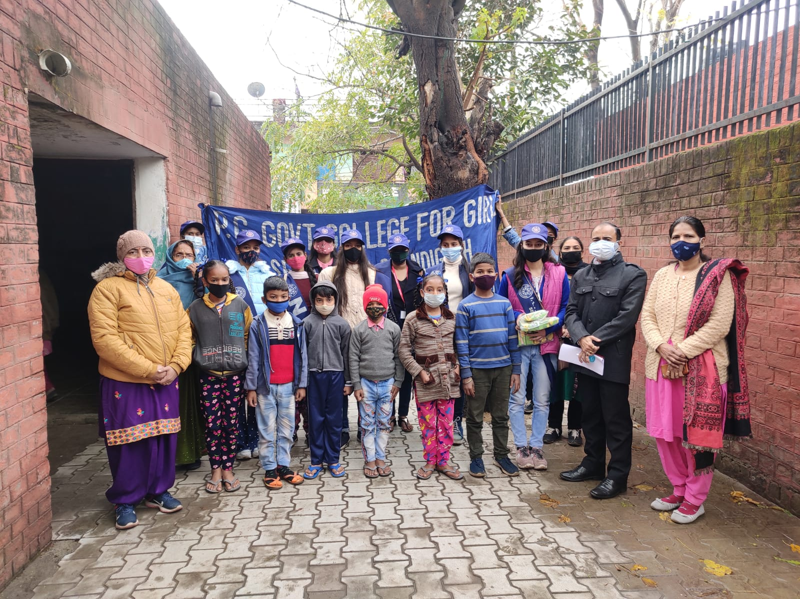
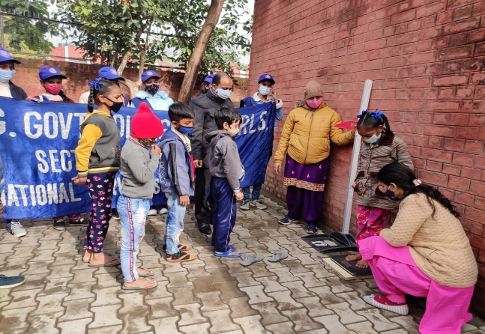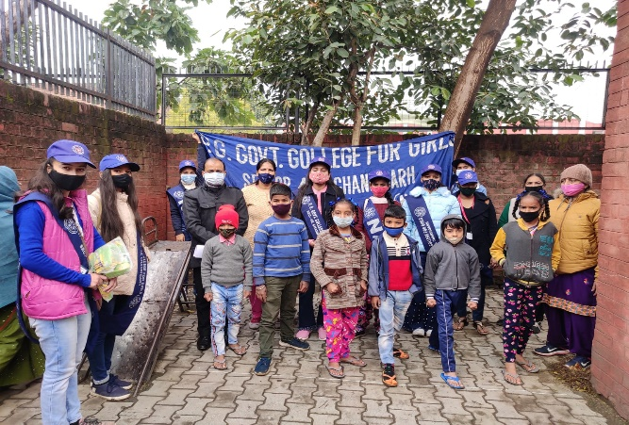

National Youth Day, (12th January 2022)
It is rightly said, “the future of a nation depends upon the youth of the country.” The youth is the major driving force of the country and has the ability to change the face of the nation by their very determination and hard work. On 12th January every year we celebrate the birth anniversary of Swami Vivekananda. This day is celebrated as National Youth Day in order to honor this great philosopher and monk who guided the people especially the youth through the light of life.
This year too the National Youth Day was commemorated by the government of India in virtual mode with the theme, “it is all in the mind.” Prime Minister Sh. Narendra Modi inaugurated the 25th National Youth Festival in Puducherry on January 12. The festival aimed to shape the minds of India's youth and transform them into a united force for nation building. It is one of the biggest exercises in social cohesion and intellectual and cultural integration. It aims to bring diverse cultures of India and integrate them into a united thread of 'Ek Bharat, Shreshtha Bharat'. This year, in view of the emerging Covid situation, the festival was scheduled to be held virtually on January 12.
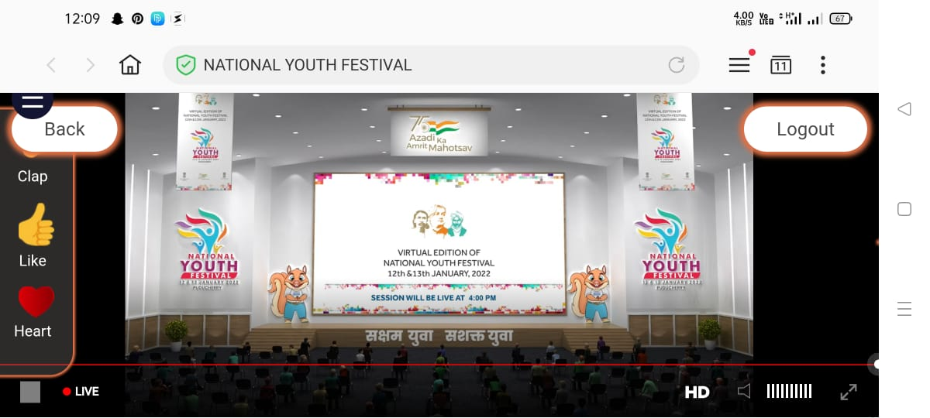
In the virtual meeting with the motivation of our college Principal, Prof.Nisha Aggarwal, the NSS volunteers of our college participated actively. Around 700 NSS volunteers took part in this virtual gathering, along with programme officers and felt really inspired by the words of our honourable Prime Minister, Sh. Narendra Modi. The programme began with the addressal of the Chief Minister of Puducherry which was followed by the address of the Prime Minister. He laid emphasis on the fact that the youth of a country is extremely powerful and they possess the power to change the nation by changing the backward mindset of the people and bringing into light the power of knowledge and advanced technology.
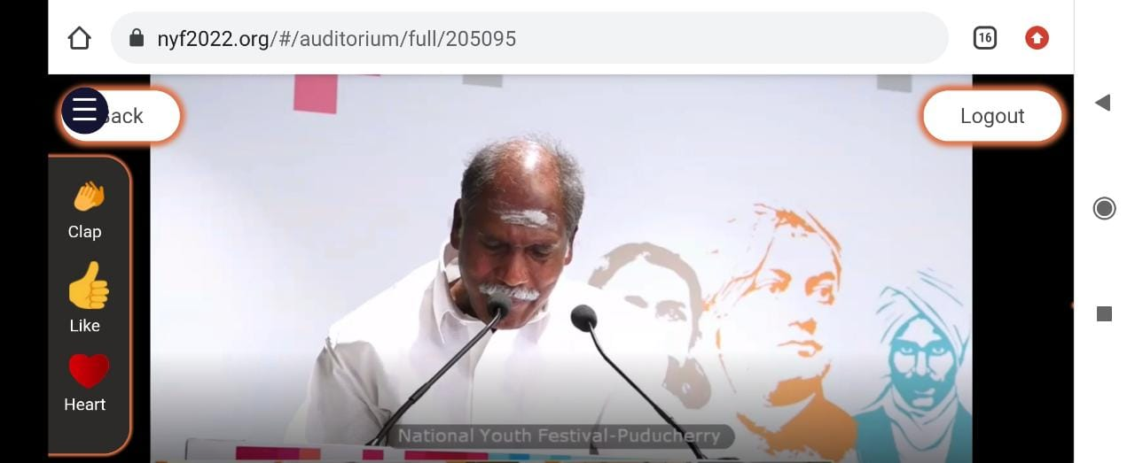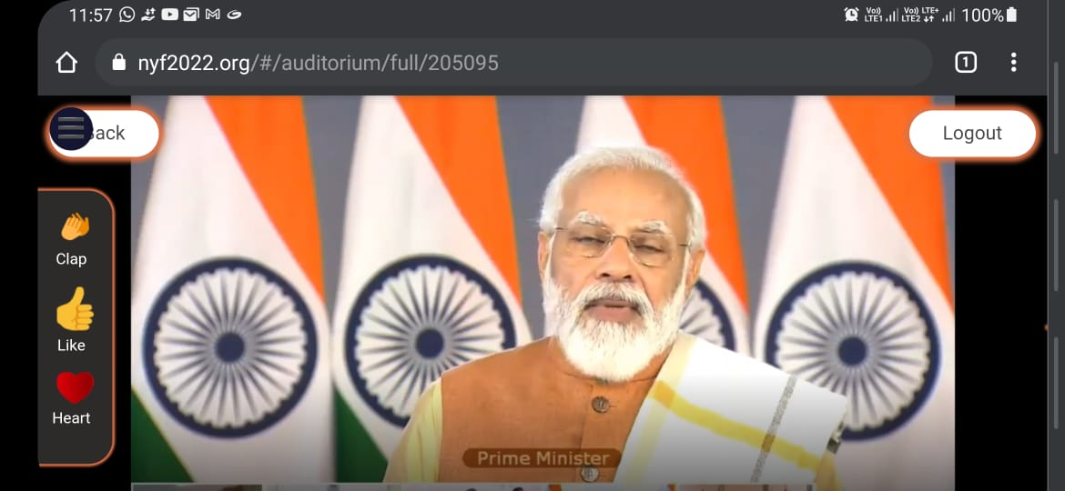
In the light of this topic the PM also brought into light that how India is developing as a fast growing nation and told the gathering that we are the country with fastest growth in online payment as well as we have over 50,000 start-ups that came up most of which belong to the tough phase of COVID. Laying stress on gender equality, he took special mention of the law wherein the marriage age for girls has been increased to 21, so that even girls can focus on their career and are not pressurised for marriage. He further motivated the youth to keep working in order to see their nation grow as they are the primary drivers of the nation.
The students of GCG-42 actively participated in the event and felt a sense of gusto and enthusiasm in them by the encouraging words of the honourable Prime Minister. The students had a positive feedback of the programme and felt motivated to work to the best of their abilities in order to develop their nation.

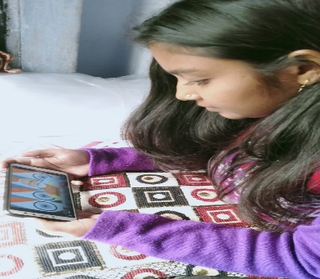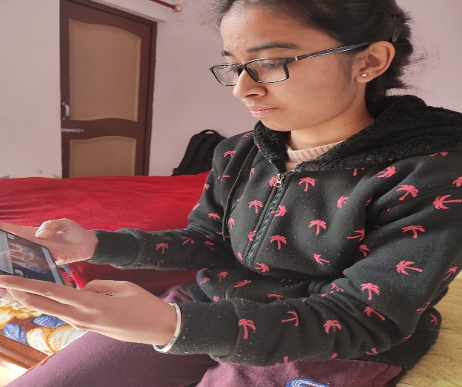
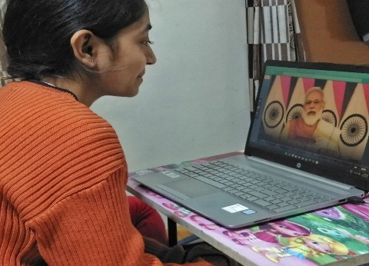
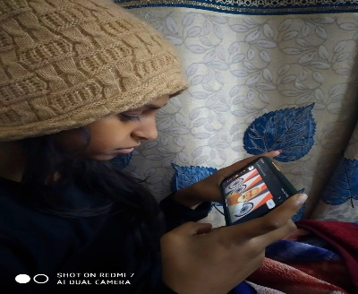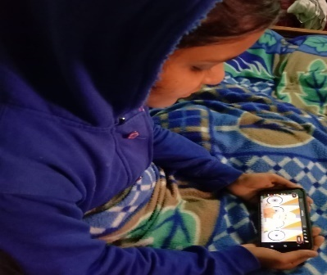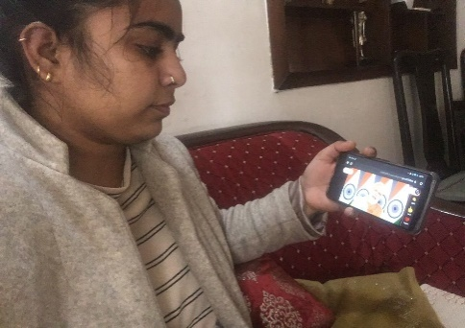
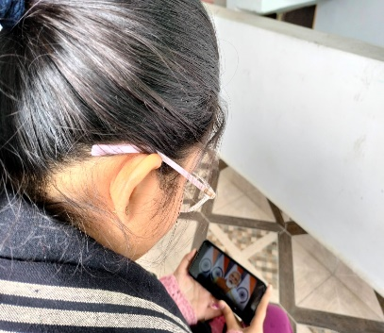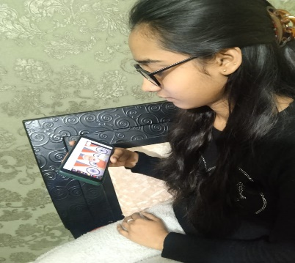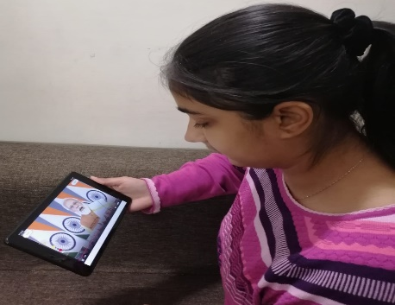

Surya Namaskar Programme- ‘Surya Namaskar for Vitality’ (January 14, 2022)

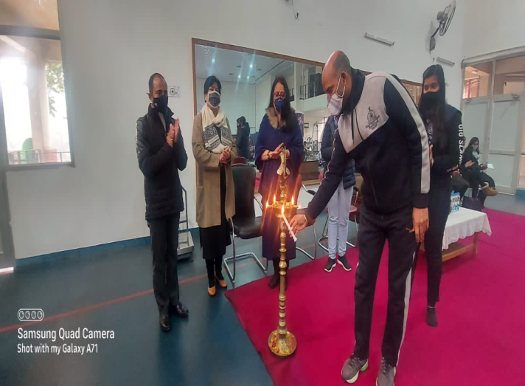
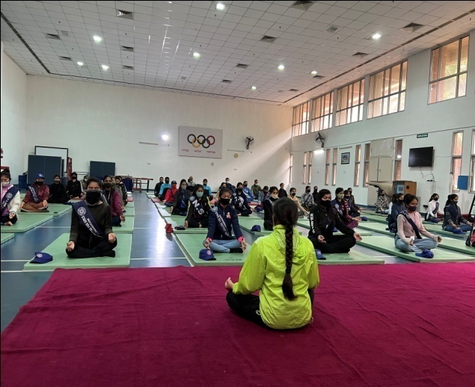
The NSS Wing and Department of Physical Education of Post Graduate Government College for Girls, Sector 42, Chandigarh organized Surya Namaskar Programme- ‘Surya Namaskar for Vitality’ to mark Azadi ka Amrit Mahotsav @75 India. College Principal Prof. Nisha Aggarwal was the Chief Guest for the event. She motivated students to practice Surya Namaskar daily, and motivated students to incorporate surya namaskar in their daily lives. Dr. Ram Niwas, Head, Department of Physical Education organised the spectacular programme. Dr. Harpreet Kaur handled the stage. Mr. Mehar Chand explained the 12 important benefits of surya namaskar. As many as 60 and 650 students, teaching and non teaching staff participated physically and virtually in this programme bearing the covid protocol. Prof Sudhir Hindwan, Overall Convener of Azadi Ka Amrit MahotsavIndia@75 under the Aegis of Ministry of Education appreciated the great efforts made to make the event a mega success.Aarti (Gold medalist inAsian Yoga Championship and Pooja Heer (yoga and wellness Coach) made wonderful presentation followed by students and faculty members in great number.
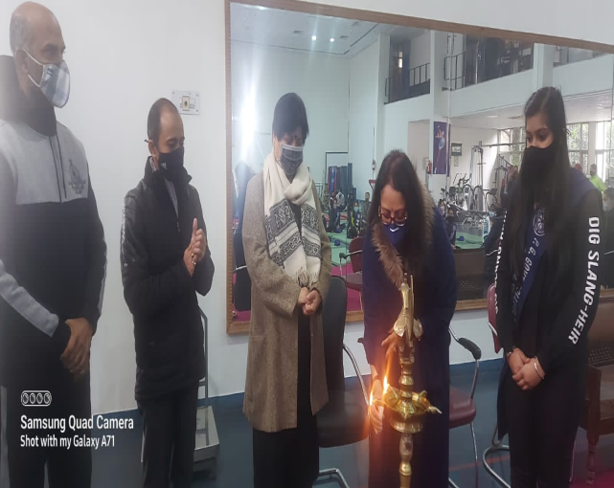
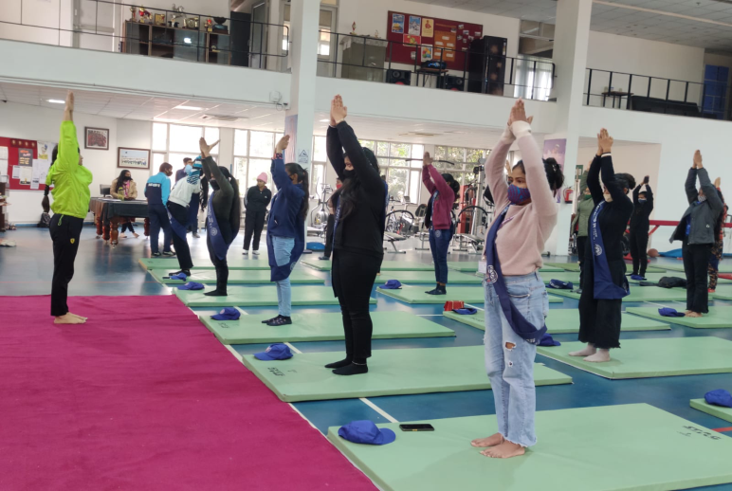

Mr. Mehar Chand Prof. Nisha Aggarwal
(NSS In-Charge) (Principal, PGGCG-42, Chandigarh)

